#include <iostream>

using namespace std;

int min(int x);

int max(int x);

int main()

{

int x,y,a[5],m=0 ,c=0,n =0,t=0,q=0;

cin >> x;

while (t < 4)

{

y = x;

m = min(y);

n = max(y);

a[t] = x;

cin >> x;

t++;

}

a[t] = x;

if (x < m)

{

m = x;

}

if (x > n)

{ n = x;

}

for (c = 0; c < 5; c++)

{if ((a[c] > 0 && a[c] < 100) || (a[c] == 0) || (a[c] == 100))

q++;

}

if (q == 5)

cout << "min=" << m << endl << "max=" << n << endl;

else

cout << "已超出范围" << endl;

return 0;

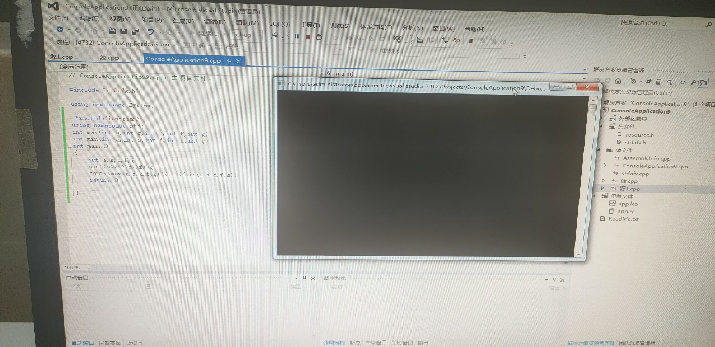感想：min，max函数在main函数中使用而且在main函数后定义，要注意对其进行声明

