**实验3 11.5**

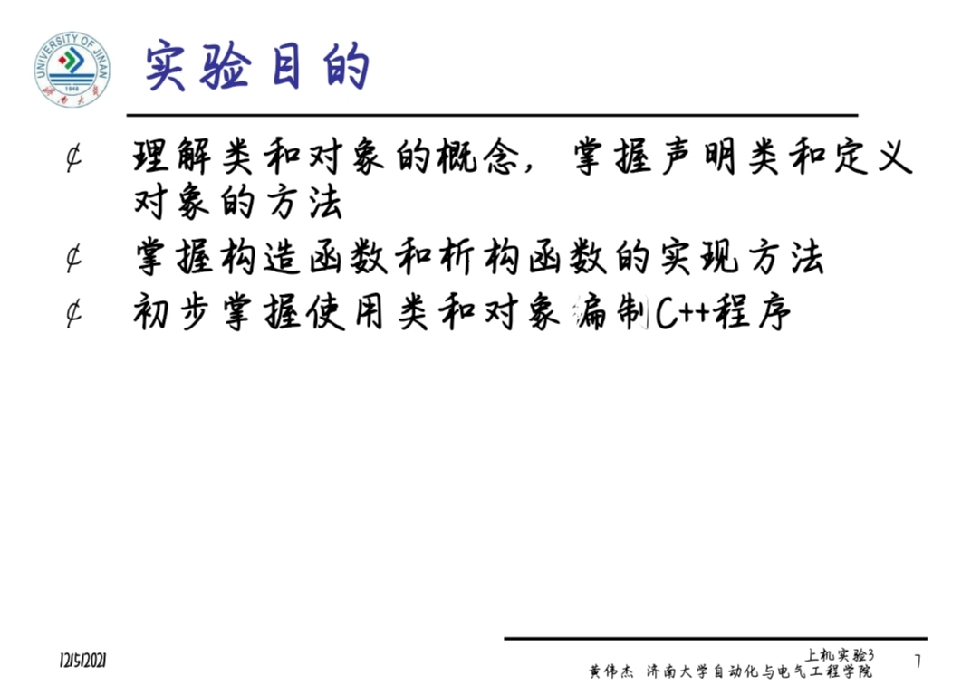

1. **操作**

#include<iostream>

using namespace std;

class Coordinate { // 定义Coordinate类

public:

Coordinate()

{

times = 2;

cout << "Coordinate construction1 called!" << endl;

}

Coordinate(int times1)

{

times = times1;

cout << "Coordinate construction2 called!" << endl;

}

~Coordinate()

{

cout << "Coordinate destruction called!" << endl;

}

void InputCoord()

{

for (int i = 0; i < times; i++)

{

cout << "Please Input x:" << endl;

cin >> Coord[i][1];

cout << "Please Input y:" << endl;

cin >> Coord[i][2];

}

}

void ShowCoord()

{

cout << "The coord is:" << endl;

for (int i = 0; i < times; i++)

{

cout << "(" << Coord[i][1] << "," << Coord[i][2] << ")" << endl;

}

}

void ShowAvgCoord()

{

float avgx = 0;

float avgy = 0;

for (int i = 0; i < times; i++)

{

avgx = avgx + Coord[i][1];

avgy = avgy + Coord[i][2];

}

avgx = avgx / times;

avgy = avgy / times;

cout << "The AVG coord is:" << endl;

cout << "(" << avgx << "," << avgy << ")" << endl;

}

private:

float Coord[100][100]; // 存放输入坐标的数组

int times; // 存放输入坐标数目

};

int main()

{

Coordinate x;

x.InputCoord();

x.ShowCoord();

x.ShowAvgCoord();

Coordinate y(5);

y.InputCoord();

y.ShowCoord();

y.ShowAvgCoord();

return 0;

}

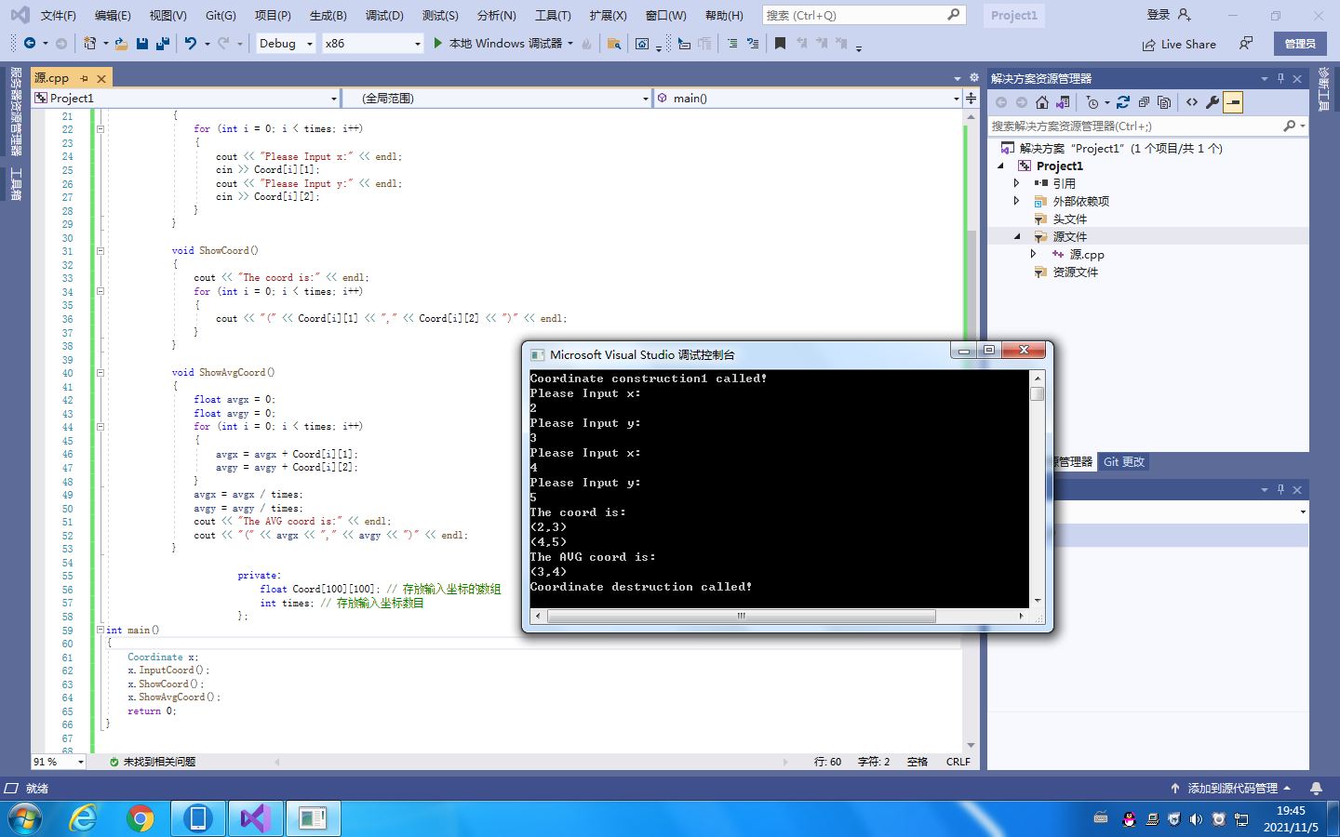

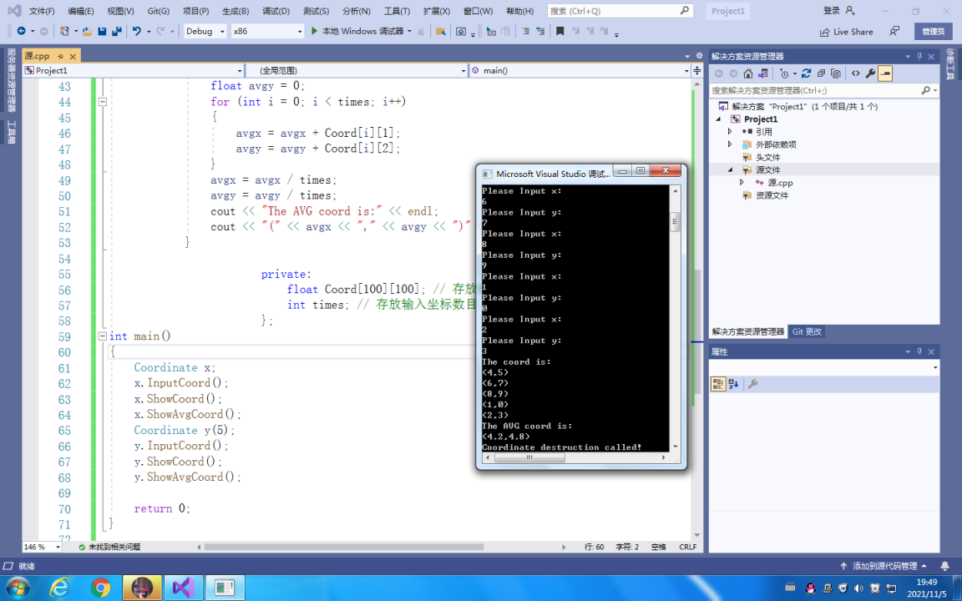

#include<iostream>

using namespace std;

class Score {

public:

Score()

{

times = 2;

cout << "Score construction1 called!" << endl;

}

Score(int times1)

{

times = times1;

cout << "Score construction2 called!" << endl;

}

~Score()

{

cout << "Score destruction called!" << endl;

}

void Input()

{

for (int i = 0; i < times; i++)

{

cout << "请输入学生姓名：" << endl;

cin >> name[i];

}

}

void InputCoord()

{

for (int i = 0; i < times; i++)

{

cout << "请输入科目A成绩:" << endl;

cin >> Coord[i][1];

cout << "请输入科目B成绩:" << endl;

cin >> Coord[i][2];

cout << "请输入科目C成绩:" << endl;

cin >> Coord[i][3];

}

}

void ShowCoord()

{

cout << "显示每科成绩:" << endl;

for (int i = 0; i < times; i++)

{

cout << "A：" << Coord[i][1] << " B：" << Coord[i][2] << " C：" << Coord[i][3] << endl;

}

cout << "显示平均成绩：" << endl;

for (int i = 0; i < times; i++)

{

cout << (Coord[i][1] + Coord[i][2] + Coord[i][3]) / 3.0 << endl;

}

}

void ShowAvgCoord()

{

float avgA = 0;

float avgB = 0;

float avgC = 0;

for (int i = 0; i < times; i++)

{

avgA = avgA + Coord[i][1];

avgB = avgB + Coord[i][2];

avgC = avgC + Coord[i][3];

}

avgA = avgA / times;

avgB = avgB / times;

avgC = avgC / times;

cout << "平均成绩是:" << endl;

cout << "课程名称A的平均成绩：" << avgA << " 课程名称B的平均成绩：" << avgB << "课程名称C的平均成绩：" << avgC << endl;

}

void Showorder()

{

cout << "A成绩排序" << endl;

for (int i = 0; i < times - 1; i++)

{

int k = i;

for (int j = i + 1; j < times; j++)

{

if (Coord[k][0] < Coord[j][0])

{

k = j;

}

}

}

}

private:

float Coord[100][100];

char name[100];

int times;

};

int main()

{

Score x;

x.Input();

x.InputCoord();

x.ShowCoord();

x.ShowAvgCoord();

return 0;

}

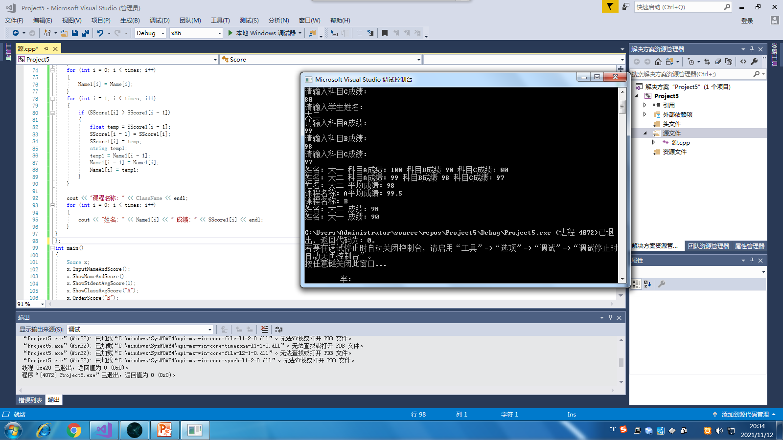

#include<iostream>

#include<string>

using namespace std;

class Score {

private:

float SScore[100][3], SScore1[100];

string Name[100], Name1[100];

int times;

public:

Score()

{

times = 2;

}

Score(int times1)

{

times = times1;

}

void InputNameAndScore()

{

for (int i = 0; i < times; i++)

{

cout << "请输入学生姓名:" << endl;

cin >> Name[i];

cout << "请输入科目A成绩:" << endl;

cin >> SScore[i][1];

cout << "请输入科目B成绩:" << endl;

cin >> SScore[i][2];

cout << "请输入科目C成绩:" << endl;

cin >> SScore[i][3];

}

}

void ShowNameAndScore()

{

for (int i = 0; i < times; i++)

{

cout << "姓名: " << Name[i] << " 科目A成绩: " << SScore[i][1] << " 科目B成绩 " << SScore[i][2] << " 科目C成绩: " << SScore[i][3] << endl;

}

}

void ShowStdentAvgScore(int Sid)

{

float avg = 0;

avg = (SScore[Sid][1] + SScore[Sid][2] + SScore[Sid][3]) / 3;

cout << "姓名: " << Name[Sid] << " 平均成绩: " << avg << endl;

}

void ShowClassAvgScore(string ClassName)

{

int Cid;

float avg = 0;

if (ClassName == "A") Cid = 1;

if (ClassName == "B") Cid = 2;

if (ClassName == "C") Cid = 3;

for (int i = 0; i < times; i++)

{

avg = avg + SScore[i][Cid];

}

avg = avg / times;

cout << "课程名称: " << ClassName << "平均成绩: " << avg << endl;

}

void OrderScore(string ClassName)

{

int Cid;

if (ClassName == "A") Cid = 1;

if (ClassName == "B") Cid = 2;

if (ClassName == "C") Cid = 3;

for (int i = 0; i < times; i++)

{

SScore1[i] = SScore[i][Cid];

}

for (int i = 0; i < times; i++)

{

Name1[i] = Name[i];

}

for (int i = 1; i < times; i++)

{

if (SScore1[i] > SScore1[i - 1])

{

float temp = SScore1[i - 1];

SScore1[i - 1] = SScore1[i];

SScore1[i] = temp;

string temp1;

temp1 = Name1[i - 1];

Name1[i - 1] = Name1[i];

Name1[i] = temp1;

}

}

cout << "课程名称: " << ClassName << endl;

for (int i = 0; i < times; i++)

{

cout << "姓名: " << Name1[i] << " 成绩: " << SScore1[i] << endl;

}

}

};

int main()

{

Score x;

x.InputNameAndScore();

x.ShowNameAndScore();

x.ShowStdentAvgScore(1);

x.ShowClassAvgScore("A");

x.OrderScore("B");

return 0;

}

1. 问题

**1.在输入中，{}使用错误导致报错。**

**2.字符串的输入用string。**

**3.构造函数一般服从顺序结构从上到下依次构造。析构函数一般析构优先顺序：局部对象>静态变量>全局变量。**

1. 感受心得

这次上机实验的难度明显加大了，因为在上机时对类和对象了解的不是很深刻，要自己完全的动手写出这个程序还是有困难的。课后通过与同学的讨论以及自己看书研究，终于明白了构造函数，析构函数以及类的定义和使用等方面的问题，因为是自己亲自编写程序，所以对于错误会更深刻，上机是对理论知识的一种实践，让我更好的掌握了知识。

Copyright©2021-2099 MengyuanWang.All rights reserved.