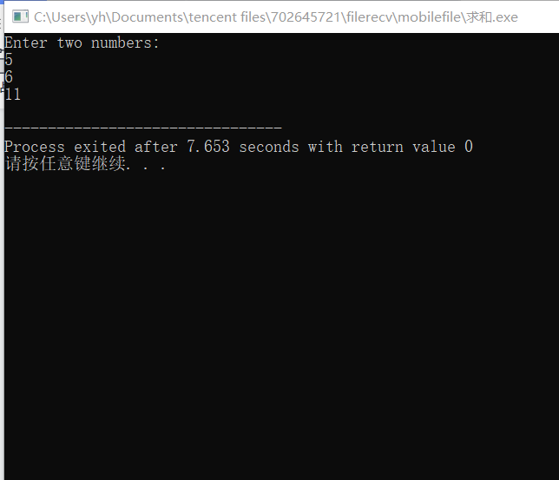

#include <iostream>

using namespace std;

int add(int, int);

int main()

{

int x, y, sum;

cout << "Enter two numbers:" << endl;

cin >> x>>y;

sum = add(x, y);

cout << sum << endl;

return 0;

}

int add(int a, int b)

{

return a + b;

}