Copyright ©2021-2099 YuanxinZhang. All rights reserved

**实验内容**

* **尝试编写一个程序，实现两个复数的乘法**

1. **程序代码**

#include<iostream>

using namespace std;

class complex {

public:

double real;

double imag;

complex(double r = 0, double i = 0)

{

real = r;

imag = i;

}

};

complex operator*(complex co1, complex co2)

{

complex temp;

temp.real = co1.real * co2.real - co1.imag * co2.imag;

temp.imag = co1.real * co2.imag + co1.imag * co2.real;

return temp;

}

int main()

{

complex com1(2, 2), com2(3, 3), total;

total = com1 * com2;

cout << "imag1: " << com1.imag << " " << "real1: " << com1.real << endl;

cout << "imag2: " << com2.imag << " " << "real2: " << com2.real << endl;

cout << "imag= " << total.imag << endl;

cout << "real= " << total.real;

}

1. **运行结果**

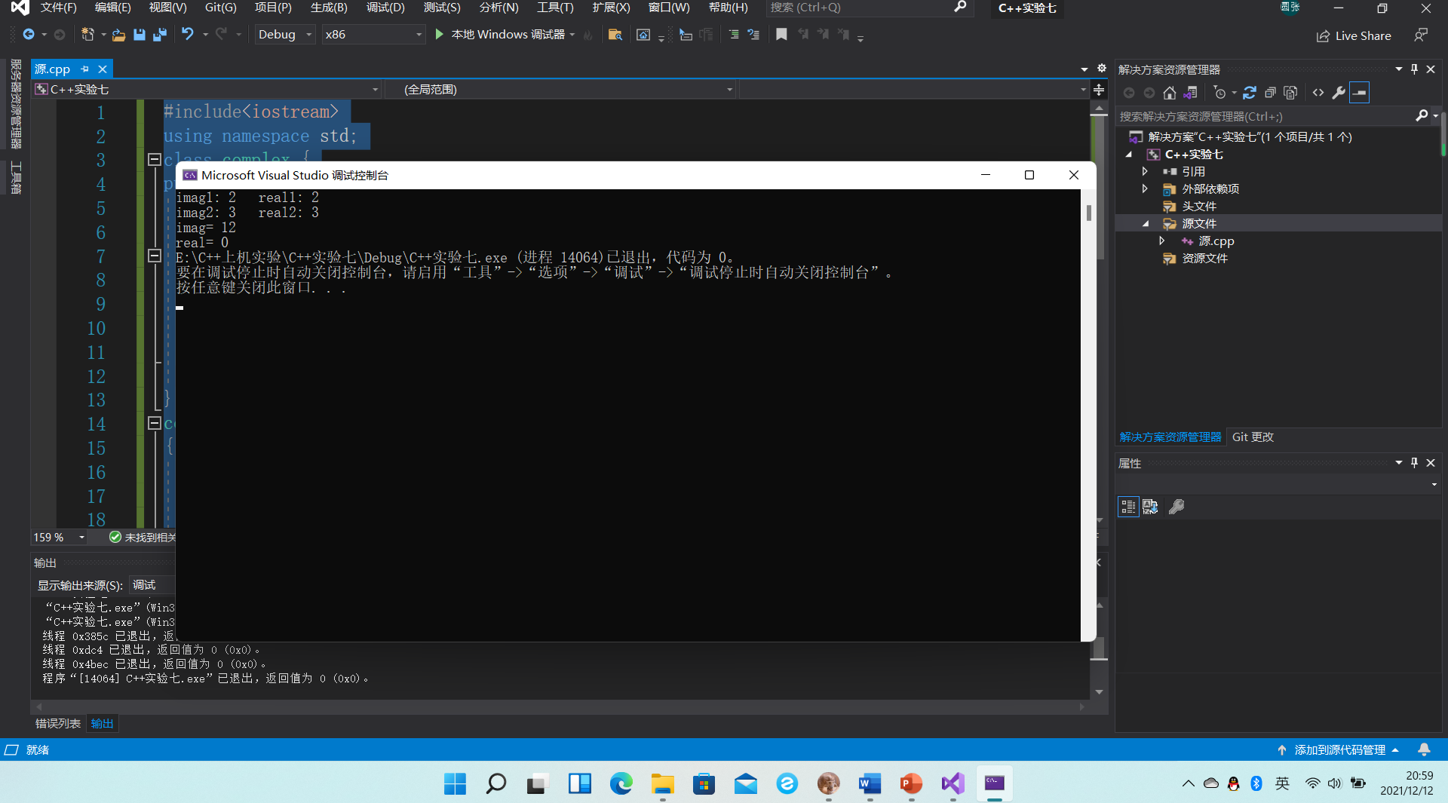

1. **心得感悟**

**此次实验比较简单，没有遇到什么问题。**