上机实验七

**班级：电自2004 学号：202030310161 姓名：徐海宸**

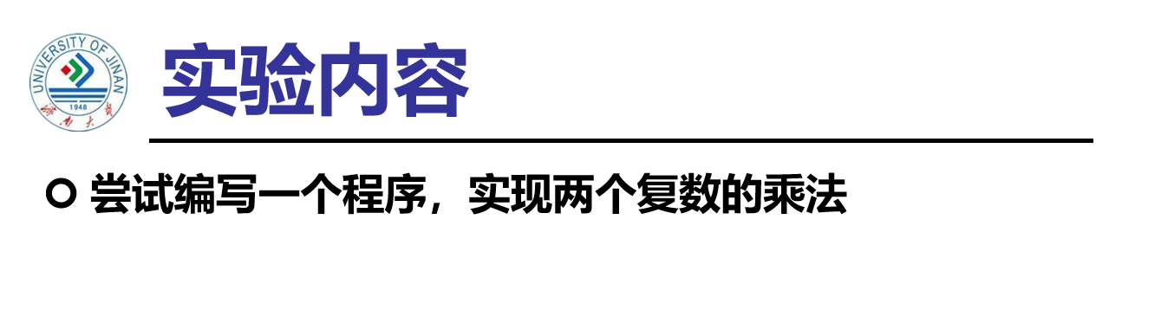

**程序代码：**

#include<iostream>

using namespace std;

class complex {

public:

double real;

double imag;

complex(double r = 0, double i = 0)

{

real = r;

imag = i;

}

};

complex operator\*(complex co1, complex co2)

{

complex temp;

temp.real = co1.real \* co2.real - co1.imag \* co2.imag;

temp.imag = co1.real \* co2.imag + co1.imag \* co2.real;

return temp;

}

int main()

{

complex com1(1, 2), com2(2, 3), total;

total = com1 \* com2;

cout << "imag1: " << com1.imag << " " << "real1: " << com1.real << endl;

cout << "imag2: " << com2.imag << " " << "real2: " << com2.real << endl;

cout << "imag= " << total.imag << " " << "real= " << total.real;

}

**运行结果：**

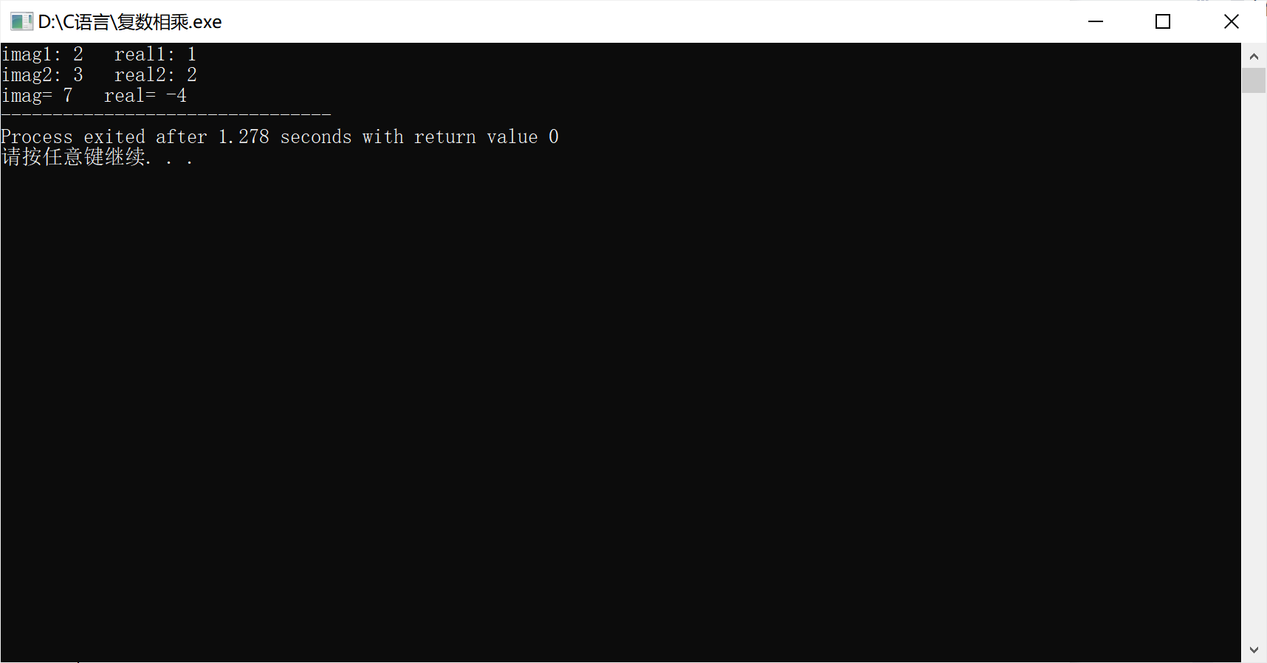

**问题总结及感想心得：**

本次试验我掌握了C++语言多态性的基本概念以及运算符重载函数的声明和定义方法，以老师给出的两个复数的加法的程序为例，慢慢写出了实现两个复数的乘法的程序，只是较加法更为复杂些，因为复数的乘法不仅仅是实部与实部相乘、虚部与虚部相乘，所以在编写这一部分时会比较困难。

Copyright IMG_2562021-2099 HaiChenXu. All rights reserved.