实验报告（七）

1.1程序代码：

#include <iostream>

using namespace std;

class matrixmul

{

private:

double real;

double imag;

public:

void output();

void initSet(double re,double im);

matrixmul matrixMul(matrixmul Z1,matrixmul Z2);

};

matrixmul matrixmul::matrixMul(matrixmul Z1,matrixmul Z2)

{

double temp1,temp2,temp3;

matrixmul result;

temp1=Z1.real\*Z2.imag;

temp2=Z1.imag\*Z2.real;

temp3=(Z1.imag+Z1.real)\*(Z2.real-Z2.imag);

result.real=temp1+temp3-temp2;

result.imag=temp1+temp2;

return result;

}

void matrixmul::initSet(double re,double im)

{

real=re;

imag=im;

}

void matrixmul::output()

{

if(imag>0)

{

cout<<real<<"+"<<imag<<"i"<<endl;

}

else if(imag==0)

{

cout<<real<<endl;

}

else if(imag<0)

{

cout<<real<<imag<<"i"<<endl;

}

}

int main()

{

matrixmul Z1,Z2,Z3,result;

Z1.initSet(1,-2);

Z2.initSet(3,-4);

cout<<"第一个复数Z1为："<<endl;

Z1.output();

cout<<"第二个复数Z2为："<<endl;

Z2.output();

result=Z3.matrixMul(Z1,Z2);

cout<<"两复数相乘结果的复数为："<<endl;

result.output();

return 0;

}

1.2程序结果：

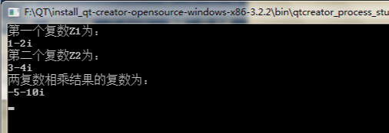

2、感想心得：通过这次上机实验我掌握了C++语言多态性的基本概念，掌握了运算符重载函数的声明和定义方法。

Copyright ©2021-2099 MingxiaoZhao. All rights reserved