实验报告（四）

1.1程序代码：

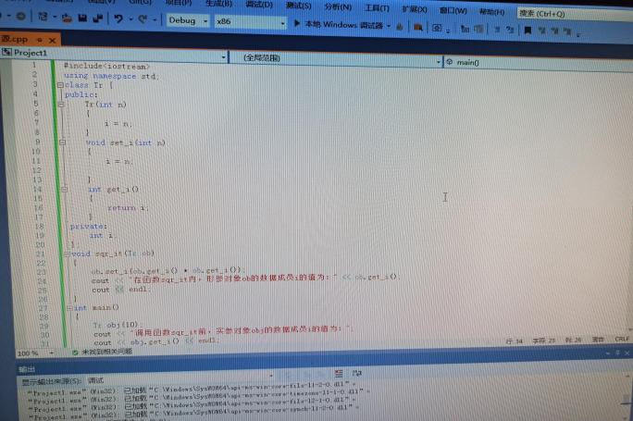

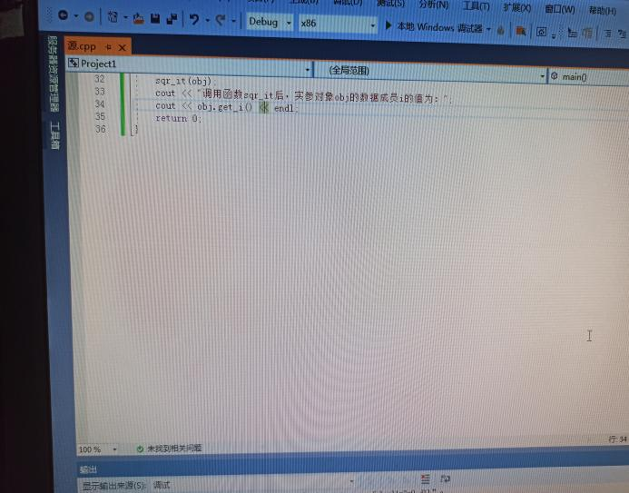

1.2程序结果：

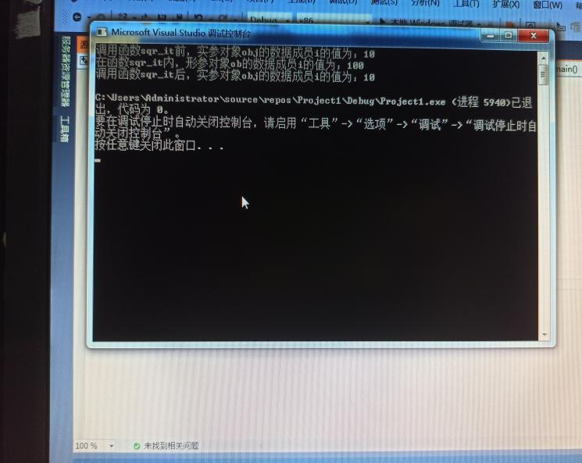

2.2程序代码：

#include "iostream.h"#include <string.h>class TStudent{private: char m_Name[6]; static float m_ClassMoney; public: void InitStudent(char *); void ExpendMoney(float); static void ShowMoney(); };float TStudent::m_ClassMoney=1000;

void TStudent::InitStudent(char name[]){ strcpy(m_Name,name);}void TStudent::ExpendMoney(float money){ m_ClassMoney-=money;

cout<<m_Name<<"花费班费"<<m_ClassMoney<<endl;} void TStudent::ShowMoney() { cout<<"班费还剩余"<< m_ClassMoney<<endl;

}

void main(){ TStudent stu[3]; stu[0].InitStudent("A"); stu[1].InitStudent("B"); stu[2].InitStudent("C"); stu[0].ExpendMoney(50); TStudent::ShowMoney(); stu[1].ExpendMoney(98.5); TStudent::ShowMoney(); stu[2].ExpendMoney(500.53); TStudent::ShowMoney();}

2.2程序结果：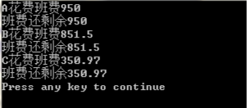

3.感想心得：

通过本次上机实验我进一步加深了对类和对象的理解，掌握了几种对象传递的使用方法和静态成员的概念和使用。

Copyright ©2021-2099 MingxiaoZhao. All rights reserved