一、程序代码

#include <iostream>

using namespace std;

class complex {

private:

float real;

float imag;

public:

complex operator\*(complex p)

{

complex temp;

temp.real = real \* p.real - imag \* p.imag;

temp.imag = real \* p.imag + imag \* p.real;

return temp;

}

complex(float a = 0, float b = 0)

{

real = a;

imag = b;

}

void show()

{

cout << "(" << real << "," << imag << ")"<<endl;

}

};

int main()

{

complex a(4, 6), b(4, -6), c;

c = a \* b;

c.show();

}

二、程序结果

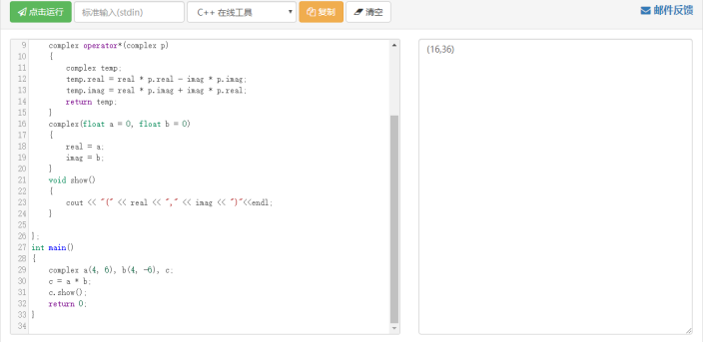

三、感想心得

通过此次实验，我掌握了模板的概念，了解了运算符重载，并对c++编程有了更进一步的理解。