1. 实验代码

#include <iostream>

#include <string>

using namespace std;

class score

{

public:

score()

{

time = 2;//默认为2

cout << "无参数解析函数的调用" << endl;

}

score(int time1)

{

time = time1;

cout << "用户自定义解析函数的调用" << endl;

}

~score()

{

cout << "析构函数的调用" << endl;

}

void input()

{

for (int i = 0; i < time; ++i)

{

cout << "请输入学生的姓名和三科的成绩" << endl;

cin >> name[i];

cin >> cj[i][1] >> cj[i][2] >> cj[i][3];

}

}

void show()

{

for (int i = 0; i < time; ++i)

{

cout << name[i] << "学科A的成绩为：" << cj[i][1] << " ";

cout << name[i] << "学科B的成绩为：" << cj[i][2] << " ";

cout << name[i] << "学科C的成绩为：" << cj[i][3] << endl;

}

}

void avg()

{

double a=0;

for (int i = 0; i < time; ++i)

{

a = cj[i][1] + cj[i][2] + cj[i][3];

cout << name[i] << "平均成绩为" << a/3 <<" ";

}

cout << endl;

}

void showavg()

{

double a=0;

double b=0;

double c=0;

for (int i=0; i < time; ++i)

a = a + cj[i][1];

for (int i=0; i < time; ++i)

b = b + cj[i][2];

for (int i=0; i < time; ++i)

c = c + cj[i][3];

cout << "学科A的平均成绩为" << a / time << " ";

cout << "学科B的平均成绩为" << b / time << " ";

cout << "学科C的平均成绩为" << c / time << endl;

}

void px()

{

for (int i = 0; i < time; ++i) //将name【】数组复制一个

copy[i] = name[i];

for (int i = 0; i < time - 1; i++)

for (int j = 0; j < time - i - 1; j++)

if (cj[j][1] < cj[j + 1][1]) //改变了name【】数组数据的位置

{

double temp = cj[j + 1][1];

cj[j + 1][1] = cj[j][1];

cj[j][1] = temp;

string t = name[j + 1];

name[j + 1] = name[j];

name[j] = t;

}

cout << "学科A的排序为" << endl;

for (int i = 0; i < time; ++i) //打印姓名和对应的成绩

{

cout << name[i] << " " << cj[i][1] << endl;

}

for (int i = 0; i < time; ++i) //重置name【】数组

name[i] = copy[i];

for (int i = 0; i < time - 1; i++)

for (int j = 0; j < time - i - 1; j++)

if (cj[j][2] < cj[j + 1][2])

{

double temp = cj[j + 1][2];

cj[j + 1][2] = cj[j][2];

cj[j][2] = temp;

string t = name[j + 1];

name[j + 1] = name[j];

name[j] = t;

}

cout << "学科B的排序为" << endl;

for (int i = 0; i < time; ++i) //打印姓名和对应的成绩

{

cout << name[i] << " " << cj[i][2] << endl;

}

for (int i = 0; i < time; ++i) //重置name【】数组

name[i] = copy[i];

for (int i = 0; i < time - 1; i++)

for (int j = 0; j < time - i - 1; j++)

if (cj[j][3] < cj[j + 1][3])

{

double temp = cj[j + 1][3];

cj[j + 1][3] = cj[j][3];

cj[j][3] = temp;

string t = name[j + 1];

name[j + 1] = name[j];

name[j] = t;

}

cout << "学科C的排序为" << endl; //打印姓名和对应的成绩

for (int i = 0; i < time; ++i)

{

cout << name[i] <<" "<< cj[i][3] << endl;

}

}

private:

int time;

double cj[100][100];

string name[100];

string copy[100];

};

int main()

{

score a(3);

a.input();

a.show();

a.avg();

a.showavg();

a.px();

return 0;

}

1. 实验结果

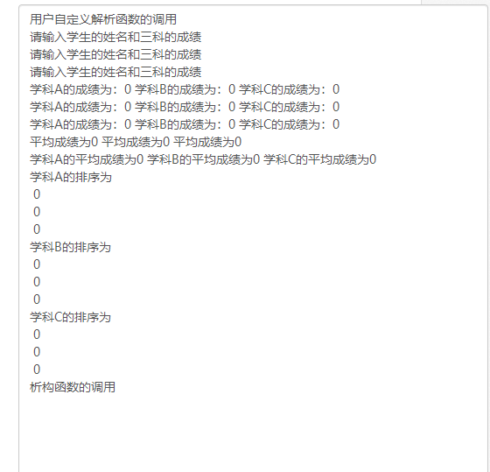

1. 实验感想

本次实验在完成基本任务的基础上增加了用户可以自行输入坐标的数目，但是编程中

出现的问题也成功解决，但是出现问题的原因还不是很清楚，而且为什么不同时间程序编译有时没有警告有时有警告，这种情况的原因也不是很清楚问题都解决了，但是出现问题的原因不是特别明确。