一、程序代码

#include<iostream>

using namespace std;

class Complex {

double real;

double imag;

public:

Complex(double r = 0, double i = 0)

{

real = r; imag = i;

}

void print();

friend Complex operator\*(Complex co1, Complex co2);

};

Complex operator\*(Complex co1, Complex co2)

{

Complex temp;

temp.real = co1.real \* co2.real-co1.imag\*co2.imag;

temp.imag = co1.real \* co2.imag+co1.imag\*co2.real;

return temp;

}

void Complex::print()

{

cout<< "total real=" << real << " " << " total imag=" << imag << endl;

}

int main()

{

float a, b, c, d;

cout << "please input real and imag:" << endl;

cin >> a>>b;

cout << "please input real and imag:" << endl;

cin >> c>>d;

Complex com1(a,b), com2(c,d), total1;

total1 = com1 \* com2;

total1.print();

return 0;

}

二、程序结果

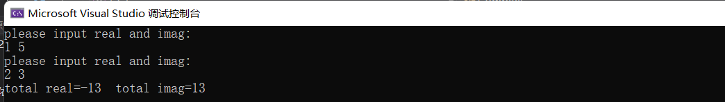

三、感悟心得

可以通过运算符重载实现一些不寻常的运算的运算。

Copyright ©2021-2099 ZhongkaiCui. All rights reserved