Copyright ©2021-2099 SongyunMo. All rights reserved

第三次上机

1.#include<iostream>

using namespace std;

class Coordinate {

public:

Coordinate()

{

times = 2;

cout << "Coordinate construction 1 called!" << endl;

}

Coordinate(int times1)

{

times = times1;

cout << "Coordinate construction 2 called!" << endl;

}

~Coordinate()

{

cout << "Coordinate destruction called!" << endl;

}

void inputCoord()

{

for (int i = 0; i < times; i++)

{

cout << "Please input x:" << endl;

cin >> Coord[i][1];

cout << "Please input y;" << endl;

cin >> Coord[i][2];

}

}

void showCoord()

{

cout << "The coord is:" << endl;

for (int i = 0; i < times; i++)

{

cout << "(" << Coord[i][1] << "," << Coord[i][2] << ")" << endl;

}

}

void ShowAvgCoord()

{

float avgx = 0;

float avgy = 0;

for (int i = 0; i < times; i++)

{

avgx = avgx + Coord[i][1];

avgy = avgy + Coord[i][2];

}

avgx = avgx / times;

avgy = avgy / times;

cout << "The AVG coord is:" << endl;

cout << "(" << avgx << "," << avgy << ")" << endl;

}

private:

float Coord[100][100];

int times;

};

int main()

{

Coordinate x;

x.inputCoord();

x.showCoord();

x.ShowAvgCoord();

return 0;

}

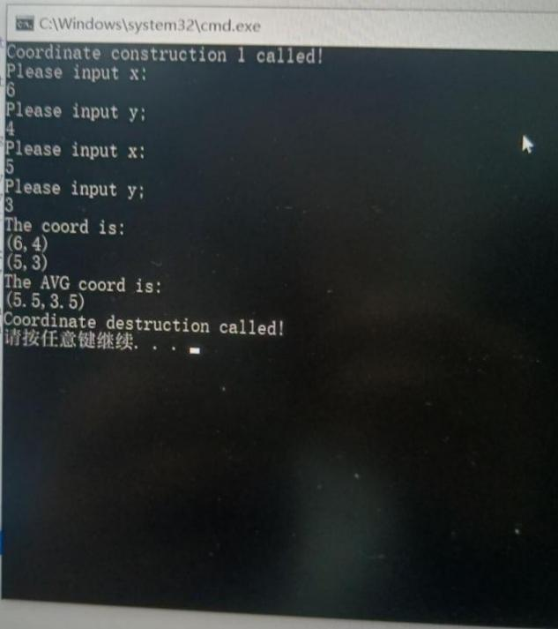

2.#include<iostream>

using namespace std;

class Score

{

public:

Score(int stnumber=2)

{

if(stnumber>100)

number=100;

else number=stnumber;

}

void input()

{

for(int i=0;i<number;i++)

{

//输入姓名

cout<<"请输入学生姓名:"<<endl;

cin>>name[i];

//输入学生成绩

cout<<"请输入科目A成绩："<<endl;

cin>>grade[i][1];

cout<<"请输入科目B成绩："<<endl;

cin>>grade[i][2];

cout<<"请输入科目C成绩："<<endl;

cin>>grade[i][3];

}

}

void showallstu()

{

for(int i=0;i<number;i++)

{

cout<<"姓名："<<name[i]<<" 科目A成绩："<<grade[i][1]<< " 科目B成绩："<<grade[i][2]<<" 科目C成绩："<<grade[i][2]<<endl;

}

}

void showstuavg(int m)

{

cout<<"姓名:"<<name[m]<<" 平均成绩："<<(grade[m][1]+grade[m][2]+grade[m][3])/3<<endl;

}

void showavg(int i)

{

double all=0;

switch (i)

{

case 1:

for(int m=0;m<number;m++)

   {

   all+=grade[m][1];

};

cout<<"课程名称：A平均成绩："<<all/number<<endl;

break;

case 2:

for(int m=0;m<number;m++)

   {

   all+=grade[m][2];

};

cout<<"课程名称：B平均成绩："<<all/number<<endl;

break;

case 3:

for(int m=0;m<number;m++)

   {

   all+=grade[m][3];

};

cout<<"课程名称：C平均成绩："<<all/number<<endl;

break;

}

}

void rank(int m)

{

int temp;

char tempname[100];

switch (m)

{

case 1:cout<<"课程名：A"<<endl;

break;

case 2:cout<<"课程名：B"<<endl;

break;

case 3:cout<<"课程名：C"<<endl;

break;

}

for (int i = 0; i < number-1; i++)

{

if(grade[i][m]>grade[i+1][m])

{

temp=grade[i+1][m];

grade[i+1][m]=grade[i][m];

grade[i][m]=grade[i+1][m];

tempname[100]=name[i+1][100];

name[i+1][100]=name[i][100];

name[i][100]=tempname[100];

}

}

for (int i = number-1; i > -1; i--)

{

cout<<"姓名："<<name[i]<<" 成绩："<<grade[i][m]<<endl;

}

}

private:

int number;

char name[100][100];

double grade[100][3];

};

int main()

{

Score stu;

stu.input();

stu.showallstu();

stu.showstuavg(1);

stu.showavg(1);

stu.rank(1);

getchar();

getchar();

return 0;

}

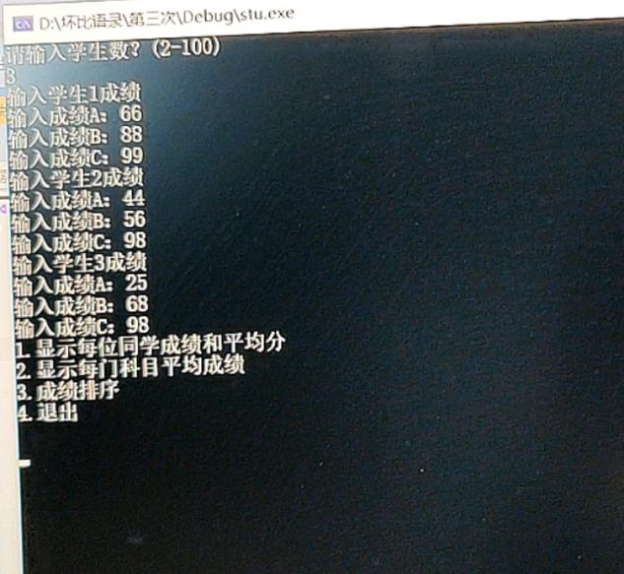

感想心得：

初步掌握使用类和对象编写c++程序。

为了完成多个任务时，可以使用模块化编程。