#include<iostream>

#include<string>

using namespace std;

class MyArray {

public:

MyArray(int length);

~MyArray();

void Input();

void Display(string);

protected:

int\* a;

int length;

};

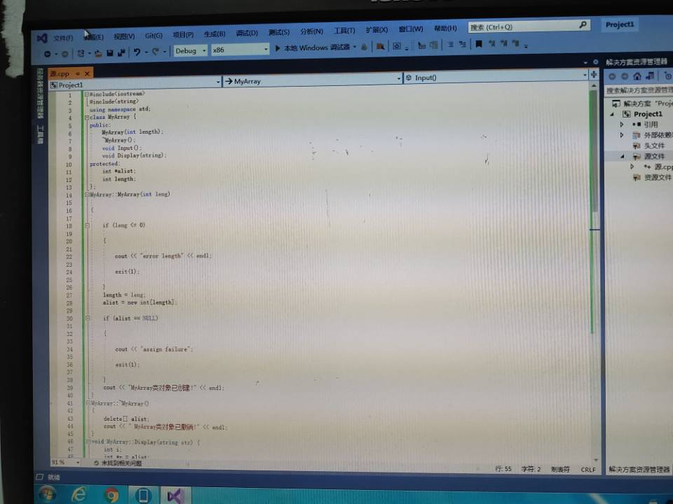MyArray::MyArray(int leng)

{

if (leng <= 0)

{

cout << "error length";

exit(1);

}

length = leng;

a = new int[length];

if (a == NULL)

{

cout << "assign failure";

exit(1);

}

cout << "MyArray类对象已创建!" << endl;

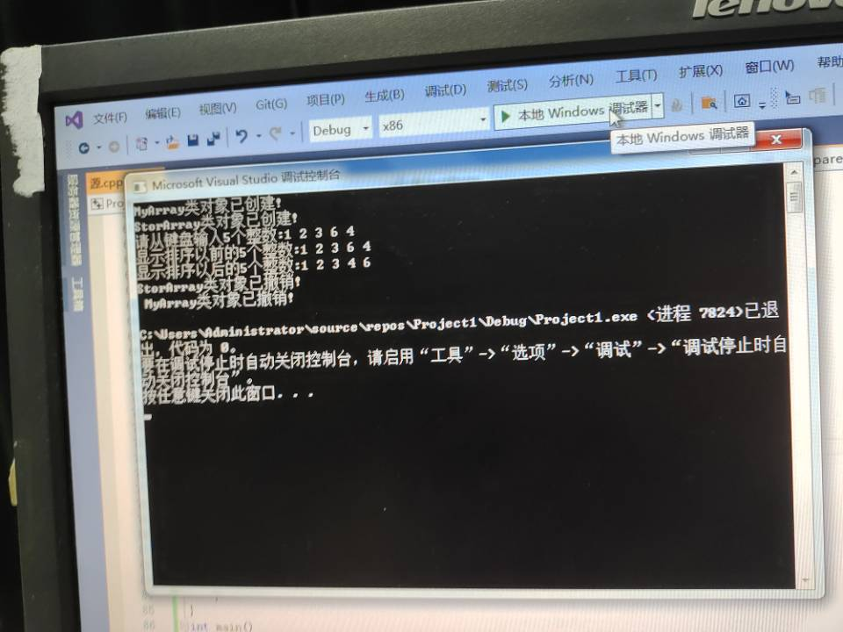}

MyArray::~MyArray()

{

delete[] a;

cout << "MyArray类对象已撤销!" << endl;

}

void MyArray::Display(string str)

{

int i;

int\* p = a;

cout << str << length << "个整数: ";

for (i = 0; i < length; i++, p++)

cout << \*p << " ";

cout << endl;

}

void MyArray::Input()

{

cout << "请从键盘输入" << length << "个整数:";

int i;

int\* p = a;

for (i = 0; i < length; i++, p++)

cin >> \*p;

}

class SortArray : public MyArray {

public:

void Sort();

SortArray(int leng) :MyArray(leng)

{

cout << "SortArray类对象已创建!" << endl;

}

~SortArray();

};

SortArray::~SortArray()

{

cout << "SortArray类对象已撤销!" << endl;

}

void SortArray::Sort()

{

int i, j, temp;

for (i = 0; i < length - 1; i++)

for (j = 0; j < length - i - 1; j++)

{

if (a[j] > a[j + 1])

{

temp = a[j];

a[j] = a[j + 1];

a[j + 1] = temp;

}

}

}

int main()

{

SortArray s(5);

s.Input();

s.Display("显示排序以前的");

s.Sort();

s.Display("显示排序以后的");

return 0;

实验心得

通过实验学习，掌握了派生类的声明方法和派生类构造函数的定义方法，掌握了不同方式下构造函数与析构函数的执行顺序和构造规则，整体感觉难度较大

Copyright ©2021-2099 张作轩. All rights reserved