实验1．

程序代码

#include <iostream>

using namespace std;

class A

{

public:

A()

{

times = 2;

cout << "A construction1 called!" << endl;

}

A(int times1)

{

times = times1;

cout << "A construction2 called!" << endl;

}

~A()

{

cout << "A destruction called!" << endl;

}

void inputA()

{

for (int i = 0; i < times; i++)

{

cout << "Please Intup x; " << endl;

cin >> a[i][1];

cout << "Please Intup y; " << endl;

cin >> a[i][2];

}

}

void showA()

{

cout << "The A is; " << endl;

for (int i = 0; i < times; i++)

{

cout << "(" << a[i][1] << "," << a[i][2] << ") ";

}

cout << endl;

}

void showAA()

{

float x = 0, y = 0;

for (int i = 0; i < times; i++)

{

x = x + a[i][1];

y = y + a[i][2];

}

x = x / times;

y = y / times;

cout << "The AA is; " << endl;

cout << "(" << x << "," << y << ")" << endl;

}

private:

float a[100][100];

int times;

};

int main()

{

A x(5);

x.inputA();

x.showA();

x.showAA();

return 0;

}

运行结果

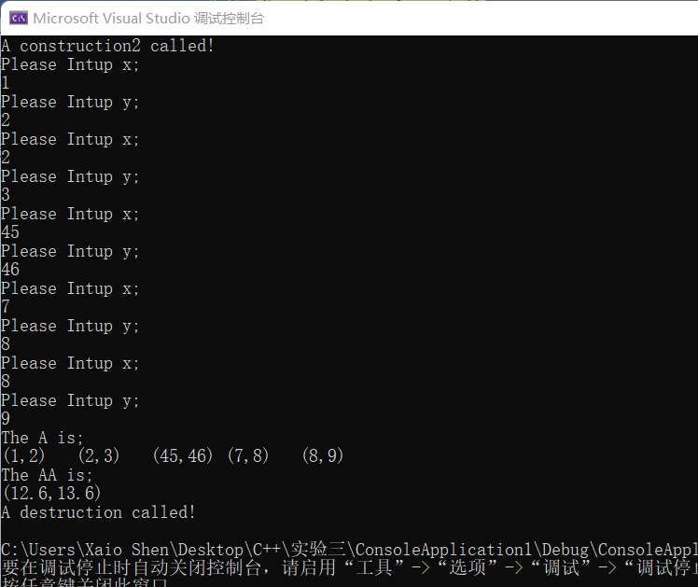

**实验2.**

程序代码

#include <iostream>

#include<string>

using namespace std;

class A

{

public:

A()

{

p = 2;

}

A(int p1)

{

p = p1;

}

~A()

{}

void cinA()

{

for (int i = 0; i < p; i++)

{

cout << "学生姓名:" << endl;

cin >> name[i];

cout << "成绩A: " << endl;

cin >> x[i];

cout << "成绩B: " << endl;

cin >> y[i];

cout << "成绩C: " << endl;

cin >> z[i];

}

}

void coutA()

{

for(int i=0;i<p;i++)

cout << name[i] << "各科成绩与平均值如下:" <<endl<< "A:" << x[i] << " B:" << y[i] << " Z: " << z[i] <<" 平均值："<<float((x[i]+y[i]+z[i]))/3<< endl;

}

void paixuA(int x[100],string name[100])

{

int i, j,n;

string Name[100],t;

for (i = 0; i < p; i++)

Name[i] = name[i];

for (j = 0;j < p; j++)

{

for (i = j + 1; i <p; i++)

{

if (x[j] < x[i])

{

n= x[i];

x[i] = x[j];

x[j] = n;

t = Name[i];

Name[i] = Name[j];

Name[j] = t;

}

}

}

for (i = 0; i < p; i++)

cout << i+1 << "." << Name[i] << ": " << x[i] << endl;

}

void paixuAA()

{

cout << "成绩A的排名: " << endl;

paixuA(x, name);

cout << "成绩B的排名: " << endl;

paixuA(y, name);

cout << "成绩C的排名: " << endl;

paixuA(z, name);

}

void pingjunA()

{

float X=0, Y=0, Z=0;

for (int i=0;i<p;i++)

{

X = X + x[i];

Y = Y + y[i];

Z = Z + z[i];

}

X = X / p;

Y = Y / p;

Z = Z / p;

cout << "成绩A的平均值：" << X << endl << "成绩B的平均值：" << Y << endl << "成绩C的平均值：" << Z << endl;

}

private:

int x[100], y[100], z[100];

int p;

string name[100];

};

int main()

{

int n;

cout << "请输入班级人数： ";

cin >> n;

A x(n);

x.cinA();

x.coutA();

x.pingjunA();

x.paixuAA();

return 0;

}

运行结果

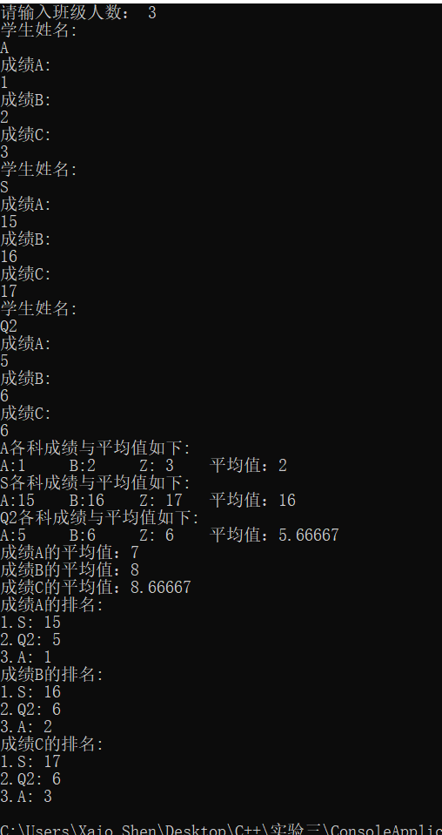

感想心得

本次实验是我对与类的首次运用，通过对类的使用，我感觉类有点像是一个新的主函数，在类中有变量也有函数，它就像是一个十分完整的函数，而我们需要的就是对它进行适当的调用，以此达到相应的目的，当然这并不是说它就是函数只是有相似。

而对于对象的创建则是和声明基本变量一样，不同的是对象的赋值不是直接的等于复制，而是在对象后面的括号中对其复制传参，如“A x(5);”，而且在使用对象=对象赋值是，也不是和变量=1一样，而对象=对象则是以赋值法调用拷贝构造函数进行赋值。

同时通过本次实验我了解到类中的函数并不是会一一运行，而是需要在主函数定义对象后通过对象来进行调用，如“x.coutA();”就是对象x调用类中的函数“void coutA()”；在结合类中的private、public、protected三类，我可以很好的感受到C++相较于C语言的更好的安全性。