代码1

# include<iostream>

using namespace std;

int add(int a,int b);

int main()

{

int x,y,sum;

cout<<"Enter two numbers:"<<endl;

cin>>x>>y;

sum = add(x,y);

cout<<x<<"+"<<y<<"="<<sum<<endl;

return 0;

}

int add(int a,int b)

{

return a+b;

}

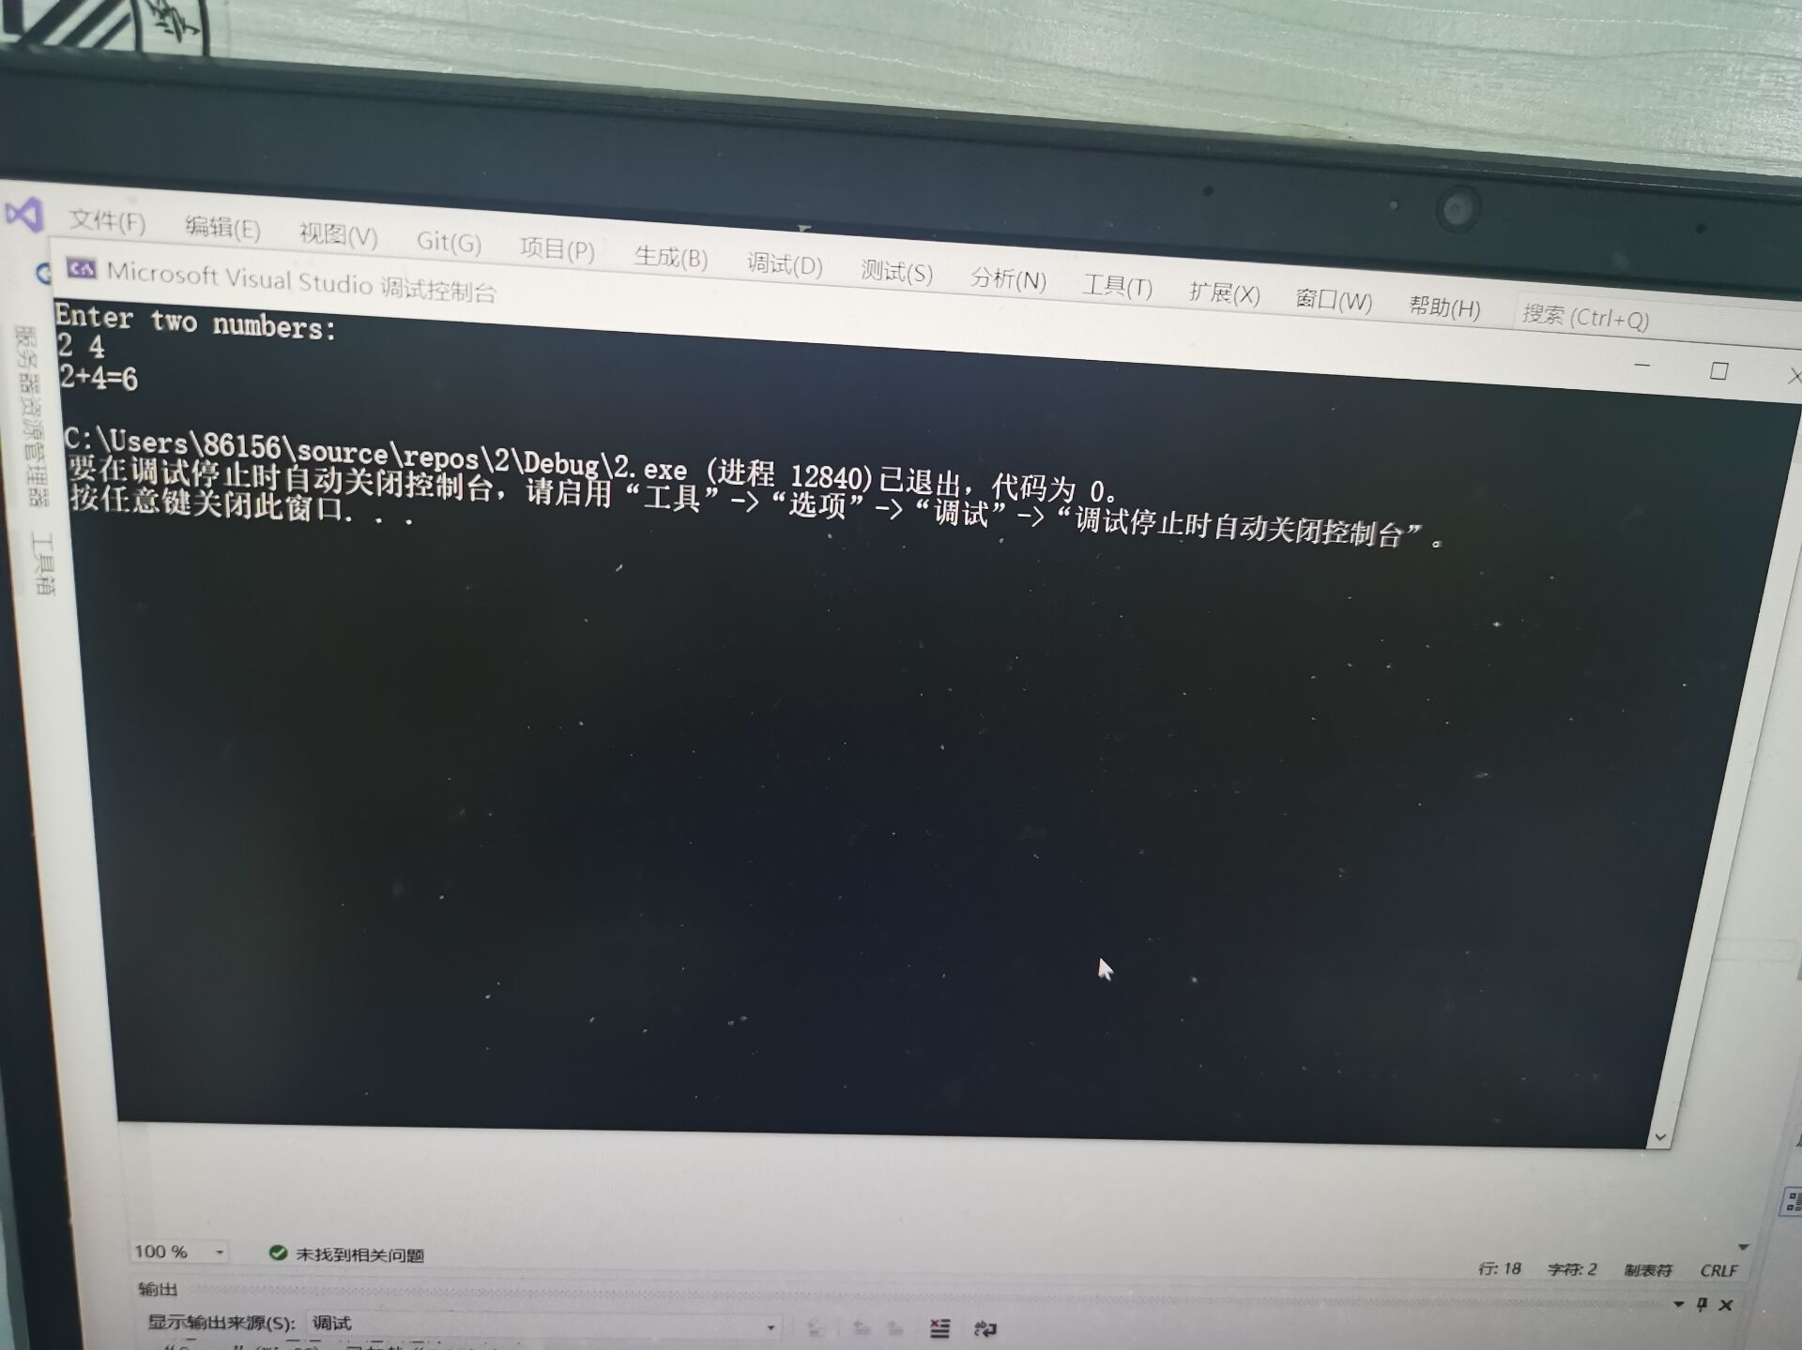

代码2

# include<iostream>

using namespace std;

int max1(int a[5]);

int min1(int a[5]);

int main()

{

int b[5];

for (int i = 0; i < 5; i++)

{

cout << "输数"<<endl;

cin >> b[i];

}

cout << "结果" << endl;

for (int i = 0; i < 5; i++)

{

cout << b[i] << endl;

}

cout << "min" << endl;

cout <<min1(b) << endl;

cout << "max" << endl;

cout << max1(b) <<endl;

return 0;

}

int max1(int a[5])

{

int max = a[0];

for (int j = 0; j < 5; j++)

{

if (max > a[j])

{

max = a[j];

}

}

return max;

}

int min1(int a[5])

{

int min = a[0];

for (int k = 0; k < 5; k++)

{

if (min < a[k])

{

min = a[k];

}

}

return min;

}

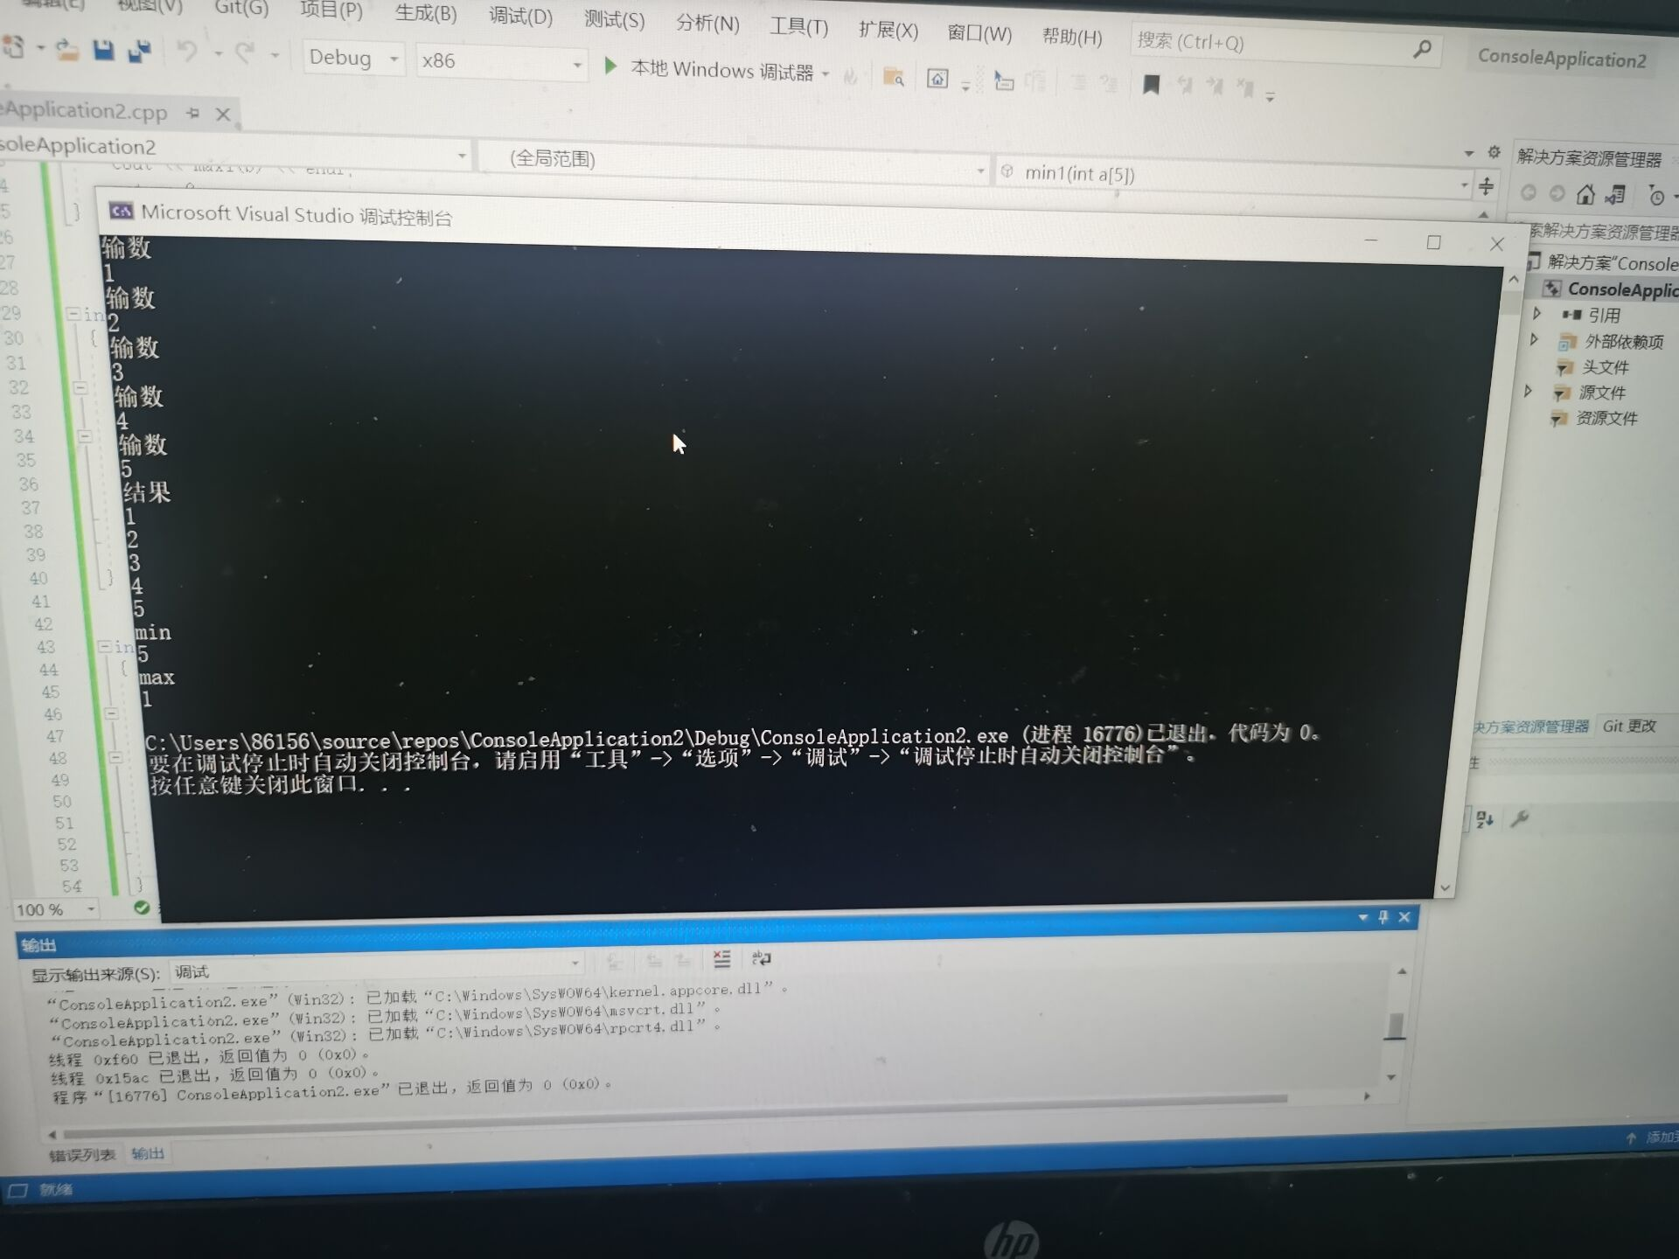

感悟

通过本次实验，我学会了建立和运行单文件程序，建立和运行多文件程序。

并能将其熟练的运用到实际编程中，让我对vs的使用更加精通了，这对我的学习生活是极有帮助的。

Copyright©2021-2099 SiYuan Miao.All rights reserved