**实验报告**

**一、程序代码**

**include <iostream>**

**using namespace std;**

**class matrixmul**

**{**

**private:**

**double real;**

**double imag;**

**public:**

**void output();//打印输出**

**void initSet(double re,double im);//初始化**

**matrixmul matrixMul(matrixmul Z1,matrixmul Z2);//函数返回值是multirxmul，所以此函数类型为matrixmal**

**};**

**matrixmul matrixmul::matrixMul(matrixmul Z1,matrixmul Z2)**

**{**

**double temp1,temp2,temp3;**

**matrixmul result;**

**temp1=Z1.real*Z2.imag;**

**temp2=Z1.imag*Z2.real;**

**temp3=(Z1.imag+Z1.real)*(Z2.real-Z2.imag);**

**result.real=temp1+temp3-temp2;**

**result.imag=temp1+temp2;**

**return result;**

**}**

**void matrixmul::initSet(double re,double im)**

**{**

**real=re;**

**imag=im;**

**}**

**void matrixmul::output()**

**{**

**if(imag>0)**

**{**

**cout<<real<<"+"<<imag<<"i"<<endl;**

**}**

**else if(imag==0)**

**{**

**cout<<real<<endl;**

**}**

**else if(imag<0)**

**{**

**cout<<real<<imag<<"i"<<endl;**

**}**

**}**

**int main()**

**{**

**matrixmul Z1,Z2,Z3,result;**

**Z1.initSet(1,-2);**

**Z2.initSet(3,-4);**

**cout<<"第一个复数Z1为："<<endl;**

**Z1.output();**

**cout<<"第二个复数Z2为："<<endl;**

**Z2.output();**

**result=Z3.matrixMul(Z1,Z2);**

**cout<<"两复数相乘结果的复数为："<<endl;**

**result.output();**

**return 0;**

**}**

**二、代码运行结果**

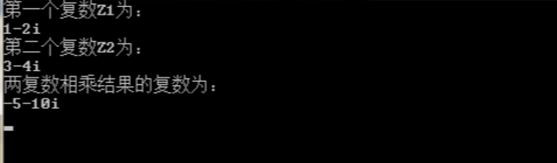

**三、心得感想**

**通过这次上机，我掌握了C++语言多态性的基本概念，掌握了运算符重载函数的声明和定义方法。**

**Copyright ©2021-2099 WenqiqiLuo. All rights reserved**