**实验报告**

**一、程序代码**

**①二维坐标值**

**#include<iostream>**

**using namespace std;**

**class Coordinate{**

**public:**

**Coordinate()**

**{**

**times=2;**

**cout<<"Coordinate construction1 called!"<<endl;**

**}**

**Coordinate(int times1)**

**{**

**times=times1;**

**cout<<"Coordinate construction2 called!"<<endl;**

**}**

**~Coordinate()**

**{**

**cout<<"Coordinate destruction called!"<<endl;**

**}**

**void InputCoord() {**

**for(int i=0;i<times;i++)**

**{**

**cout<<"Please Input x:"<<endl;**

**cin>>Coord[i][1];**

**cout<<"Please Input y:"<<endl;**

**cin>>Coord[i][2];**

**}**

**}**

**void ShowCoord()**

**{**

**cout<<"The coord is:"<<endl;**

**for(int i=0;i<times;i++)**

**{**

**cout<<"("<<Coord[i][1]<<","<<Coord[i][2]<<")"<<endl;**

**}**

**}**

**void ShowAvgCoord()**

**{**

**float avgx = 0;**

**float avgy = 0;**

**for(int i=0;i<times;i++)**

**{**

**avgx = avgx + Coord[i][1];**

**avgy = avgy + Coord[i][2];**

**}**

**avgx = avgx/times;**

**avgy = avgy/times;**

**cout<<"The AVG coord is:"<<endl;**

**cout<<"("<<avgx<<","<<avgy<<")"<<endl;**

**}**

**private:**

**float Coord[100][100];**

**int times;**

**};**

**int main()**

**{**

**Coordinate x;**

**x.InputCoord();**

**x.ShowCoord();**

**x.ShowAvgCoord();**

**return 0;**

**}**

**②学生成绩**

**#include<iostream>**

**#include<string>**

**using namespace std;**

**class Score{**

**public:**

**Score()**

**{ times=2; }**

**Score(int times1)**

**{ times=times1; }**

**void InputNameAndScore()**

**{**

**for(int i=0;i<times;i++)**

**{**

**cout<<"请输入学生姓名:"<<endl;**

**cin>>Name[i];**

**cout<<"请输入科目A成绩:"<<endl;**

**cin>>SScore[i][1];**

**cout<<"请输入科目B成绩:"<<endl;**

**cin>>SScore[i][2];**

**cout<<"请输入科目C成绩:"<<endl;**

**cin>>SScore[i][3];**

**}**

**}**

**void ShowNameAndScore()**

**{**

**for(int i=0;i<times;i++) {**

**cout<<"姓名: "<<Name[i]<<" 科目A成绩: "<<SScore[i][1]<<" 科目B成绩 "<<SScore[i][2]<<" 科目C成绩: "<<SScore[i][3]<<endl;**

**}**

**}**

**void ShowStdentAvgScore(int Sid)**

**{**

**float avg = 0;**

**avg = (SScore[Sid][1]+SScore[Sid][2]+SScore[Sid][3])/3;**

**cout<<"姓名: "<<Name[Sid]<<" 平均成绩: "<<avg<<endl;**

**}**

**void ShowClassAvgScore(string ClassName)**

**{ int Cid;**

**float avg = 0;**

**if(ClassName == "A") Cid = 1;**

**if(ClassName == "B") Cid = 2;**

**if(ClassName == "C") Cid = 3;**

**for(int i=0;i<times;i++)**

**{ avg = avg + SScore[i][Cid]; }**

**avg = avg/times;**

**cout<<"课程名称: "<<ClassName<<"平均成绩: "<<avg<<endl;**

**}**

**}**

**void OrderScore(string ClassName)**

**{**

**int Cid;**

**if(ClassName == "A") Cid = 1;**

**if(ClassName == "B") Cid = 2;**

**if(ClassName == "C") Cid = 3;**

**for(int i=0;i<times;i++)**

**{ SScore1[i] = SScore[i][Cid]; }**

**for(i=0;i<times;i++)**

**{ Name1[i] = Name[i]; }**

**for(i=1;i<times;i++)**

**{ if(SScore1[i] > SScore1[i-1])**

**{ float temp = SScore1[i-1];**

**SScore1[i-1] = SScore1[i];**

**SScore1[i] = temp;**

**string temp1;**

**temp1 = Name1[i-1];**

**Name1[i-1] = Name1[i];**

**Name1[i]= temp1;**

**}**

**}**

**cout<<"课程名称: "<<ClassName<<endl;**

**for(i=0;i<times;i++)**

**{**

**cout<<"姓名: "<<Name1[i]<<" 成绩: "<<SScore1[i]<<endl;**

**}**

**}private:**

**float SScore[100][3],SScore1[100];string Name[100],Name1[100];**

**int times;**

**};**

**int main()**

**{ Score x;**

**x.InputNameAndScore();**

**x.ShowNameAndScore();**

**x.ShowStdentAvgScore(1);**

**x.ShowClassAvgScore("A");**

**x.OrderScore("B");**

**return 0;**

**}**

**二、代码运行结果**

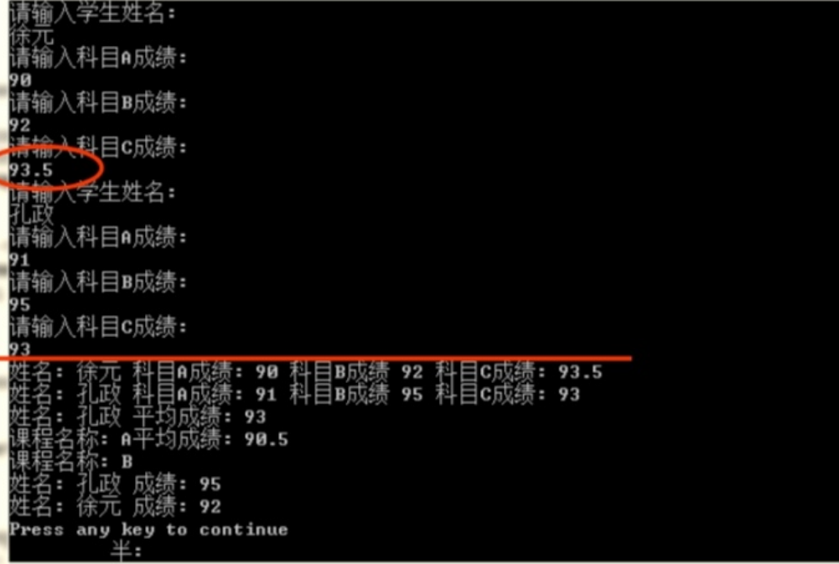

**三、心得感想**

**通过这次上机，我理解了类和对象的概念，掌握了声明类和定义对象的方法，掌握了构造函数和析构函数的实现方法，初步掌握了使用类和对象编制C++程序。通过引例明白了如何通过创建一个类来完成一组二维坐标值的显示。明白了构造函数和析构函数的执行顺序。学会了如何创建一个Score类，并实现输入成绩、显示成绩及平均分、对成绩进行排序的目的。**

**Copyright ©2021-2099 WenqiqiLuo. All rights reserved**