程序1
// 实验三1.cpp : 此文件包含 "main" 函数。程序执行将在此处开始并结束。
//

#include<iostream>
using namespace std;
class Coordinate
{ // 定义Coordinate类
public:
Coordinate()
{
times = 2;
cout << "Coordinate construction1 called!" << endl;
}
Coordinate(int times1)

{
times = times1;
cout << "Coordinate construction2 called!" << endl;
}
~Coordinate()
{
cout << "Coordinate destruction called!" << endl;
}
void InputCoord()
{
for (int i = 0; i < times; i++)
{
cout << "Please Input x:" << endl;
cin >> Coord[i][1];
cout << "Please Input y:" << endl;
cin >> Coord[i][2];
}
}
void ShowCoord()
{
cout << "The coord is:" << endl;
for (int i = 0; i < times; i++)
{
cout << "(" << Coord[i][1] << "," << Coord[i][2] << ")" << endl;
}
}
void ShowAvgCoord()
{
float avgx = 0;
float avgy = 0;
for (int i = 0; i < times; i++)
{
avgx = avgx + Coord[i][1];
avgy = avgy + Coord[i][2];
}
avgx = avgx / times;
avgy = avgy / times;
cout << "The AVG coord is:" << endl;
cout << "(" << avgx << "," << avgy << ")" << endl;
}
private:
float Coord[100][100]; // 存放输入坐标的数组
int times; // 存放输入坐标数目
};

int main()
{
Coordinate x;
x.InputCoord();
x.ShowCoord();
x.ShowAvgCoord();
return 0;
}

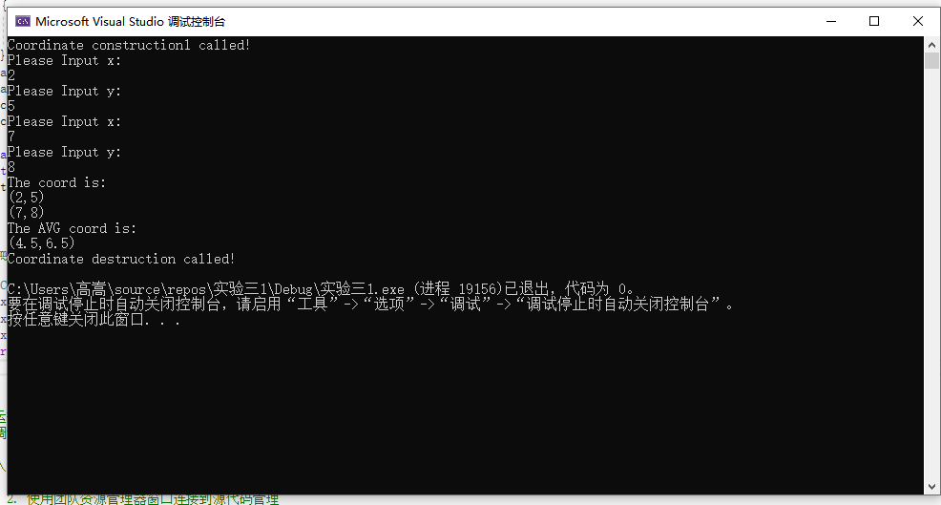
实验二
程序
// 实验三2.cpp : 此文件包含 "main" 函数。程序执行将在此处开始并结束。
//

#include<iostream>
using namespace std;

class Score
{
public:
Score(int stnumber = 2)
{
if (stnumber > 100)
number = 100;
else number = stnumber;
}

void input()
{
for (int i = 0; i < number; i++)
{
//输入姓名
cout << "请输入学生姓名:" << endl;
cin >> name[i];
//输入学生成绩
cout << "请输入科目A成绩：" << endl;
cin >> grade[i][1];
cout << "请输入科目B成绩：" << endl;
cin >> grade[i][2];
cout << "请输入科目C成绩：" << endl;
cin >> grade[i][3];
}
}

void showallstu()
{
for (int i = 0; i < number; i++)
{
cout << "姓名：" << name[i] << " 科目A成绩：" << grade[i][1] << " 科目B成绩：" << grade[i][2] << " 科目C成绩：" << grade[i][2] << endl;
}
}

void showstuavg(int m)
{
cout << "姓名:" << name[m] << " 平均成绩：" << (grade[m][1] + grade[m][2] + grade[m][3]) / 3 << endl;
}

void showavg(int i)
{
double all = 0;
switch (i)
{
case 1:
for (int m = 0; m < number; m++)
{
all += grade[m][1];
};
cout << "课程名称：A平均成绩：" << all / number << endl;
break;
case 2:
for (int m = 0; m < number; m++)
{
all += grade[m][2];
};
cout << "课程名称：B平均成绩：" << all / number << endl;
break;
case 3:
for (int m = 0; m < number; m++)
{
all += grade[m][3];
};
cout << "课程名称：C平均成绩：" << all / number << endl;
break;
}
}

void rank(int m)
{
int temp;
char tempname[100];
switch (m)
{
case 1:cout << "课程名：A" << endl;
break;
case 2:cout << "课程名：B" << endl;
break;
case 3:cout << "课程名：C" << endl;
break;
}
for (int i = 0; i < number - 1; i++)
{
if (grade[i][m] > grade[i + 1][m])
{
temp = grade[i + 1][m];
grade[i + 1][m] = grade[i][m];
grade[i][m] = grade[i + 1][m];
tempname[100] = name[i + 1][100];
name[i + 1][100] = name[i][100];
name[i][100] = tempname[100];
}
}
for (int i = number - 1; i > -1; i--)
{
cout << "姓名：" << name[i] << " 成绩：" << grade[i][m] << endl;
}
}

private:
int number;
char name[100][100];
double grade[100][3];
};

int main()
{
Score stu;
stu.input();
stu.showallstu();
stu.showstuavg(1);
stu.showavg(1);
stu.rank(1);
getchar();
getchar();
return 0;
}

// 运行程序: Ctrl + F5 或调试 >“开始执行(不调试)”菜单
// 调试程序: F5 或调试 >“开始调试”菜单

// 入门使用技巧:
// 1. 使用解决方案资源管理器窗口添加/管理文件
// 2. 使用团队资源管理器窗口连接到源代码管理
// 3. 使用输出窗口查看生成输出和其他消息
// 4. 使用错误列表窗口查看错误
// 5. 转到“项目”>“添加新项”以创建新的代码文件，或转到“项目”>“添加现有项”以将现有代码文件添加到项目
// 6. 将来，若要再次打开此项目，请转到“文件”>“打开”>“项目”并选择 .sln 文件

结果
