程序代码：
#include<iostream>
#include"string"
using namespace std;

class Score
{
public:
Score(int stnumber = 2)
{
if (stnumber > 100)
number = 100;
else number = stnumber;
}

void input();

void showallstu()
{
for (int i = 0; i < number; i++)
{
cout << "姓名：" << name[i] << " 科目A成绩：" << grade[i][0]
<< " 科目B成绩：" << grade[i][1] << " 科目C成绩：" << grade[i][2] << endl;
}
}

void showstuavg();

void showavger();

void rank();

private:
int number;
char name[100][100];
double grade[100][3];
};

int main()
{
Score stu;
stu.input();
stu.showallstu();
stu.showstuavg();
stu.showavger();
stu.rank();
getchar();
getchar();
return 0;
}
void Score::input()
{
for (int i = 0; i < number; i++)
{
cout << "请输入学生姓名:" << endl;
cin >> name[i];
cout << "请输入科目A成绩：" << endl;
cin >> grade[i][0];
cout << "请输入科目B成绩：" << endl;
cin >> grade[i][1];
cout << "请输入科目C成绩：" << endl;
cin >> grade[i][2];
}
}
void Score::showstuavg()
{
for (int i = 0; i < number; i++)
{
cout << "姓名:" << name[i] << " 平均成绩："
<< (grade[i][0] + grade[i][1] + grade[i][2]) / 3 << endl;
}
}
void Score::showavger()
{
double sum = 0;
for (int i = 0; i <3; i++)
{
switch (i)
{
case 0:
for (int m = 0; m < number; m++)
{
sum += grade[m][0];
};
cout << "课程名称A平均成绩：" << sum / number << endl;
sum = 0;
break;
case 1:
for (int m = 0; m < number; m++)
{
sum += grade[m][1];
};
cout << "课程名称B平均成绩：" << sum / number << endl;
sum = 0;
break;
case 2:
for (int m = 0; m < number; m++)
{
sum += grade[m][2];
};
cout << "课程名称C平均成绩：" << sum / number << endl;
sum = 0;
break;
default:break;
}
}
}
void Score::rank()
{
double temp;
char tempname[100];
string names[100];
cout << "成绩排序：" << endl;
for (int m = 0; m < 3; m++)
{
switch (m)
{
case 0:cout << "课程名：A" << endl;
break;
case 1:cout << "课程名：B" << endl;
break;
case 2:cout << "课程名：C" << endl;
break;
}
for (int i = 0; i < number-1 ; i++)
{
if (grade[i][m] < grade[i + 1][m])
{
temp = grade[i + 1][m];
grade[i + 1][m] = grade[i][m];
grade[i][m] = temp;

names[i+1]=name[i];
names[i]=name[i + 1];
}

}
for (int i = 0; i <number; i++)
{
cout <<"第"<<i+1<< "名 姓名：" << names[i] << " 成绩：" << grade[i][m] << endl;
}
}
cout << "成绩排序完成" << endl;
}

程序结果：
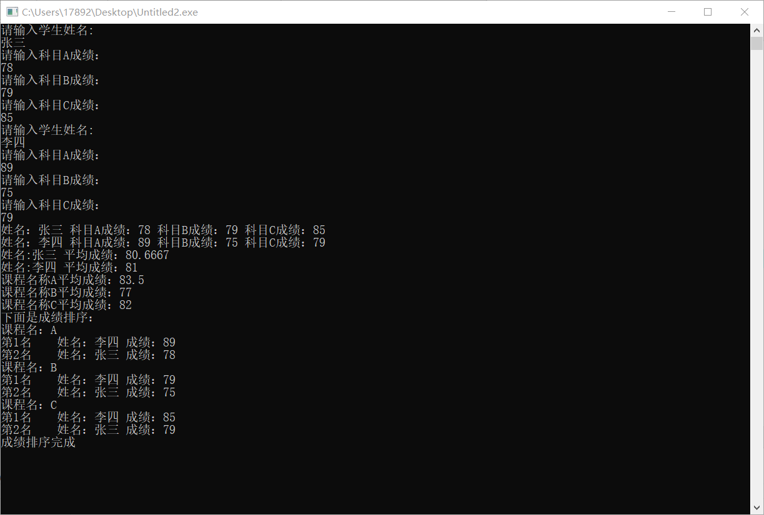

感想心得：
通过本次实验，理解了构造函数和析构函数作用，掌握了各种类型的构造函数与析构函数的使用，并且掌握了构造函数和析构函数的调用顺序。

Copyright ©2021-2099 ChenChaofan. All rights reserved

