第七次上机实验报告
学号：202030310234 姓名：李昱霖 班级：自2003
程序代码
#include<iostream>
using namespace std;
class Complex {
double real;
double imag;
public:
Complex(double r = 0.0, double i = 0.0);
void print();
Complex operator+(Complex c);
};
Complex::Complex(double r, double i)
{
real = r; imag = i;
}
Complex Complex::operator+(Complex c)
{
Complex temp;
temp.real = real*c.real-imag*c.imag;
temp.imag = real*c.imag+c.real*imag;
return temp;
}
void Complex::print()
{
cout << "total real=" << real << " " << " total imag=" << imag << endl;
}
int main()
{
double x1, x2, y1, y2;
cin >> x1 >> y1 >> x2 >> y2;
Complex com1(x1, y1), com2(x2, y2), total1;
total1 = com1 + com2;
total1.print();
return 0;
}
程序结果
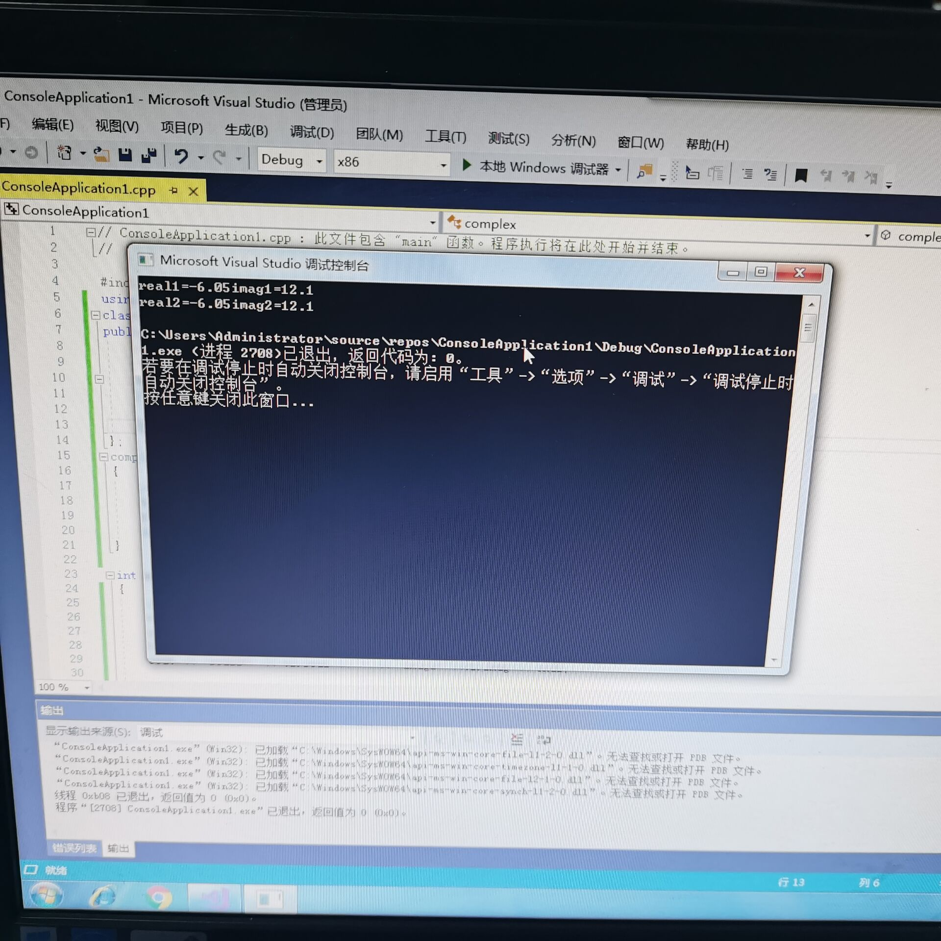
四、实验心得
本次c＋＋的实验后，我对构造函数和析构函数的理解又进了一步，让我能更透彻的理解到c++这项语言的优化之处。
Copyright ©2021-2099 erximofu. All rights reserved

