实验三 构造函数与析构函数
1：
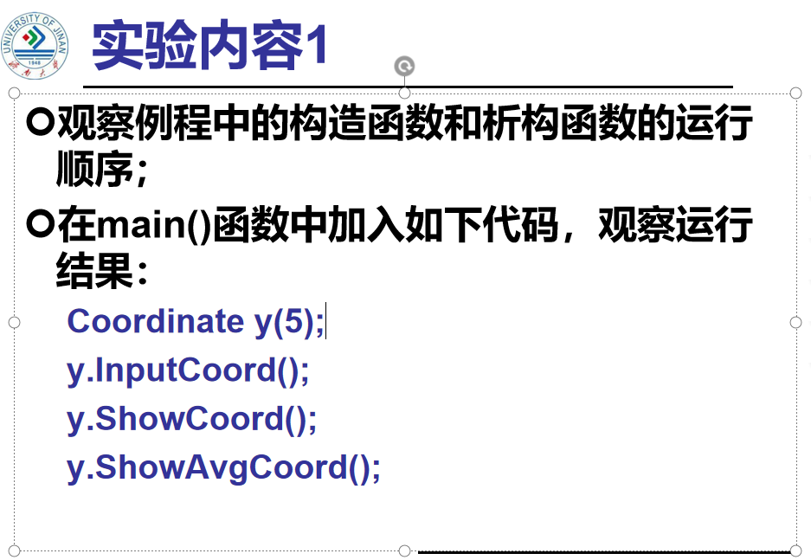
代码：
#include<iostream>
using namespace std;
class Coordinate{
public:
Coordinate()
{
times=2;
cout<<"Coordinate construction1 called!"<<endl;
}
Coordinate(int times1)
{
times=times1;
cout<<"Coordinate construction2 called!"<<endl;
}
~Coordinate()
{
cout<<"Coordinate destruction called!"<<endl;
}
void inputCoord()
{
for(int i=0;i<times;i++)
{
cout<<"Please input x:"<<endl;
cin>>Coord[i][1];
cout<<"Please input y:"<<endl;
cin>>Coord[i][2];
}
}
void showCoord()
{
cout<<"The coord is:"<<endl;
for(int i=0;i<times;i++)
{
cout<<"("<<Coord[i][1]<<","<<Coord[i][2]<<")"<<endl;
}
}
void Showavgcoord()
{
float avgx=0;
float avgy=0;
for(int i=0;i<times;i++)
{
avgx=avgx+Coord[i][1];
avgy=avgy+Coord[i][2];
}
avgx=avgx/times;
avgy=avgy/times;
cout<<"The avg coord is:"<<endl;
cout<<"("<<avgx<<","<<avgy<<")"<<endl;
}
private:
float Coord[100][100];
int times;
};
int main()
{
Coordinate x;
x.inputCoord();
x.showCoord();
x.Showavgcoord();
return 0;
}
2：

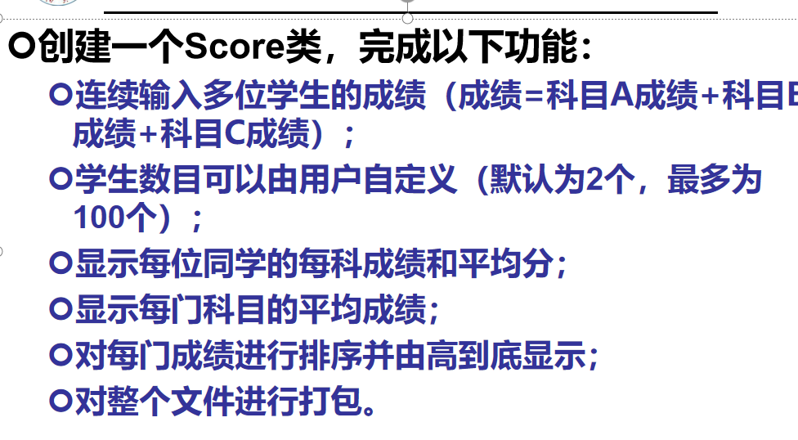
代码：
#include<iostream>
using namespace std;
class Score {
public:
Score()
{
Students = 2;
}
Score(int number)
{
Students = number;
}
~Score()
{
}
int i = 1;
void getgrade()
{
for (i = 1;i <= Students; i++) {
cout << "请输入学生姓名：" << endl;
cin >> name[i];
cout << "请输入科目A的成绩：" << endl;
cin >> a[i];
cout << "请输入科目B的成绩：" << endl;
cin >> b[i];
cout << "请输入科目C的成绩：" << endl;
cin >> c[i];
}
}
void showgrade()
{
for (i = 1;i <= Students;i++)
{
cout <<"姓名："<<name[i] << "科目A的成绩：" << a[i] <<" " << "科目B的成绩：" << b[i]<<" " << "科目C的成绩：" << c[i]<<" " << endl;
}
}
void showavgstu()
{
for (i = 1;i <= Students;i++)
{
cout <<name[i]<<":" << ((a[i] + b[i] + c[i]) / 3);
}
}
void showclassgrade(char f)
{
float avg = 0;
if (f == 'a')
{
for (i = 1; i <= Students;i++)
{
avg = avg+a[i];
}
avg = avg / Students;
cout << "课程名称:A" << "平均成绩:" << avg << endl;
}
if (f == 'b')
{
for (i = 1; i <= Students;i++)
{
avg = avg + b[i];
}
avg = avg / Students;
cout << "课程名称:B" << "平均成绩:" << avg << endl;
}
if (f == 'c')
{
for (i = 1;i <= Students;i++)
{
avg = avg + c[i];
}
avg = avg / Students;
cout << "课程名称:C" << "平均成绩：" << avg << endl;
}
}
private:
int Students;
float a[100], b[100], c[100];
string name[100];
};
int main()
{
Score A;
A.getgrade();
A.showgrade();
A.showclassgrade('a');
A.showavgstu();
return 0;
}
结果：
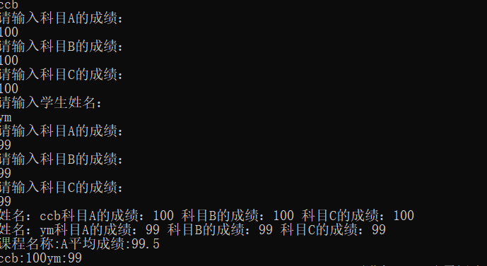
心得：构造函数 ，是一种特殊的方法。主要用来在创建对象时初始化对象， 即为对象成员变量赋初始值构造函数的命名必须和类名完全相同.它不需要用户来调用，而是在建立对象时自动执行的。析构函数负责回收存储空间。与构造函数相反，当对象结束其生命周期，如对象所在的函数已调用完毕时，系统会自动执行析构函数。析构函数名也应与类名相同，只是在函数名前面加一个位取反符~进行以上实验时，我深刻的体会到了C++语言比C可读性更好的特点，并且掌握了关于类和对象的知识。
Copyright ©2021-2099 Chenxu Miao. All rights reserved

