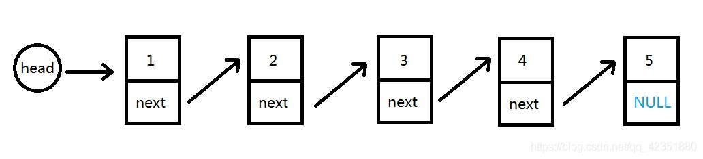
struct ListNode {
int a;
struct ListNode *next;
};
struct ListNode* reverseList(struct ListNode* head)
{
struct ListNode*frist=NULL;
struct ListNode*mid=NULL;
struct ListNode* last=NULL;
mid=head;
if(head==NULL)
{
return NULL;
}
else
{
while(mid->next)
{
last=mid->next;
mid->next=frist;
frist=mid;
mid=last;
}
}
mid->next=frist;
return mid;
}

