实验内容（1）
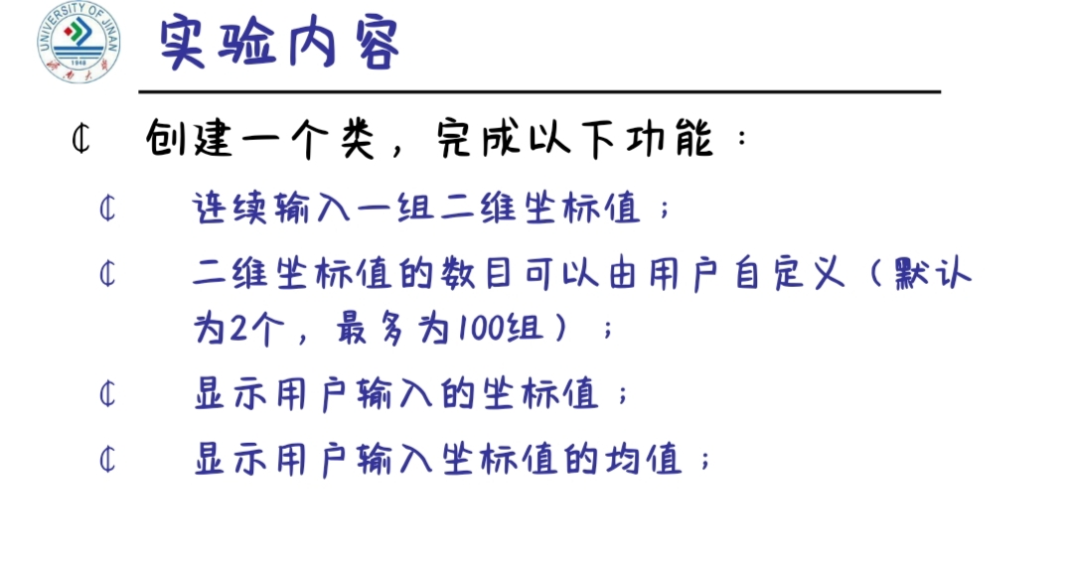
程序编码
#include<iostream>
using namespace std;
class Coordinate{ // 定义Coordinate类
public:
Coordinate()
{ times=2;
cout<<"Coordinate construction1 called!"<<endl; }
Coordinate(int times1)
{ times=times1;
cout<<"Coordinate construction2 called!"<<endl;
}
~Coordinate()
{ cout<<"Coordinate destruction called!"<<endl;
}
void InputCoord()
{ for(int i=0;i<times;i++)
{
cout<<"Please Input x:"<<endl;
cin>>Coord[i][1];
cout<<"Please Input y:"<<endl;
cin>>Coord[i][2];
}
}
void ShowCoord()
{ cout<<"The coord is:"<<endl;
for(int i=0;i<times;i++)
{
cout<<"("<<Coord[i][1]<<","<<Coord[i][2]<<")"<<endl;
}
}
void ShowAvgCoord()
{ float avgx = 0;
float avgy = 0;
for(int i=0;i<times;i++)
{
avgx = avgx + Coord[i][1];
avgy = avgy + Coord[i][2];
}
avgx = avgx/times;
avgy = avgy/times;
cout<<"The AVG coord is:"<<endl;
cout<<"("<<avgx<<","<<avgy<<")"<<endl;
}
private:
float Coord[100][100]; // 存放输入坐标的数组
int times; // 存放输入坐标数目
};
int main()
{
return 0;
}

运行结果
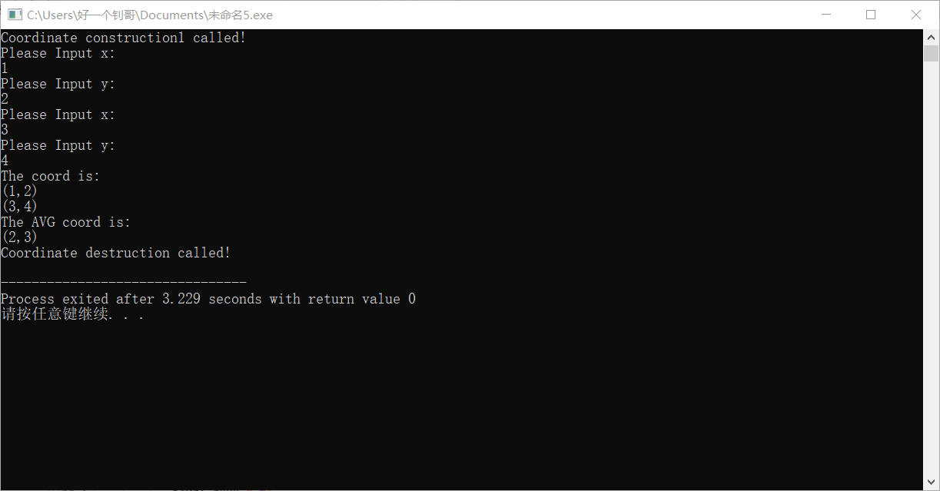

实验内容（2）
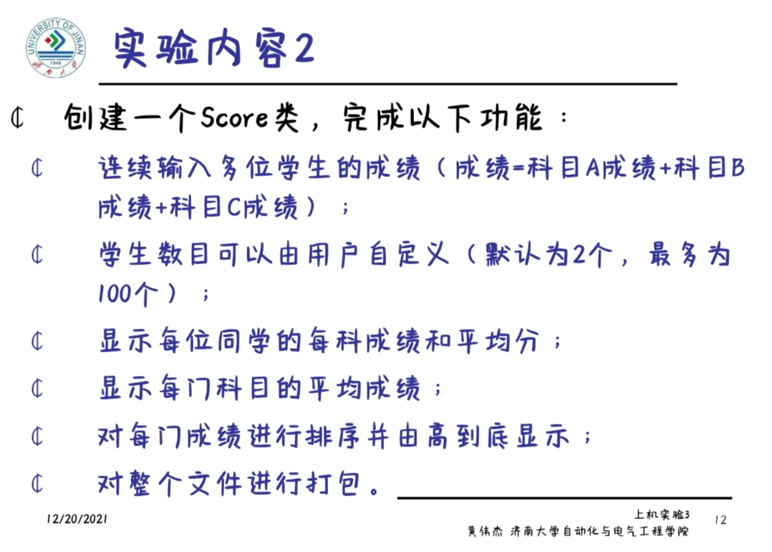
程序编码
#include<iostream>
#include<string>
using namespace std;
class Score{
public:
Score()
{ times=2; }
Score(int times1)
{ times=times1; }
void InputNameAndScore()
{ for(int i=0;i<times;i++)
{
cout<<"请输入学生姓名:"<<endl;
cin>>Name[i];
cout<<"请输入科目A成绩:"<<endl;
cin>>SScore[i][1];
cout<<"请输入科目B成绩:"<<endl;
cin>>SScore[i][2];
cout<<"请输入科目C成绩:"<<endl;
cin>>SScore[i][3];
}
}
void ShowNameAndScore()
{ for(int i=0;i<times;i++)
{
cout<<"姓名: "<<Name[i]<<" 科目A成绩: "<<SScore[i][1]<<" 科目B成绩 "<<SScore[i][2]<<" 科目C成绩: "<<SScore[i][3]<<endl;
}
}
void ShowStdentAvgScore(int Sid)
{ float avg = 0;
avg = (SScore[Sid][1]+SScore[Sid][2]+SScore[Sid][3])/3;
cout<<"姓名: "<<Name[Sid]<<" 平均成绩: "<<avg<<endl;
}
void ShowClassAvgScore(string ClassName)
{ int Cid;
float avg = 0;
if(ClassName == "A") Cid = 1;
if(ClassName == "B") Cid = 2;
if(ClassName == "C") Cid = 3;
for(int i=0;i<times;i++)
{ avg = avg + SScore[i][Cid]; }
avg = avg/times;
cout<<"课程名称: "<<ClassName<<"平均成绩: "<<avg<<endl;
}
void OrderScore(string ClassName)
{ int Cid;
if(ClassName == "A") Cid = 1;
if(ClassName == "B") Cid = 2;
if(ClassName == "C") Cid = 3;
for(int i=0;i<times;i++)
{ SScore1[i] = SScore[i][Cid]; }
for(i=0;i<times;i++)
{ Name1[i] = Name[i]; }
for(i=1;i<times;i++)
{ if(SScore1[i] > SScore1[i-1])
{ float temp = SScore1[i-1];
SScore1[i-1] = SScore1[i];
SScore1[i] = temp;
string temp1;
temp1 = Name1[i-1];
Name1[i-1] = Name1[i];
Name1[i]= temp1;
}
}

cout<<"课程名称: "<<ClassName<<endl;
for(i=0;i<times;i++)
{
cout<<"姓名: "<<Name1[i]<<" 成绩: "<<SScore1[i]<<endl;
}
}
private:
float SScore[100][3],SScore1[100];
string Name[100],Name1[100];
int times;
};
int main()
{ Score x;
x.InputNameAndScore();
x.ShowNameAndScore();
x.ShowStdentAvgScore(1);
x.ShowClassAvgScore("A");
x.OrderScore("B");
return 0;
}

运行结果
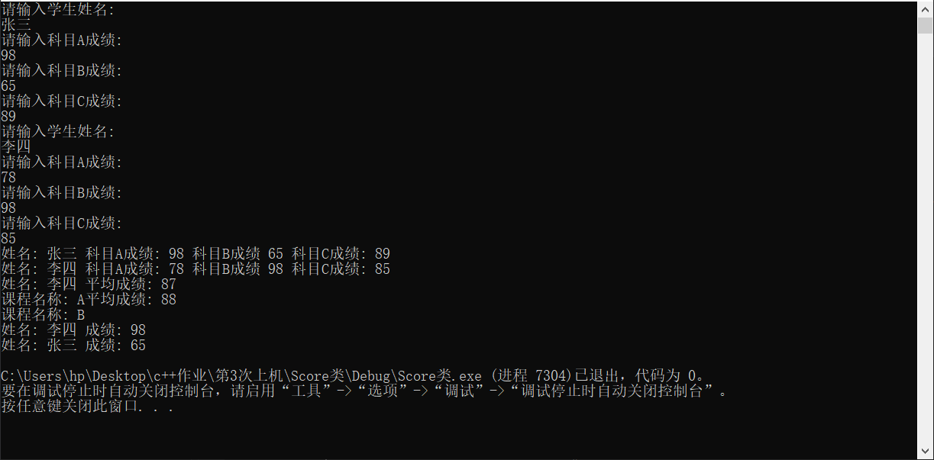
心得体会
太复杂了，搞了很久，尤其是第二个，第一个还好，C语言时整过，但第二个中间好几个成员函数都出错了，步骤很长，打错一点回头都得看半天，务必要认真细心点

