实验内容
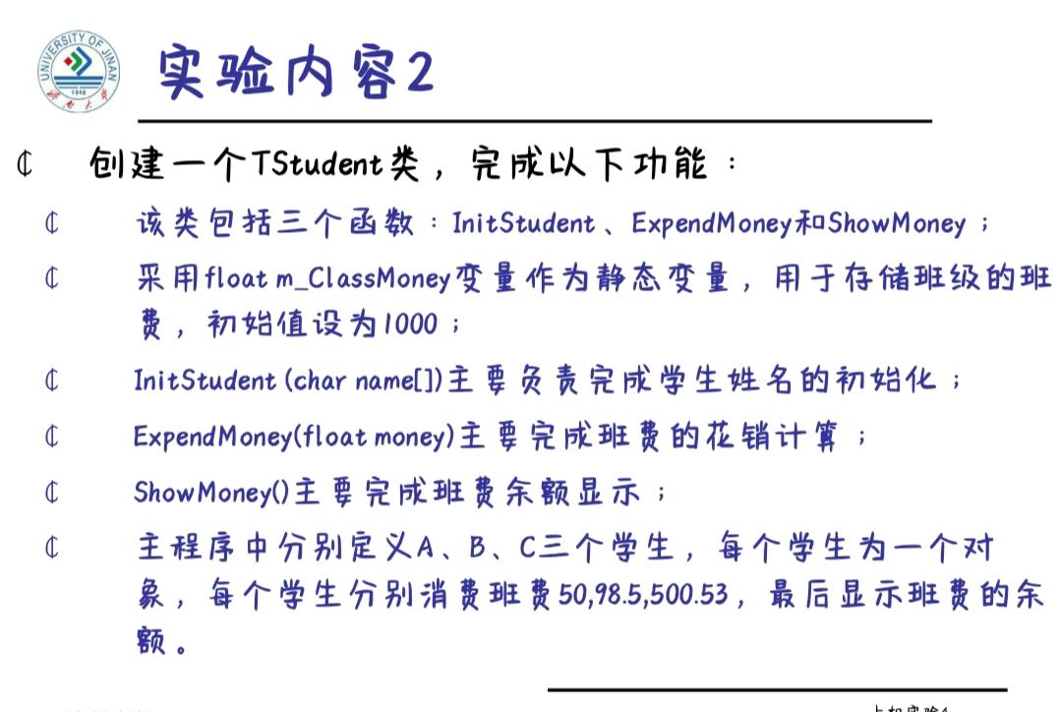

程序编码
#include <iostream>
class TStudent
{
private:
char m_Name[6];
static float m_ClassMoney;
//m_ClassMoney为静态成员变量，保存班费
public:
void InitStudent(char *);
void ExpendMoney(float);
static void ShowMoney(); //静态成员函数
};
float TStudent::m_ClassMoney=1000; //静态成员变量的初始化
void TStudent::InitStudent(char name[])
{
strcpy(m_Name,name);
}
void TStudent::ExpendMoney(float money)
{
m_ClassMoney-=money; //班费为原先的减去花费的
cout<<m_Name<<"花费班费"<<m_ClassMoney<<endl;
}
void TStudent::ShowMoney()
{
cout<<"班费还剩余"<< m_ClassMoney<<endl;
}
void main()
{
TStudent stu[3];//定义三个学生
stu[0].InitStudent("A");
stu[1].InitStudent("B");
stu[2].InitStudent("C");
stu[0].ExpendMoney(50);
TStudent::ShowMoney();
stu[1].ExpendMoney(98.5);
TStudent::ShowMoney();
stu[2].ExpendMoney(500.53);
TStudent::ShowMoney();
}
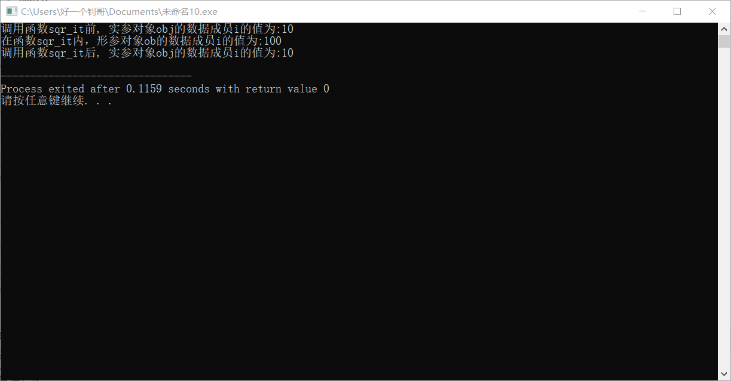

心得体会
这次实验内容有些地方看不懂，翻书和问同学才搞明白，还算不太难

