实验内容
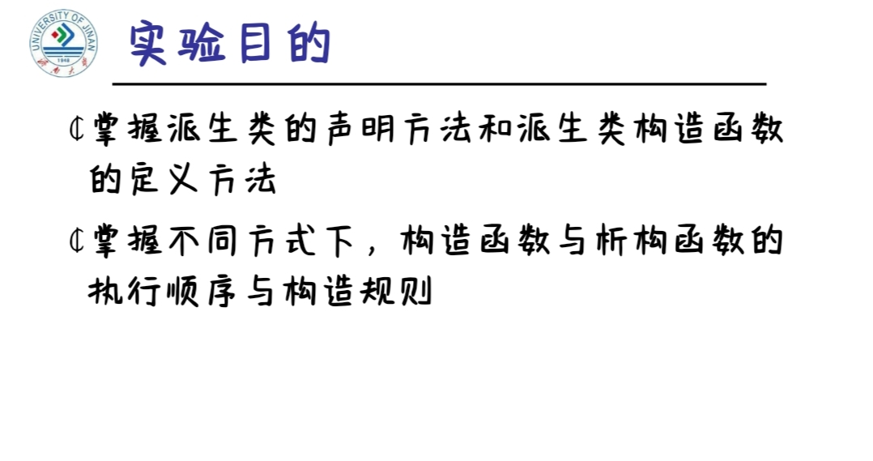
程序编码
#include<iostream>
#include<string>
using namespace std;
class MyArray{
public:
MyArray(int length);
~MyArray();
void Input();
void Display(string);
protected:
int *alist;
int length;
};
MyArray::MyArray(int leng)
{
if(leng<=0)
{
cout<<"error length";
exit(1);
}
alist = new int [length];
length = leng;
if(alist == NULL)
{ cout<<"assign failure";
exit(1);
}
cout<<"MyArray类对象已创建!"<<endl;
}
MyArray::~MyArray()
{
delete [ ] alist;
cout<<"MyArray类对象已撤销!"<<endl;
}
void MyArray::Display(string str)
{
int i;
int *p=alist;
cout<<str<<length<<"个整数: ";
for(i=0;i<length;i++,p++)
cout<<*p<<"";
cout<<endl;
}
void MyArray::Input()
{
cout<<"请从键盘输入"<<length<<"个整数:";
int i;
int *p=alist;
for(i=0;i<length;i++,p++)
cin>>*p;
}
int main()
{
MyArray a(5);
a.Input();
a.Display("显示已经输入的");
return 0;
}

运行结果
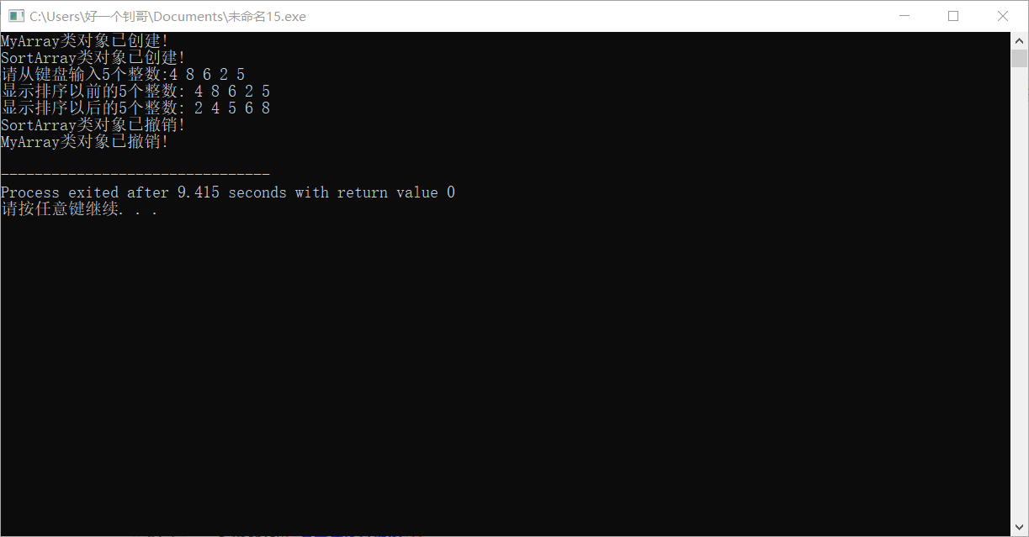
心得体会
还行，搞懂书上的习题后，做起来不算太难

