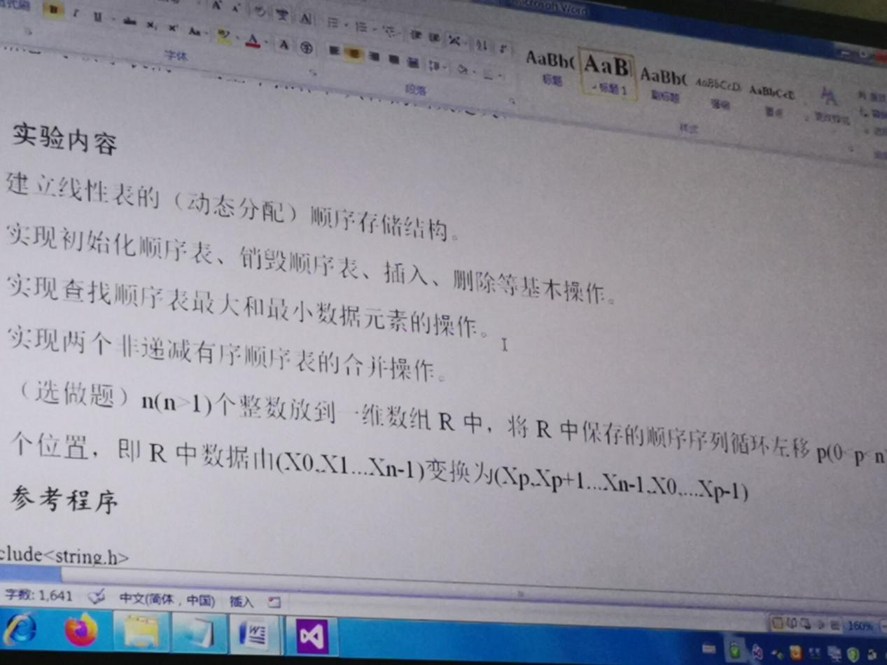

1.寻找最大值、最小值函数
void chazhao(SqList* L)
{

int i = 1, max, min;
max = (*L).elem[i - 1];
min = (*L).elem[i - 1];
while (i < (*L).length && (*L).elem[i - 1])
{
if ((*L).elem[i] >= max)
max = (*L).elem[i];
if ((*L).elem[i] <= min)
min = (*L).elem[i];
i++;
}
printf("max=%d\nmin=%d\n", max, min);
}

2.合并两个线性表
MergeList(L1, L2, &L3);

3.全部代码
#include<string.h>
#include<ctype.h>
#include<malloc.h> /* malloc()等 */
#include<limits.h> /* INT_MAX等 */
#include<stdio.h> /* EOF(=^Z或F6),NULL */
#include<stdlib.h> /* atoi() */
#include<io.h> /* eof() */
#include<math.h> /* floor(),ceil(),abs() */
#include<process.h> /* exit() */
#define TRUE 1
#define FALSE 0
#define OK 1
#define ERROR 0
#define INFEASIBLE -1

#define LIST_INIT_SIZE 100
#define LISTINCREMRNT 10

typedef int ElemType;
typedef int Status;
typedef int Boolean;

typedef struct
{
ElemType* elem; //储存空间基地址
int length; // 记录当前链表长度
int listsize; //链表规模
} SqList;

Status InitList(SqList* L)
{
(*L).elem = (ElemType*)malloc(LIST_INIT_SIZE * sizeof(ElemType));
if (!(*L).elem)
exit(OVERFLOW);
(*L).length = 0;
(*L).listsize = LIST_INIT_SIZE;
return OK;
}

Status DestroyList(SqList* L)
{ /* 操作结果：三元组T被销毁 */
free((*L).elem);
(*L).elem = NULL;
(*L).length = 0;
return OK;
}

void ClearList(SqList* L) {
(*L).length = 0;
}

Status ListEmpty(SqList L) //值拷贝
{
return L.length == 0 ? 1 : 0;

}

Status ListLength(SqList L)
{
return L.length;

}

Status GetEle(SqList L, int i, int* e)
{
if (i<1 || i>L.length)
return ERROR;
*e = L.elem[i - 1];
return OK;
}

Status ListInsert(SqList* L, int i, int e)
{
int* newbase;
int* p, * q;
if (i<1 || i>(*L).length + 1)
return ERROR;
if ((*L).length > (*L).listsize)
{
newbase = (ElemType*)realloc((*L).elem, ((*L).listsize + LISTINCREMRNT) * sizeof(ElemType));
if (!newbase)
exit(OVERFLOW);
(*L).elem = newbase;
(*L).listsize += LISTINCREMRNT;
}
q = &((*L).elem[i - 1]);
for (p = &(*L).elem[(*L).length - 1]; p >= q; --p)
{
*(p + 1) = *p;
}
*q = e;
++(*L).length;
return OK;
}

Status LocateElem(SqList* L, int e)
{
int i = 1;
while (i < (*L).length && (*L).elem[i - 1])
i++;
if (i < (*L).length)
return i;
else
return ERROR;
}

Status ListDelete(SqList* L, int i, int* e)
{
int* p;
if (i<1 || i>(*L).length)
return ERROR;
*e = (*L).elem[i - 1];
for (p = &(*L).elem[i - 1]; p < &(*L).elem[(*L).length - 2]; p--)
{
*p = *(p + 1);
}
(*L).length--;
return OK;
}

Status ListTraverse(SqList L)
{
for (int i = 0; i <= L.length - 1; i++)
{
printf(" %d ", L.elem[i]);
}
return OK;
}
void MergeList(SqList La, SqList Lb, SqList* Lc)
{
InitList(Lc);
int i = 1, j = 1, k = 0;
int La_length = ListLength(La);
int Lb_length = ListLength(Lb);
int ai, bj;
while ((i <= La_length) && (j <= Lb_length))
{

GetEle(La, i, &ai);
GetEle(Lb, j, &bj);
if (ai <= bj)
{
ListInsert(Lc, ++k, ai);
++i;
}
else
{
ListInsert(Lc, ++k, bj);
++j;
}
}
while (i <= La_length)
{
GetEle(La, i++, &ai);
ListInsert(Lc, ++k, ai);
}

while (j <= Lb_length)
{
GetEle(Lb, j++, &bj);
ListInsert(Lc, ++k, bj);
}
}
void chazhao(SqList* L)
{

int i = 1, max, min;
max = (*L).elem[i - 1];
min = (*L).elem[i - 1];
while (i < (*L).length && (*L).elem[i - 1])
{
if ((*L).elem[i] >= max)
max = (*L).elem[i];
if ((*L).elem[i] <= min)
min = (*L).elem[i];
i++;
}
printf("max=%d\nmin=%d\n", max, min);

}
void main()
{
SqList L1, L2, L3;
//int e;
int i;
if (InitList(&L1) == 1 && InitList(&L2) == 1)
{
printf("顺序表初始化成功\n");
}

for (i = 1; i < 10; i++)
ListInsert(&L1, i, 2 * i);
for (i = 1; i < 8; i++)
ListInsert(&L2, i, (2 * i + 1));
chazhao(&L1);
chazhao(&L2);
MergeList(L1, L2, &L3);
chazhao(&L3);
ListTraverse(L3);
DestroyList(&L1);
DestroyList(&L2);
DestroyList(&L3);
}
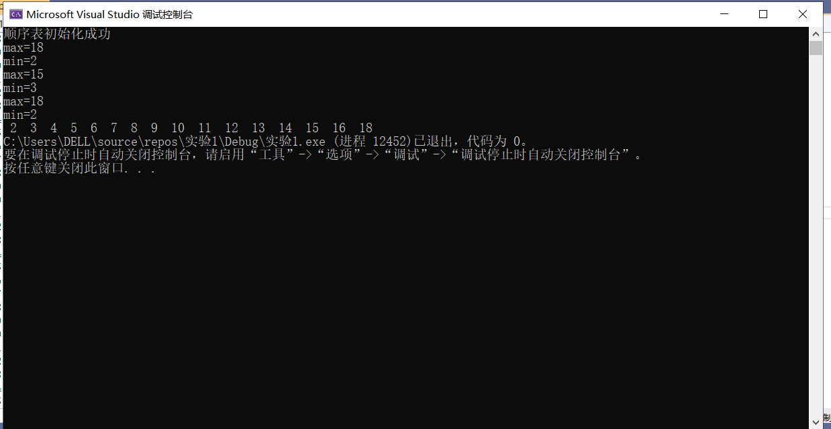
总结：
编写代码不熟练，甚至刚开始无从下手。本次实验的主要目的是掌握线性表的熟练运用，实现初始化、删除、插入、销毁等基本操作。并且通过循环查找实现找到最大值和最小值，并且实现合并两表。还应该多加练习，先实现逻辑问题进而转化为代码实现。

