程序代码：
#include<iostream>
#include<string>
using namespace std;
class MyArray
{
public:
MyArray()
{
cout << "MyArray类对象已创建!" << endl;
}
MyArray(int length);
~MyArray();
void Input();
void Display(string);
protected:
int *alist;
int length;
};

MyArray::MyArray(int leng)
{
if (leng <= 0)
{
cout << "error length";
exit(1);
}
length = leng;
alist = new int[length];
if (alist == NULL)
{
cout << "assign failure";
exit(1);
}
cout << "MyArray类对象已创建!" << endl;
}
MyArray::~MyArray()
{
delete[] alist;
cout << "MyArray类对象已撤销!" << endl;
}
void MyArray::Display(string str)
{
int i;
int *p = alist;
cout << str << length << "个整数: ";
for (i = 0; i < length; i++, p++)
cout << *p << "";
cout << endl;
}
void MyArray::Input()
{
cout << "请从键盘输入" << length << "个整数:";
int i;
int *p = alist;
for (i = 0; i < length; i++, p++)
cin >> *p;
}
class SortArray:public MyArray
{
public:
SortArray(int leng)
{
if (leng <= 0)
{
cout << "error length";
exit(1);
}
length = leng;
alist = new int[length];
if (alist == NULL)
{
cout << "assign failure";
exit(1);
}
cout << "SortArray已创建" << endl;
}
~SortArray()
{
cout << "SortArray已销毁" << endl;
}
void rank()
{
int *p = alist;
int i, j,temp;
for (j = 0; j < length - 1; j++)
{
for (i = 0; i < length - 1 - j; i++)
if (p[i] > p[i+1])
{
temp = p[i];
p[i] = p[i + 1];
p[i + 1] = temp;
}
}
cout << "从小到大排序如下" << endl;
for (int k=0; k < length; k++)
cout << p[k] << endl;
}

};

int main()
{
SortArray a(5);
a.Input();
a.Display("显示已经输入的");
a.rank();
return 0;
}

程序结果：
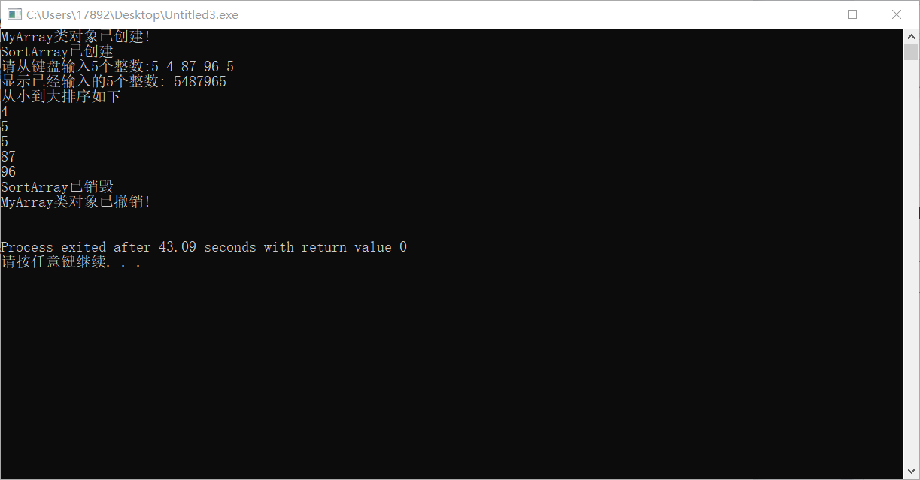
感想心得：
通过本次实验，掌握了派生类的声明方法和派生类构造函数的定义方法，掌握了在不同方式下，构造函数与析构函数的执行顺序与构造规则，加深了对派生类和继承的理解。

Copyright ©2021-2099 ChenChaofan. All rights reserved

