程序代码：
#include<iostream>
using namespace std;
class Complex {
double real;
double imag;
public:
Complex(double r = 0, double i = 0)
{
real = r; imag = i;
}
void print();
friend Complex operator*(Complex co1, Complex co2);
};
Complex operator*(Complex co1, Complex co2)
{
Complex temp;
temp.real = co1.real * co2.real - co1.imag * co2.imag;
temp.imag = co1.real * co2.imag + co1.imag * co2.real;
return temp;
}
void Complex::print()
{
cout << "total real=" << real << " " << " total imag=" << imag << endl;
}
int main()
{
float a, b, c, d;
cout << "please input real and imag:" << endl;
cin >> a >> b;
cout << "please input real and imag:" << endl;
cin >> c >> d;
Complex com1(a, b), com2(c, d), total1;
total1 = com1 * com2;
total1.print();
return 0;
}

程序结果：
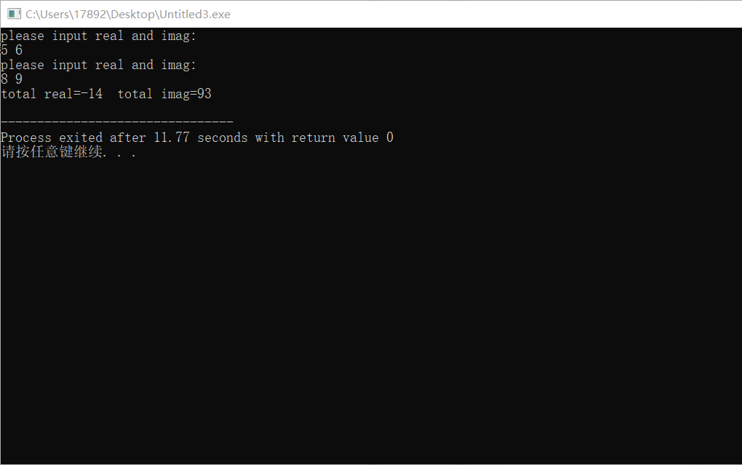

感想心得：
通过本次实验，掌握了C++语言多态性的基本概念，掌握了运算符重载函数的声明和定义方法。

Copyright ©2021-2099 ChenChaofan. All rights reserved

