上机实验七
#include<iostream>
using namespace std;
class Complex {
public:
double real;
double imag;
Complex(double r = 0, double i = 0)
{
real = r; imag = i;
}
};
Complex operator*(Complex c1, Complex c2)
{
Complex temp;
temp.real = c1.real * c2.real - c1.imag * c2.imag;
temp.imag = c1.real * c2.imag + c2.real * c1.imag;
return temp;
}
int main()
{
Complex com1(1.1, 2.2), com2(3.3, 4.4), total;
total = operator*(com1, com2);
cout << "real=" << total.real << " " << "imag=" << total.imag << endl;
return 0;
}

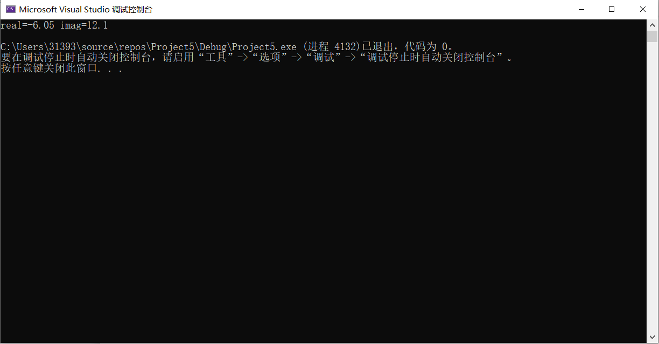

上机感受
我们可以使用运算符号来重载函数操作，使我们利用数据更加的方便。

