实验内容
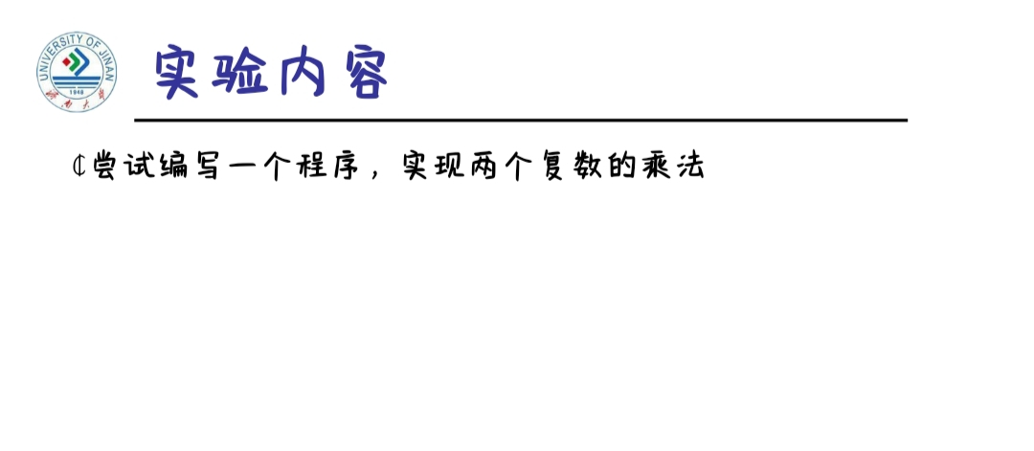
程序编码
#include<iostream>
using namespace std;
class complex {
public:
double real;
double imag;
complex(double r = 0, double i = 0)
{
real = r;
imag = i;
}

};
complex operator*(complex co1, complex co2)
{
complex temp;
temp.real = co1.real * co2.real - co1.imag * co2.imag;
temp.imag = co1.real * co2.imag + co1.imag * co2.real;
return temp;
}
int main()
{
complex com1(2, 2), com2(3, 3), total;
total = com1 * com2;
cout << "imag1: " << com1.imag << " " << "real1: " << com1.real << endl;
cout << "imag2: " << com2.imag << " " << "real2: " << com2.real << endl;
cout << "imag= " << total.imag << endl;
cout << "real= " << total.real;
return 0;
}
运行结果

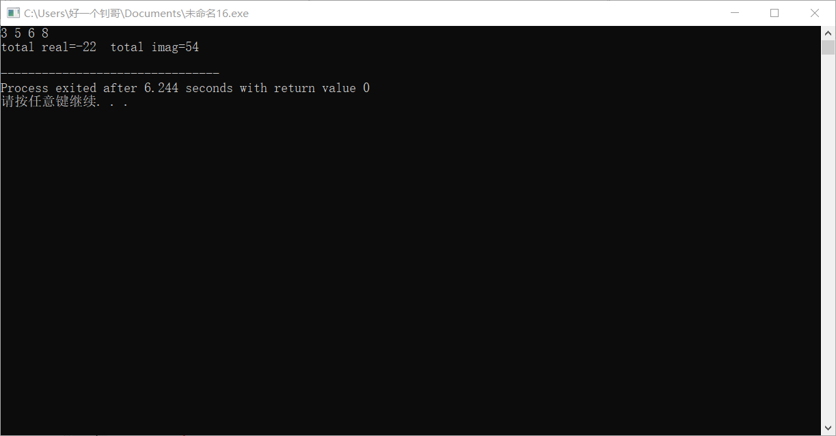

心得体会
过程比较复杂，开始时有些费时间，整好几次出错后总算理清思路做出来了，计算题感觉整体思路搞懂的话还行

