上机实验三
#include<iostream>
#include<string>
using namespace std;
class Score {
public:
Score()
{
s = 2;
}
Score(int s1)
{
s = s1;
}
void InputNameAndScore()
{
int i;
for (i = 0; i < s; i++)
{
cout << "请输入学生姓名:" << endl;
cin >> Name[i];
cout << "请输入科目A成绩:" << endl;
cin >> SScore[i][1];
cout << "请输入科目B成绩:" << endl;
cin >> SScore[i][2];
cout << "请输入科目C成绩:" << endl;
cin >> SScore[i][3];
}
}
void ShowNameAndScore()
{
int i;
for (i = 0; i < s; i++)
{
cout << "姓名: " << Name[i] << " 科目A成绩: " << SScore[i][1] << " 科目B成绩 " << SScore[i][2] << " 科目C成绩: " << SScore[i][3] << endl;
}
}
void ShowStdentAvgScore(int a)
{
float avg = 0;
avg = (SScore[a][1] + SScore[a][2] + SScore[a][3]) / 3;
cout << "姓名: " << Name[a] << " 平均成绩: " << avg << endl;
}
void ShowClassAvgScore(string ClassName)
{
int b;
float avg = 0;
if (ClassName == "A") b = 1;
if (ClassName == "B") b = 2;
if (ClassName == "C") b = 3;
for (int i = 0; i < s; i++)
{
avg = avg + SScore[i][b];
}
avg = avg / s;
cout << "课程名称: " << ClassName << "平均成绩: " << avg << endl;
}
void OrderScore(string ClassName)
{
int b;
if (ClassName == "A") b = 1;
if (ClassName == "B") b = 2;
if (ClassName == "C") b = 3;
for (int i = 0; i < s; i++)
{
SScore1[i] = SScore[i][b];
}
for (int i = 0; i < s; i++)
{
Name1[i] = Name[i];
}
for (int i = 1; i < s; i++)
{
if (SScore1[i] > SScore1[i - 1])
{
float temp = SScore1[i - 1];
SScore1[i - 1] = SScore1[i];
SScore1[i] = temp;
string temp1;
temp1 = Name1[i - 1];
Name1[i - 1] = Name1[i];
Name1[i] = temp1;
}
}
cout << "课程(由高到低排序): " << ClassName << endl;
for (int i = 0; i < s; i++)
{
cout << "姓名: " << Name1[i] << " 成绩: " << SScore1[i] << endl;
}
}
private:
float SScore[100][3], SScore1[100];
string Name[100], Name1[100];
int s;
};
int main()
{
Score S;
S.InputNameAndScore();
S.ShowNameAndScore();
S.ShowStdentAvgScore(0);
S.ShowStdentAvgScore(1);
S.ShowClassAvgScore("A");
S.OrderScore("A");
S.ShowClassAvgScore("B");
S.OrderScore("B");
S.ShowClassAvgScore("C");
S.OrderScore("C");
return 0;
}

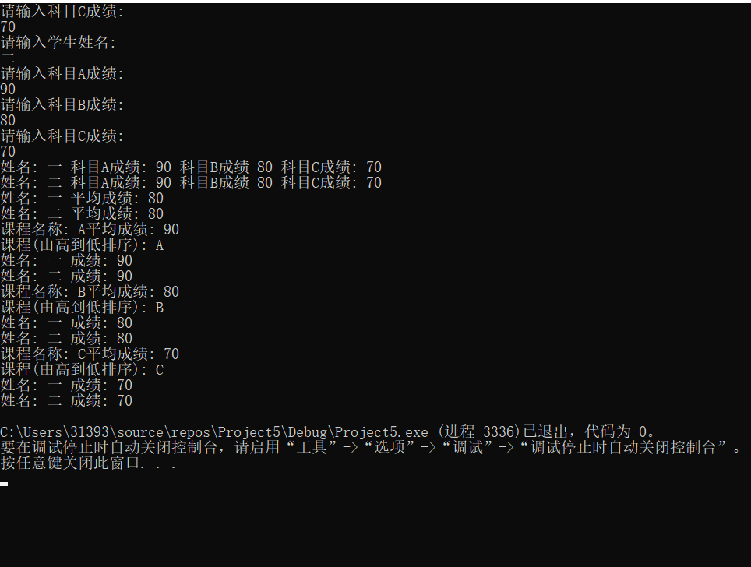

上机感受
这次上机实验使我学会了构造函数与析构函数的调用顺序，以及他们的特性都有什么，能够加深我对其运用的理解。

