第三次上机实验报告
学号：202030310234 姓名：李昱霖 班级：自2003
实验一程序代码
#include<iostream>
using namespace std;
class Coordinate {
public:
Coordinate()
{
times = 2;
cout << "Coordinate construction1 called!" << endl;
}
Coordinate(int times1)
{
times = times1;
cout << "Coordinate construction2 called!" << endl;
}
~Coordinate()
{
cout << "Coordinate destruction called!" << endl;
}
void InputCoord()
{
for (int i = 0; i < times; i++)
{
cout << "Please Input x:" << endl;
cin >> Coord[i][1];
cout << "Please Input y:" << endl;
cin >> Coord[i][2];
}
}
void ShowCoord()
{
cout << "The coord is:" << endl;
for (int i = 0; i < times; i++)
{
cout << "(" << Coord[i][1] << "," << Coord[i][2] << ")" << endl;
}
}
void ShowAvgCoord()
{
float avgx = 0;
float avgy = 0;
for (int i = 0; i < times; i++)
{
avgx = avgx + Coord[i][1];
avgy = avgy + Coord[i][2];
}
avgx = avgx / times;
avgy = avgy / times;
cout << "The AVG coord is:" << endl;
cout << "(" << avgx << "," << avgy << ")" << endl;
}
private:
float Coord[100][100];
int times;
};
int main()
{
Coordinate y(5);
y.InputCoord();
y.ShowCoord();
y.ShowAvgCoord();
}
实验一程序结果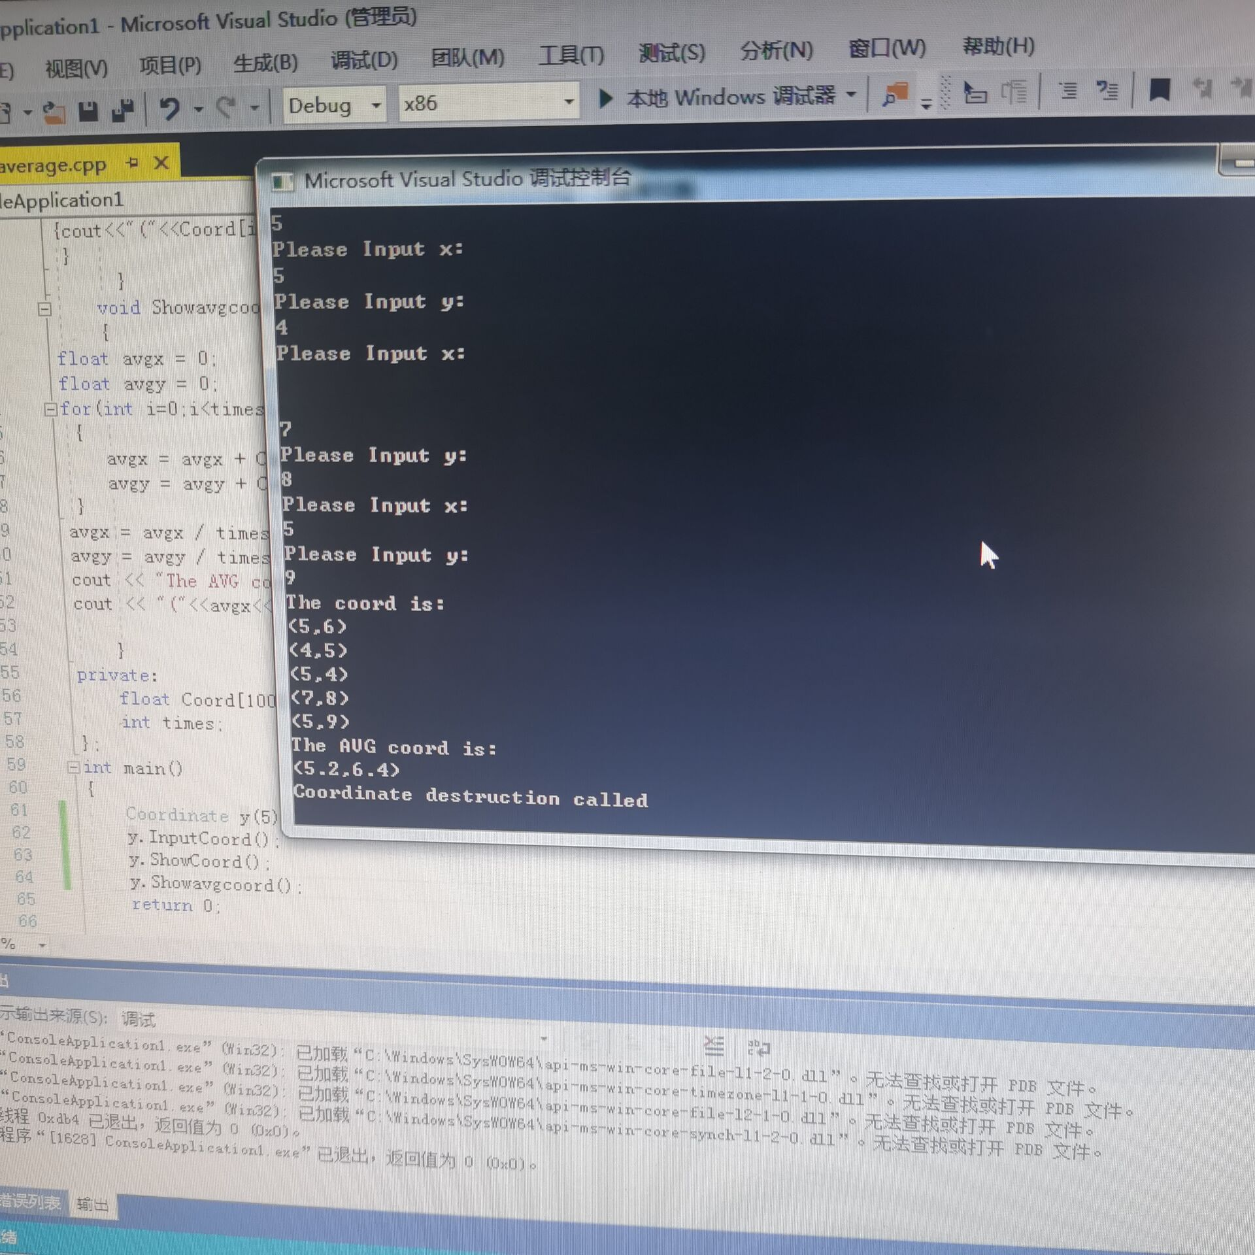
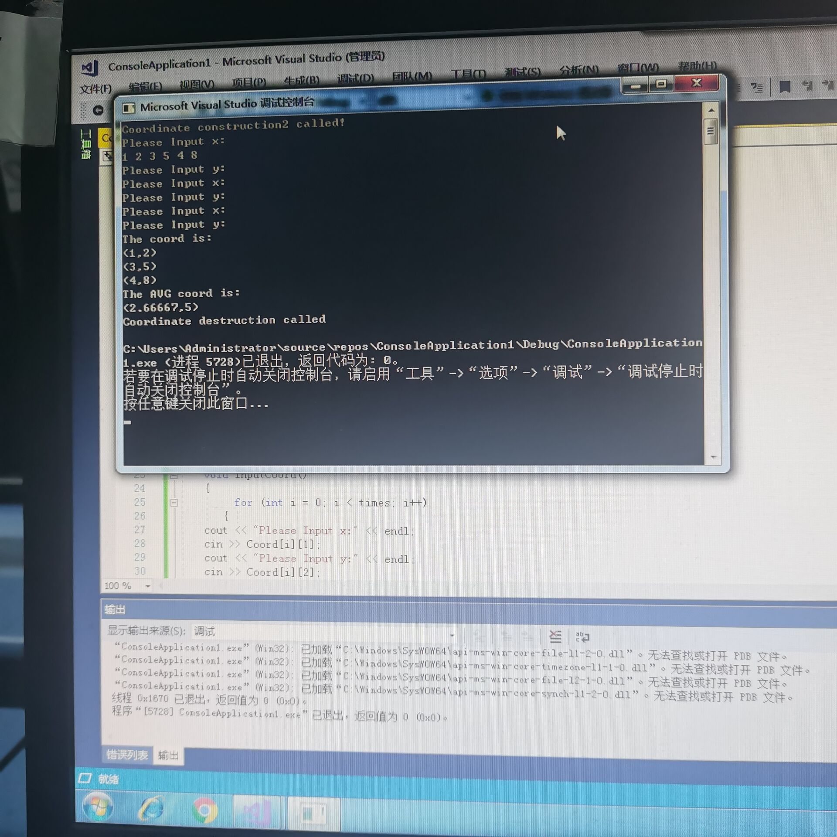

- 实验二程序代码
#include<iostream>
#include<string>
using namespace std;
class Score {
public:
Score()
{
times = 2;
}
Score(int times1)
{
times = times1;
}
void InputNameAndScore()
{
for (int i = 0; i < times; i++)
{
cout << "请输入学生姓名:" << endl;
cin >> Name[i];
cout << "请输入科目A成绩:" << endl;
cin >> SScore[i][1];
cout << "请输入科目B成绩:" << endl;
cin >> SScore[i][2];
cout << "请输入科目C成绩:" << endl;
cin >> SScore[i][3];
}
}

void ShowNameAndScore()
{
for (int i = 0; i < times; i++)
{
cout << "姓名: " << Name[i] << " 科目A成绩: " << SScore[i][1] << " 科目B成绩 " << SScore[i][2] << " 科目C成绩: " << SScore[i][3] << endl;
}
}

void ShowStdentAvgScore(int Sid)
{
float avg = 0;
avg = (SScore[Sid][1] + SScore[Sid][2] + SScore[Sid][3]) / 3;
cout << "姓名: " << Name[Sid] << " 平均成绩: " << avg << endl;
}

void ShowClassAvgScore(string ClassName)
{
int Cid;
float avg = 0;
if (ClassName == "A") Cid = 1;
if (ClassName == "B") Cid = 2;
if (ClassName == "C") Cid = 3;
for (int i = 0; i < times; i++)
{
avg = avg + SScore[i][Cid];
}
avg = avg / times;
cout << "课程名称: " << ClassName << "平均成绩: " << avg << endl;
}

void OrderScore(string ClassName)
{
int Cid;
if (ClassName == "A") Cid = 1;
if (ClassName == "B") Cid = 2;
if (ClassName == "C") Cid = 3;
for (int i = 0; i < times; i++)
{
SScore1[i] = SScore[i][Cid];
}
for (int i = 0; i < times; i++)
{
Name1[i] = Name[i];
}
for (int i = 1; i < times; i++)
{
if (SScore1[i] > SScore1[i - 1])
{
float temp = SScore1[i - 1];
SScore1[i - 1] = SScore1[i];
SScore1[i] = temp;
string temp1;
temp1 = Name1[i - 1];
Name1[i - 1] = Name1[i];
Name1[i] = temp1;
}
}

cout << "课程名称: " << ClassName << endl;
for (int i = 0; i < times; i++)
{
cout << "姓名: " << Name1[i] << " 成绩: " << SScore1[i] << endl;
}
}
private:
float SScore[100][3], SScore1[100];
string Name[100], Name1[100];
int times;
};
int main()
{
Score x;
x.InputNameAndScore();
x.ShowNameAndScore();
x.ShowStdentAvgScore(1);
x.ShowClassAvgScore("A");
x.OrderScore("B");
return 0;
}

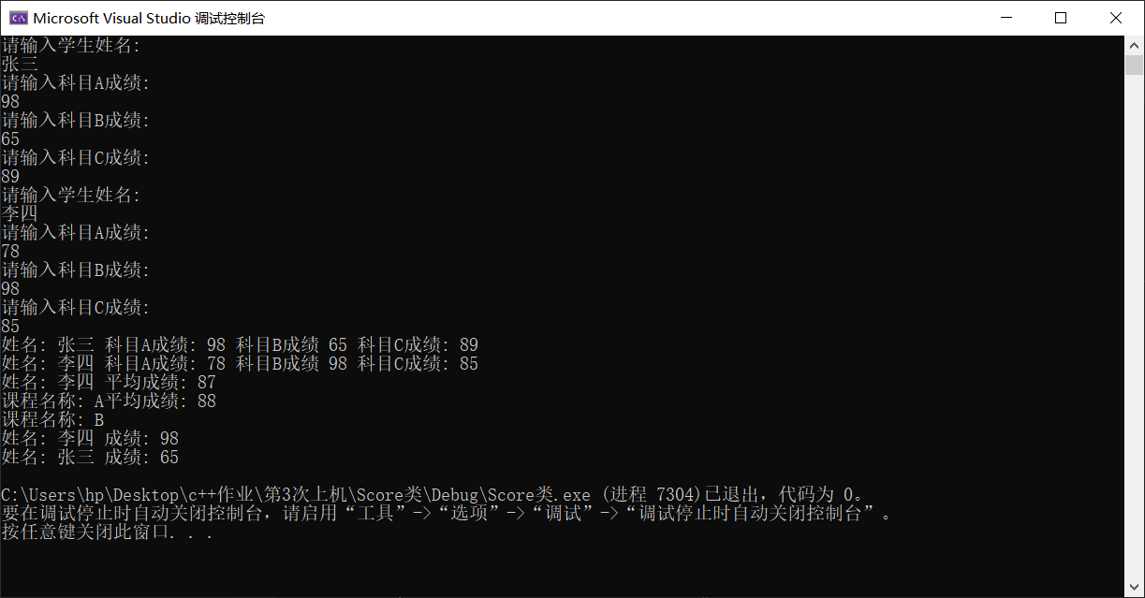
- 实验心得
本次c＋＋的题目难度还是比较高的，程序函数没什么难度，就是程序要求比较繁琐，所以经常导致忘记步骤所以耗费了比较长的时间

Copyright ©2021-2099 erximofu. All rights reserved

