实验七 运算符重载

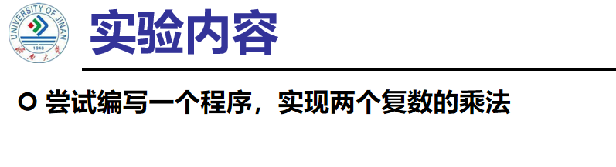

代码：

#include<iostream>

using namespace std;

class Complex {

public:

double real, img;

Complex(double r = 0 ,double i = 0)

{

real = r;

img = i;

}

};

Complex operator*(Complex a, Complex b)

{

Complex temp;

temp.real = a.real * b.real-a.img*b.img;

temp.img = a.real * b.img + a.img * b.real;

return temp;

}

int main()

{

double a,b,c,d;

cout << "请输入两个复数的实部和虚部" << endl;

cin >> a >> b >> c >> d;

Complex A(a, b);

Complex B(c, d);

Complex temp;

temp = A * B;

cout << "乘积的实部是：" << temp.real << endl;

cout << "乘积的虚部是：" << temp.img << endl;

return 0;

}

结果：

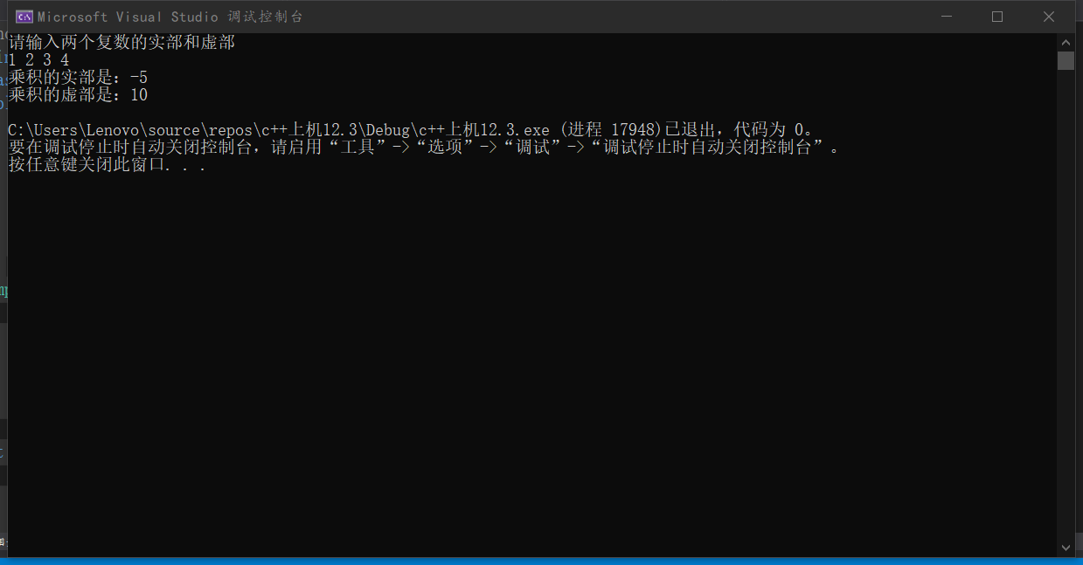

**心得：**

**运算符重载是通过创建运算符重载函数来实现的。运算符重载体现了C++的多态性。运算符重载是针对新类型数据的实际需要，对原有运算符进行适当的改造完成的。重载不能改变运算符的操作对象的个.数。**

Copyright ©2021-2099 MingTao Li. All rights reserved