Copyright ©2021-2099 Aiting Chen. All rights reserved

上机作业1

#include<iostream>

using namespace std;

int main()

{

int grade;

cout<<"Please input your grade: "<<endl;

cin>>grade;

cout<<"Hello,world!My grade is"<<grade<<endl;

system("pause");

return 0;

}

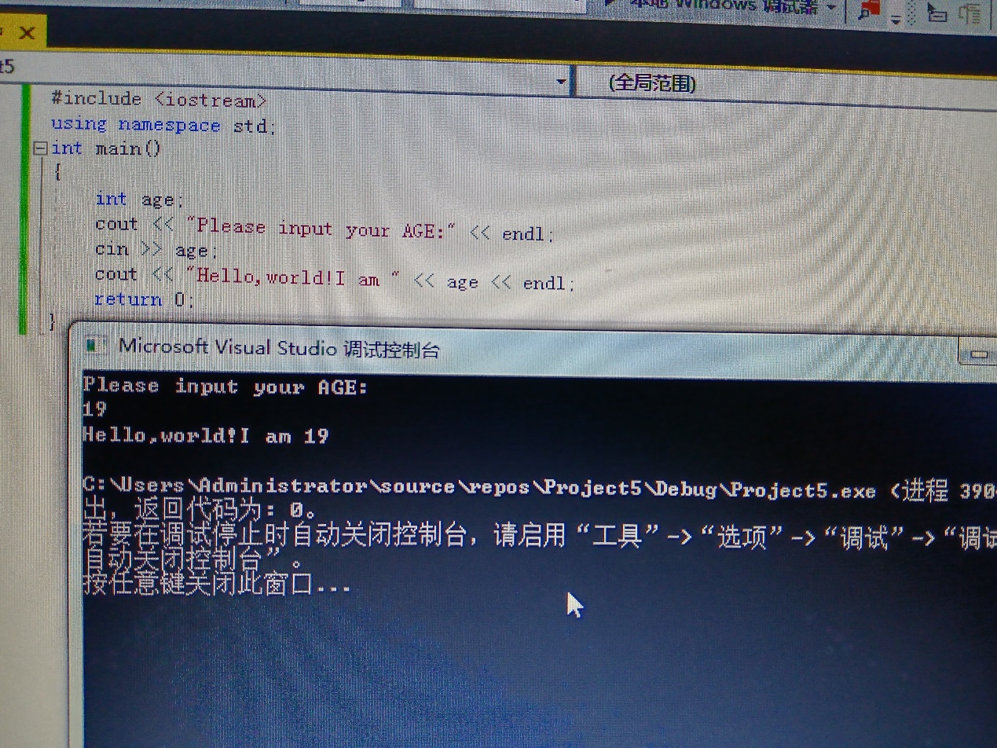

#include<iostream>

using namespace std;

int add(int a,int b);

int main()

{

int x,y,sum;

cout<<"Enter two numbers: "<<endl;

cin>>x>>y;

sum=add(x,y);

cout<<sum<<endl;

system("pause");

return 0;

}

int add(int a,int b)

{

return a+b;

}

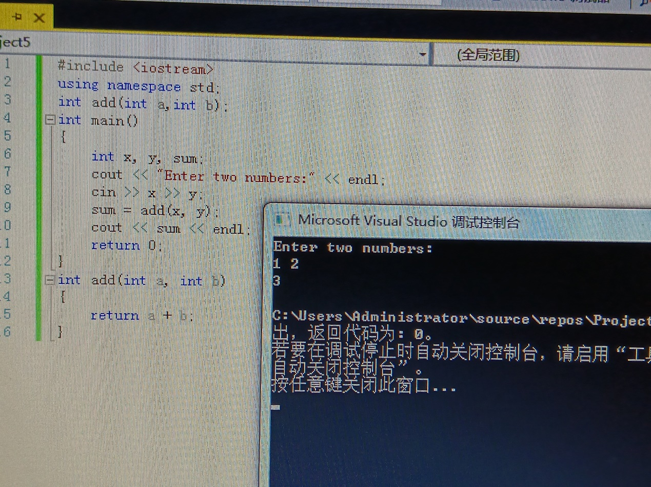

总结：初步了解了C++源程序的基本结构，学会使用简单的输入输出操作。