Copyright ©2021-2099 Aiting Chen. All rights reserved

上机作业2

#include <iostream>

using namespace std;

int max(int x1, int x2, int x3, int x4, int x5);

int min(int y1, int y2, int y3, int y4, int y5);

int main()

{

std::cout<<”Hello World!\n”;

int a,b,c,d,e;

cin >> a >> b >> c >> d >> e;

cout<<”Max number : ”<<max(a,b,c,d,e)<<endl;

cout<<”Min number : ”<<min(a,b,c,d,e)<<endl;

return 0;

}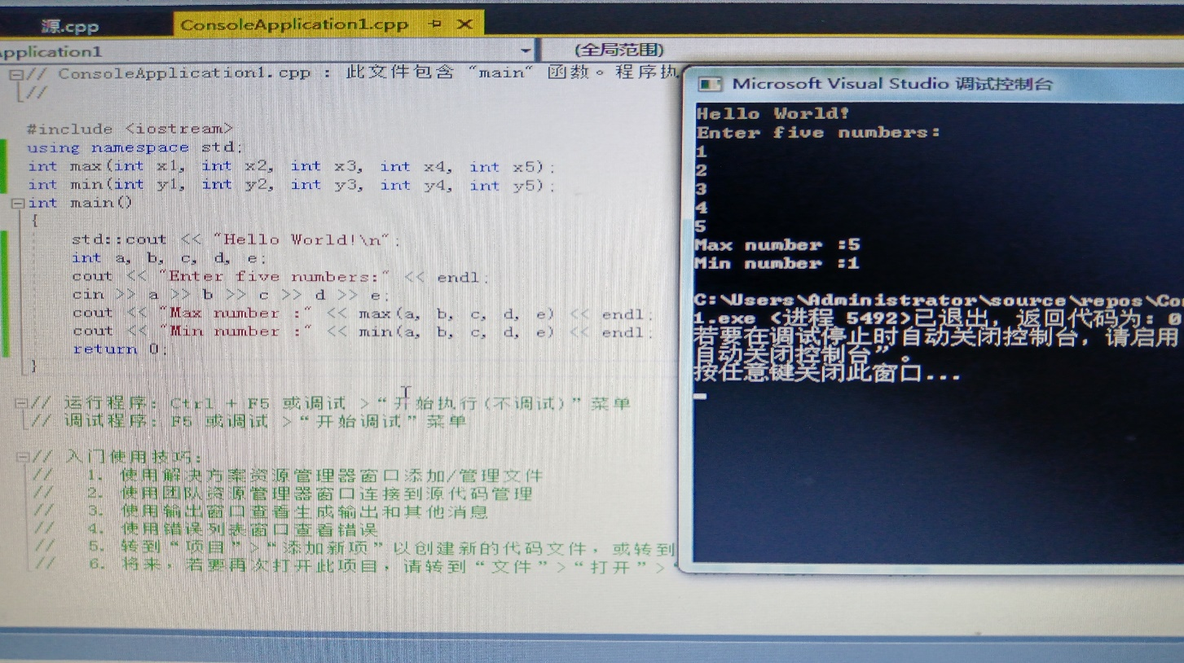

int max(int x1, int x2, int x3, int x4, int x5)

{

int MAX,k[5]={x1,x2,x3,x4,x5},i;

MAX=k[0];

for(i=0;i<5;i++)

if(MAX<k[i])

MAX=k[i];

return MAX;}

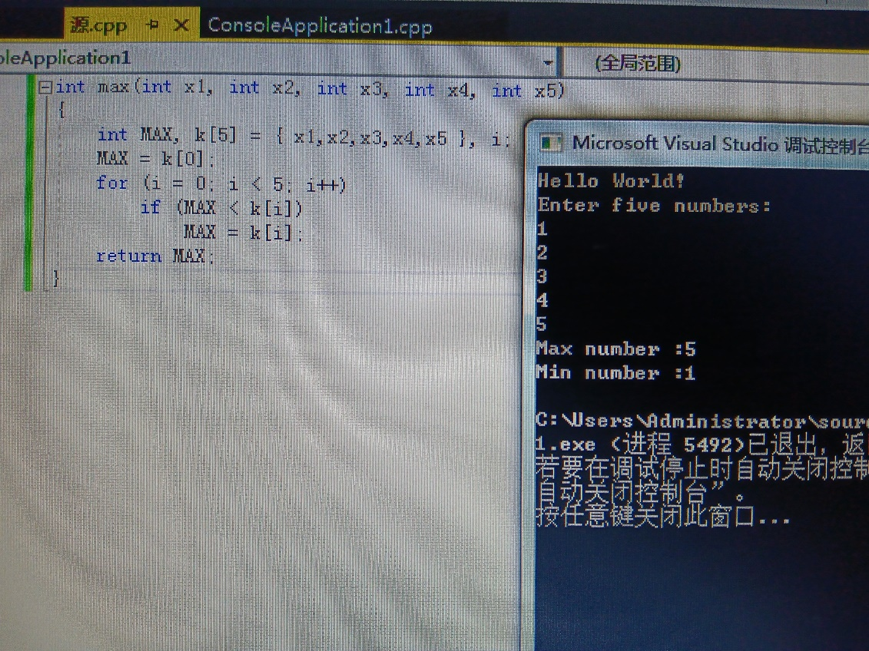

int min(int y1, int y2, int y3, int y4, int y5)

{

int MIN,r[5]={y1,y2,y3,y4,y5},j;

MIN=r[0];

for(j=0;j<5;j++)

if(MIN>r[j])

MIN=r[j];

return MIN;

}

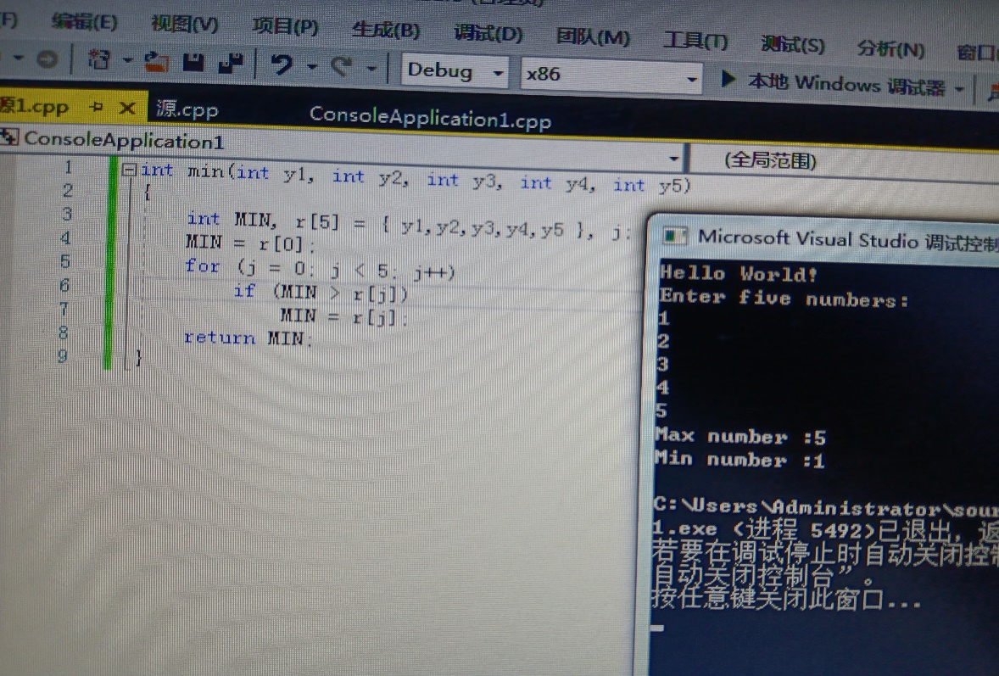

总结：学会了建立和运行单文件程序和多文件程序