Copyright ©2021-2099 Aiting Chen. All rights reserved

上机作业4

#include <iostream>

using namespace std;

class Tr{

public:

Tr(int n)

{

i=n;

}

void set_i(int n)

{

i=n;

}

int get_i()

{

return i;

}

private:

int i;

};

void sqr_it(Tr ob)

{

ob.set_i(ob.get_i()*ob.get_i());

cout<<"在函数sqr_it内，形参对象ob的数据成员i的值为："<<ob.get_i();

cout<<endl;

}

int main()

{

Tr obj(10);

cout<<"调用函数sqr_it前，实参对象obj的数据成员i的值为：";

cout<<obj.get_i()<<endl;

sqr_it(obj);

cout<<"调用函数sqr_it后，实参对象obj的数据成员i的值为：";

cout<<obj.get_i()<<endl;

return 0;

}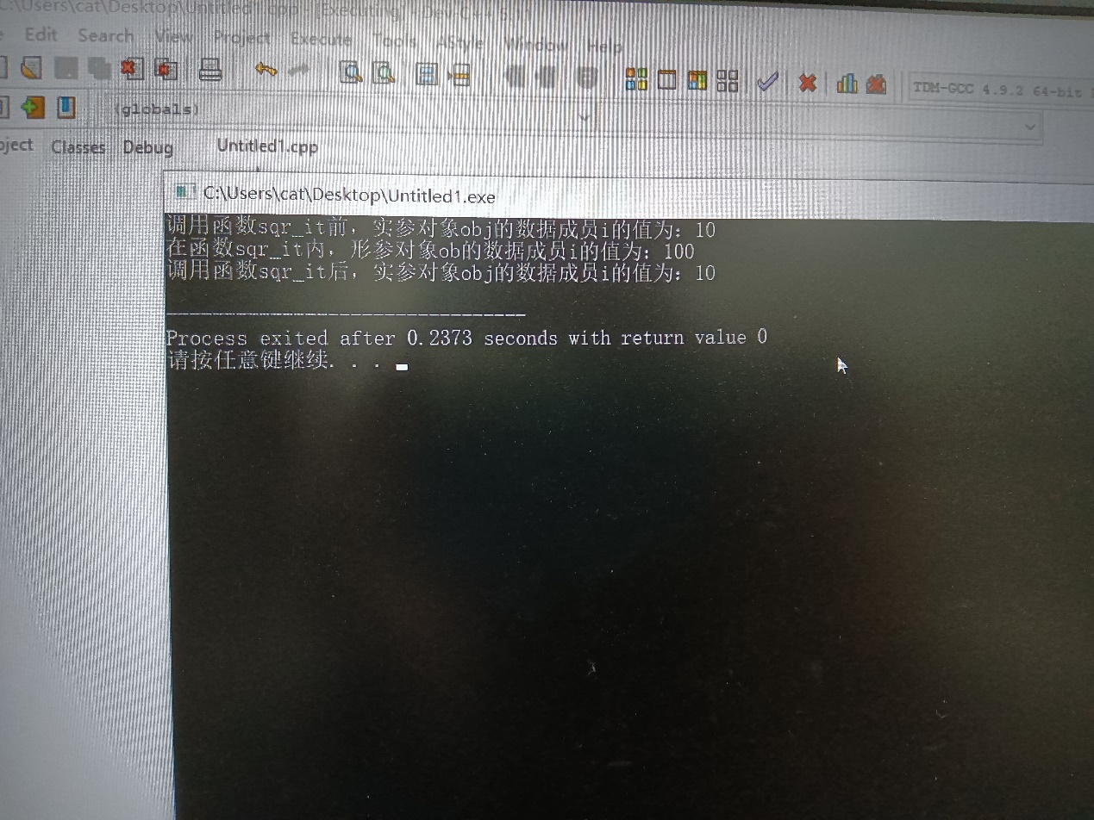

#include<iostream>

using namespace std;

class Ctest{

static int count;

public:

Ctest(){

++count;cout<<"对象数量="<<count<<'\n';

}

};

int Ctest::count=0;

int main(void){

Ctest a[3];

return 0;

}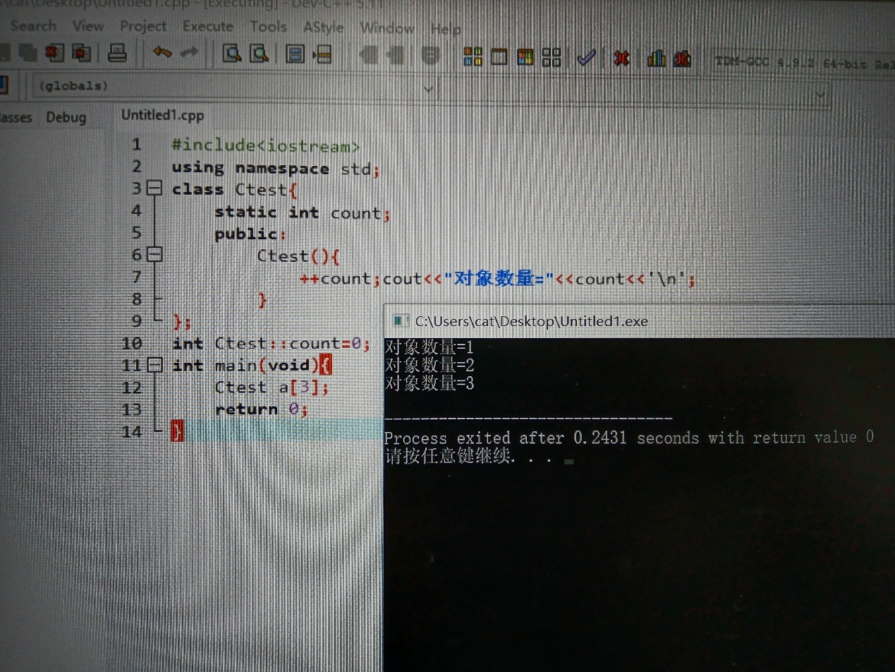

#include <iostream>

#include <string.h>

using namespace std;

class TStudent

{

private:

char m_Name[6];

static float m_ClassMoney;

public:

void InitStudent(const char name[6]);

void ExpendMoney(float);

static void ShowMoney();

};

float TStudent::m_ClassMoney = 1000;

void TStudent::InitStudent(const char name[6])

{

strcpy_s(m_Name,name);

}

void TStudent::ExpendMoney(float money)

{

m_ClassMoney-=money;

cout << m_Name << "花费班费" << m_ClassMoney << endl;

}

void TStudent::ShowMoney()

{

cout << "班费还剩余" << m_ClassMoney << endl;

}

void main()

{

TStudent stu[3];

stu[0].InitStudent("A");

stu[1].InitStudent("B");

stu[2].InitStudent("C");

stu[0].ExpendMoney(50);

TStudent::ShowMoney();

stu[1].ExpendMoney(98.5);

TStudent::ShowMoney();

stu[2].ExpendMoney(500.53);

TStudent::ShowMoney();

}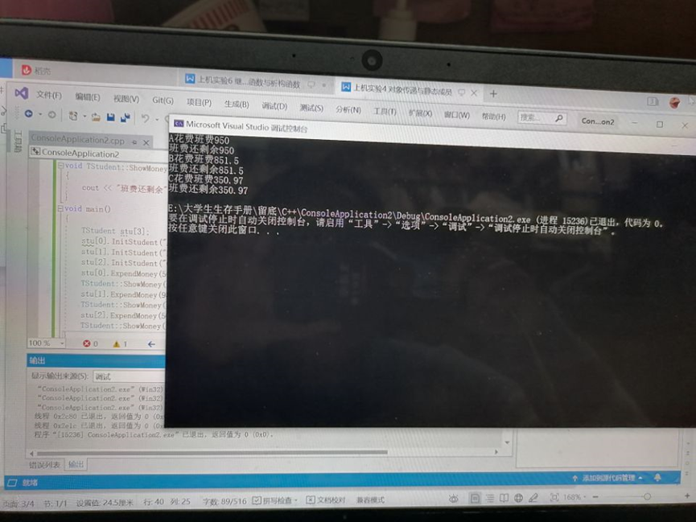

总结：这节课进一步加深了对类和对象的理解并掌握几种对象传递的方法，还掌握了静态成员的概念和使用。