Copyright ©2021-2099 Aiting Chen. All rights reserved

上机作业6

#include<iostream>  
#include<string>  
using namespace std;  
class MyArray {  
public:  
 MyArray(int length);  
 ~MyArray();  
 void Input();  
 void Display(string);  
protected:  
 int *alist;  
 int length;  
};  
MyArray::MyArray(int leng)  
{  
 if (leng <= 0)  
 {  
  cout << "error length";  
  exit(1);  
 }  
 alist = new int[length];  
 length = leng;  
 if (alist == NULL)  
 {  
  cout << "assign failure";  
  exit(1);  
 }  
 cout << "MyArray类对象已创建！" << endl;  
}  
MyArray::~MyArray()  
{  
 delete[] alist;  
 cout << "MyArray类对象已撤销！" << endl;  
}  
void MyArray::Display(string str)  
{  
 int i;  
 int *p = alist;  
 cout << str << length << "个整数";  
 for (i = 0; i < length; i++, p++)  
  cout << *p << "";  
 cout << endl;  
}  
void MyArray::Input()  
{  
 cout << "请从键盘输入" << length << "个整数";  
 int i;  
 int *p = alist;  
 for (i = 0; i < length; i++, p++)  
  cin >> *p;  
}  
int main()  
{  
 MyArray a(5);  
 a.Input();  
 a.Display("显示已经输入的");  
 return 0;  
}

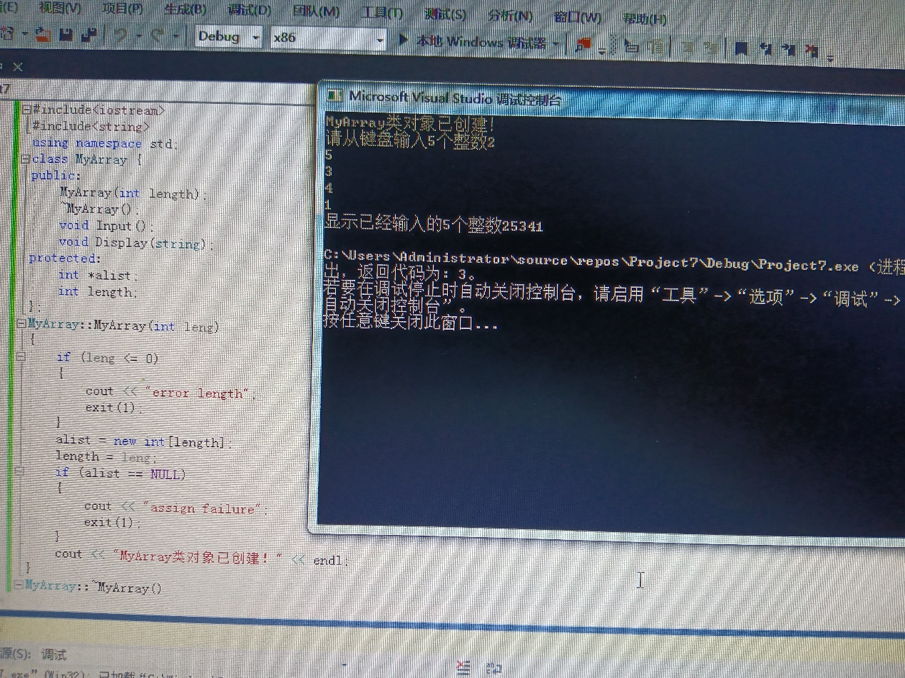

**#include<iostream>**

**#include<string>**

**using namespace std;**

**class MyArray{**

**public:**

**MyArray(int length);**

**~MyArray();**

**void Input();**

**void Display(string);**

**protected:**

**int* alist;**

**int length;};**

**MyArray::MyArray(int leng)**

**{if (leng <= 0)**

**{ cout<< "error length";**

**exit(1);**

**}**

**length =leng;**

**alist =new int[length];**

**if (alist ==NULL)**

**{**

**cout<< "assign failure"**

**exit(1);**

**}**

**cout<< "MyArray类对象已创建!" << endl;**

**}**

**MyArray::~MyArray()**

**{ delete[]alist;**

**cout<< "MyArray类对象已撤销!" << endl;**

**}**

**void MyArray::Display(string str)**

**{**

**int i;**

**int* p = alist;**

**cout<< str << length<< "个整数:";**

**for (i = 0;i < length;i++, p++)**

**cout<< *p<< " ";**

**cout<< endl;**

**}**

**void MyArray::Input()**

**{**

**cout<< "请从键盘输入" << length<< "个整数:";**

**int i;**

**int* p = alist;**

**for (i = 0;i < length;i++, p++)**

**cin>> *p;}**

**class SortArray :public MyArray {**

**public:**

**void Sort();**

**SortArray(int leng) :MyArray(leng)**

**{**

**cout<< "SortArray类对象已创建!" << endl;**

**}**

**~SortArray();**

**};**

**SortArray::~SortArray()**

**{**

**cout<< "SortArray类对象已撤销!" << endl;**

**}**

**void SortArray::Sort()**

**{ int i, j, temp;**

**for (i = 0;i < length - 1;i++)**

**for (j = 0;j < length - i - 1;j++)**

**{ if (alist[j] > alist[j + 1])**

**temp = alist[j];**

**alist[j] = alist[j + 1];**

**alist[j + 1] = temp; } }**

**int main() {**

**SortArray s(5)；**

**s.Input();**

**s.Display("显示排序以前的");**

**s.Sort();**

**s.Display("显示排序以后的");**

**return 0;**

**}**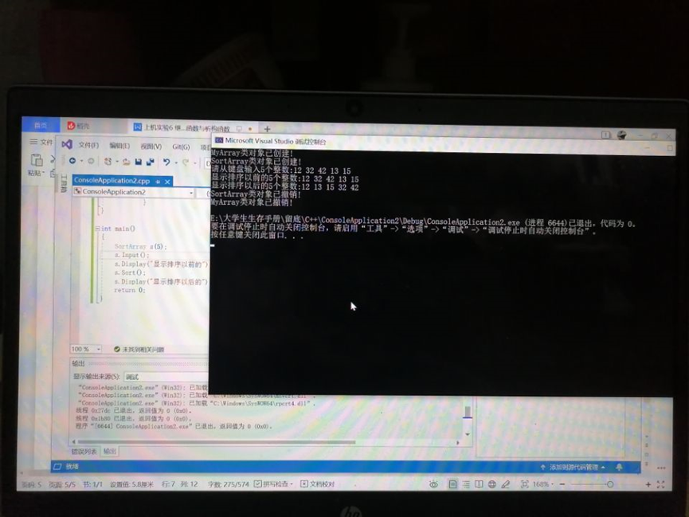

总结：掌握了派生类的声明方法和派生类构造函数的定义方法，以及掌握不同方式下，构造函数与析构函数的执行顺序与构造顺序。