Copyright ©2021-2099 Aiting Chen. All rights reserved

上机作业7

#include <iostream>

using namespace std;

class Complex {

public:

double real;

double imag;

Complex(double r = 0, double i = 0)

{

real = r; imag = i;

}

};

Complex operator\*(Complex co1, Complex co2)

{

Complex temp;

temp.real = co1.real \* co2.real - co1.imag \* co2.imag;

temp.imag = co1.real \* co2.imag + co1.imag \* co2.real;

return temp;

}

int main()

{

Complex com1(1.1, 2.2), com2(3.3, 4.4), total1, total2;

total1 = operator\*(com1, com2);

cout << "real1=" << total1.real << "" << "imag=" << total1.imag << endl;

total2 = com1 \* com2;

cout << "real2=" << total2.real << "" << "imag=" << total2.imag << endl;

return 0;

}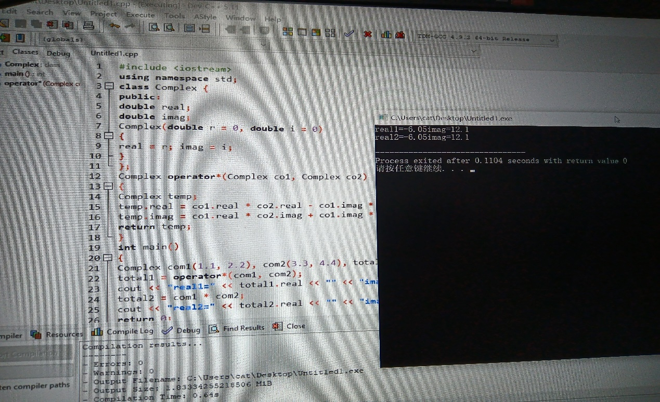

总结：掌握了C++语言多态性的基本概念，且学会了运算符重载函数的声明和定义方法。