第一次实验报告

#include<iostream>

//#include<cmath>

#include<string>

using namespace std;

int main()

{

string name1;

cout << "Please input your name: " << endl;

cin >> name1;

cout << "Hello World ! " << endl;

cout << "Your name is: " << endl;

cout<<name1<<endl;

return 0;

}

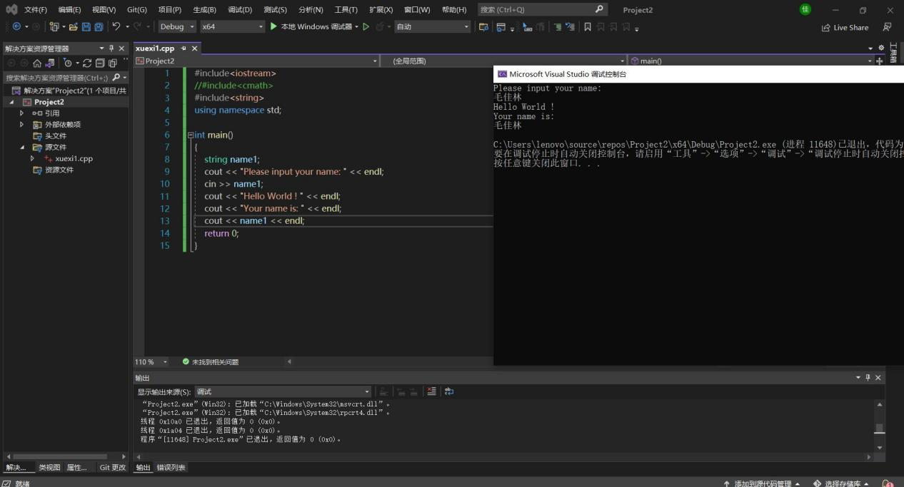

#include<iostream>

#include<cmath>

//#include<string>

using namespace std;

int sum(int a, int b)

{

int c;

c = a + b;

return c;

}

int main()

{

int x, y;

cout << "Please input your numbers: " << endl;

cin >> x >> y;

cout << "The summary is: " << endl;

cout << sum(x,y) << endl;

return 0;

}

图片：

