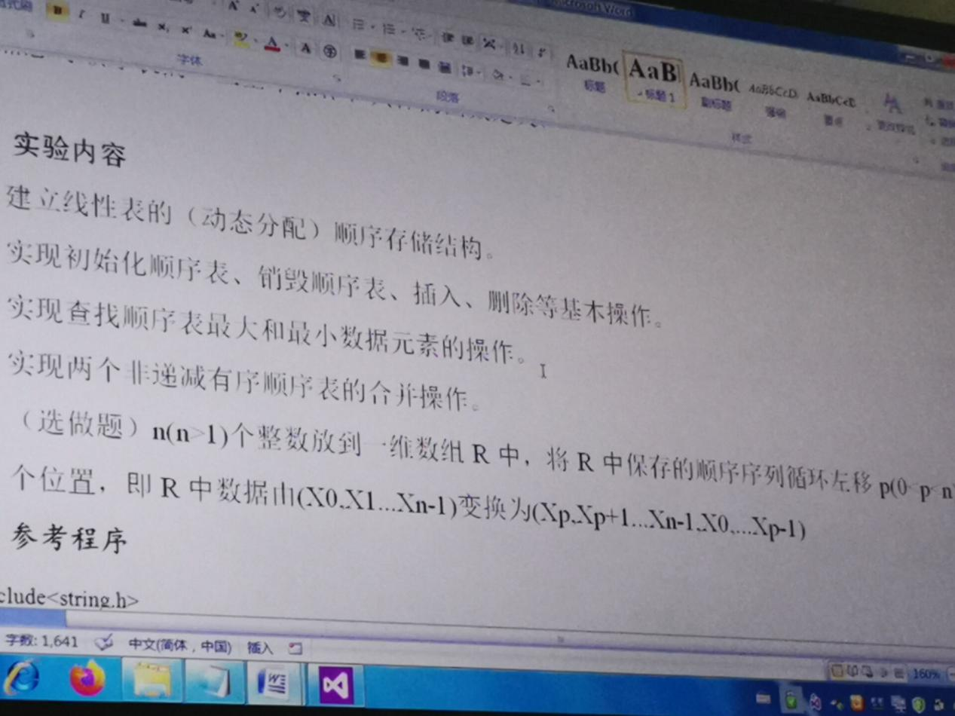

1.寻找最大值、最小值函数

void chazhao(SqList* L)

{

int i = 1, max, min;

max = (*L).elem[i - 1];

min = (*L).elem[i - 1];

while (i < (*L).length && (*L).elem[i - 1])

{

if ((*L).elem[i] >= max)

max = (*L).elem[i];

if ((*L).elem[i] <= min)

min = (*L).elem[i];

i++;

}

printf("max=%d\nmin=%d\n", max, min);

}

2.合并两个线性表

MergeList(L1, L2, &L3);

3.全部代码

#include<string.h>

#include<ctype.h>

#include<malloc.h> /* malloc()等 */

#include<limits.h> /* INT_MAX等 */

#include<stdio.h> /* EOF(=^Z或F6),NULL */

#include<stdlib.h> /* atoi() */

#include<io.h> /* eof() */

#include<math.h> /* floor(),ceil(),abs() */

#include<process.h> /* exit() */

#define TRUE 1

#define FALSE 0

#define OK 1

#define ERROR 0

#define INFEASIBLE -1

#define LIST_INIT_SIZE 100

#define LISTINCREMRNT 10

typedef int ElemType;

typedef int Status;

typedef int Boolean;

typedef struct

{

ElemType* elem; //储存空间基地址

int length; // 记录当前链表长度

int listsize; //链表规模

} SqList;

Status InitList(SqList* L)

{

(*L).elem = (ElemType*)malloc(LIST_INIT_SIZE * sizeof(ElemType));

if (!(*L).elem)

exit(OVERFLOW);

(*L).length = 0;

(*L).listsize = LIST_INIT_SIZE;

return OK;

}

Status DestroyList(SqList* L)

{ /* 操作结果：三元组T被销毁 */

free((*L).elem);

(*L).elem = NULL;

(*L).length = 0;

return OK;

}

void ClearList(SqList* L) {

(*L).length = 0;

}

Status ListEmpty(SqList L) //值拷贝

{

return L.length == 0 ? 1 : 0;

}

Status ListLength(SqList L)

{

return L.length;

}

Status GetEle(SqList L, int i, int* e)

{

if (i<1 || i>L.length)

return ERROR;

*e = L.elem[i - 1];

return OK;

}

Status ListInsert(SqList* L, int i, int e)

{

int* newbase;

int* p, * q;

if (i<1 || i>(*L).length + 1)

return ERROR;

if ((*L).length > (*L).listsize)

{

newbase = (ElemType*)realloc((*L).elem, ((*L).listsize + LISTINCREMRNT) * sizeof(ElemType));

if (!newbase)

exit(OVERFLOW);

(*L).elem = newbase;

(*L).listsize += LISTINCREMRNT;

}

q = &((*L).elem[i - 1]);

for (p = &(*L).elem[(*L).length - 1]; p >= q; --p)

{

*(p + 1) = *p;

}

*q = e;

++(*L).length;

return OK;

}

Status LocateElem(SqList* L, int e)

{

int i = 1;

while (i < (*L).length && (*L).elem[i - 1])

i++;

if (i < (*L).length)

return i;

else

return ERROR;

}

Status ListDelete(SqList* L, int i, int* e)

{

int* p;

if (i<1 || i>(*L).length)

return ERROR;

*e = (*L).elem[i - 1];

for (p = &(*L).elem[i - 1]; p < &(*L).elem[(*L).length - 2]; p--)

{

*p = *(p + 1);

}

(*L).length--;

return OK;

}

Status ListTraverse(SqList L)

{

for (int i = 0; i <= L.length - 1; i++)

{

printf(" %d ", L.elem[i]);

}

return OK;

}

void MergeList(SqList La, SqList Lb, SqList* Lc)

{

InitList(Lc);

int i = 1, j = 1, k = 0;

int La_length = ListLength(La);

int Lb_length = ListLength(Lb);

int ai, bj;

while ((i <= La_length) && (j <= Lb_length))

{

GetEle(La, i, &ai);

GetEle(Lb, j, &bj);

if (ai <= bj)

{

ListInsert(Lc, ++k, ai);

++i;

}

else

{

ListInsert(Lc, ++k, bj);

++j;

}

}

while (i <= La_length)

{

GetEle(La, i++, &ai);

ListInsert(Lc, ++k, ai);

}

while (j <= Lb_length)

{

GetEle(Lb, j++, &bj);

ListInsert(Lc, ++k, bj);

}

}

void chazhao(SqList* L)

{

int i = 1, max, min;

max = (*L).elem[i - 1];

min = (*L).elem[i - 1];

while (i < (*L).length && (*L).elem[i - 1])

{

if ((*L).elem[i] >= max)

max = (*L).elem[i];

if ((*L).elem[i] <= min)

min = (*L).elem[i];

i++;

}

printf("max=%d\nmin=%d\n", max, min);

}

void main()

{

SqList L1, L2, L3;

//int e;

int i;

if (InitList(&L1) == 1 && InitList(&L2) == 1)

{

printf("顺序表初始化成功\n");

}

for (i = 1; i < 10; i++)

ListInsert(&L1, i, 2 * i);

for (i = 1; i < 8; i++)

ListInsert(&L2, i, (2 * i + 1));

chazhao(&L1);

chazhao(&L2);

MergeList(L1, L2, &L3);

chazhao(&L3);

ListTraverse(L3);

DestroyList(&L1);

DestroyList(&L2);

DestroyList(&L3);

}

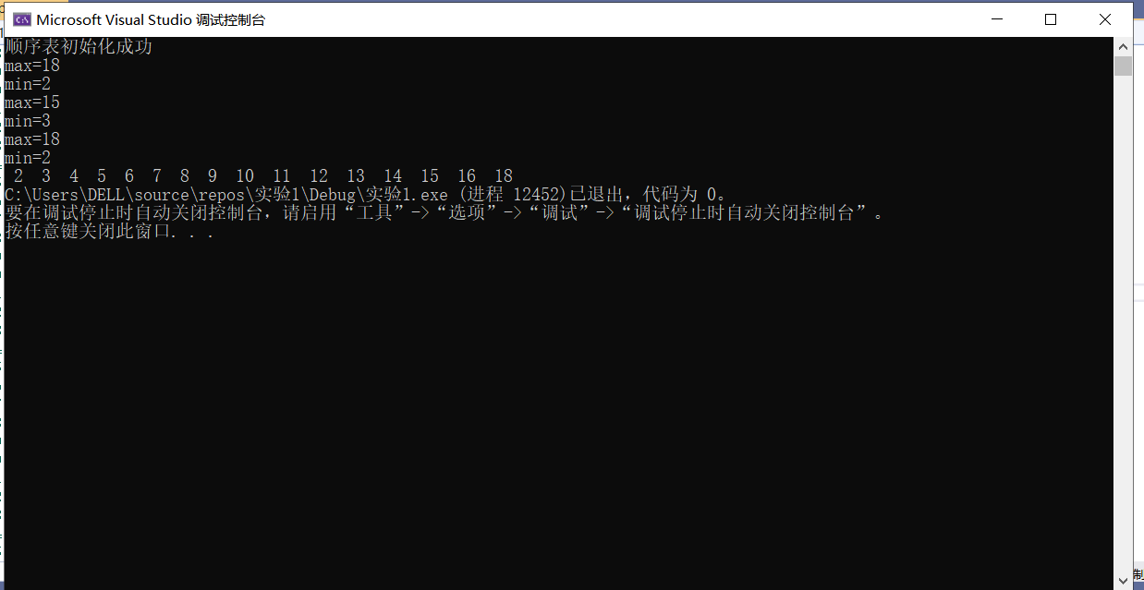

总结：

第一次上机课，从学习使用vs开始，慢慢的掌握VS的编译环境，熟练之后，就开始了学习任务。编写代码不熟练，甚至刚开始无从下手。本次实验的主要目的是掌握线性表的熟练运用，实现初始化、删除、插入、销毁等基本操作。并且通过循环查找实现找到最大值和最小值，并且实现合并两表。