实验五 采用邻接矩阵构造无向网

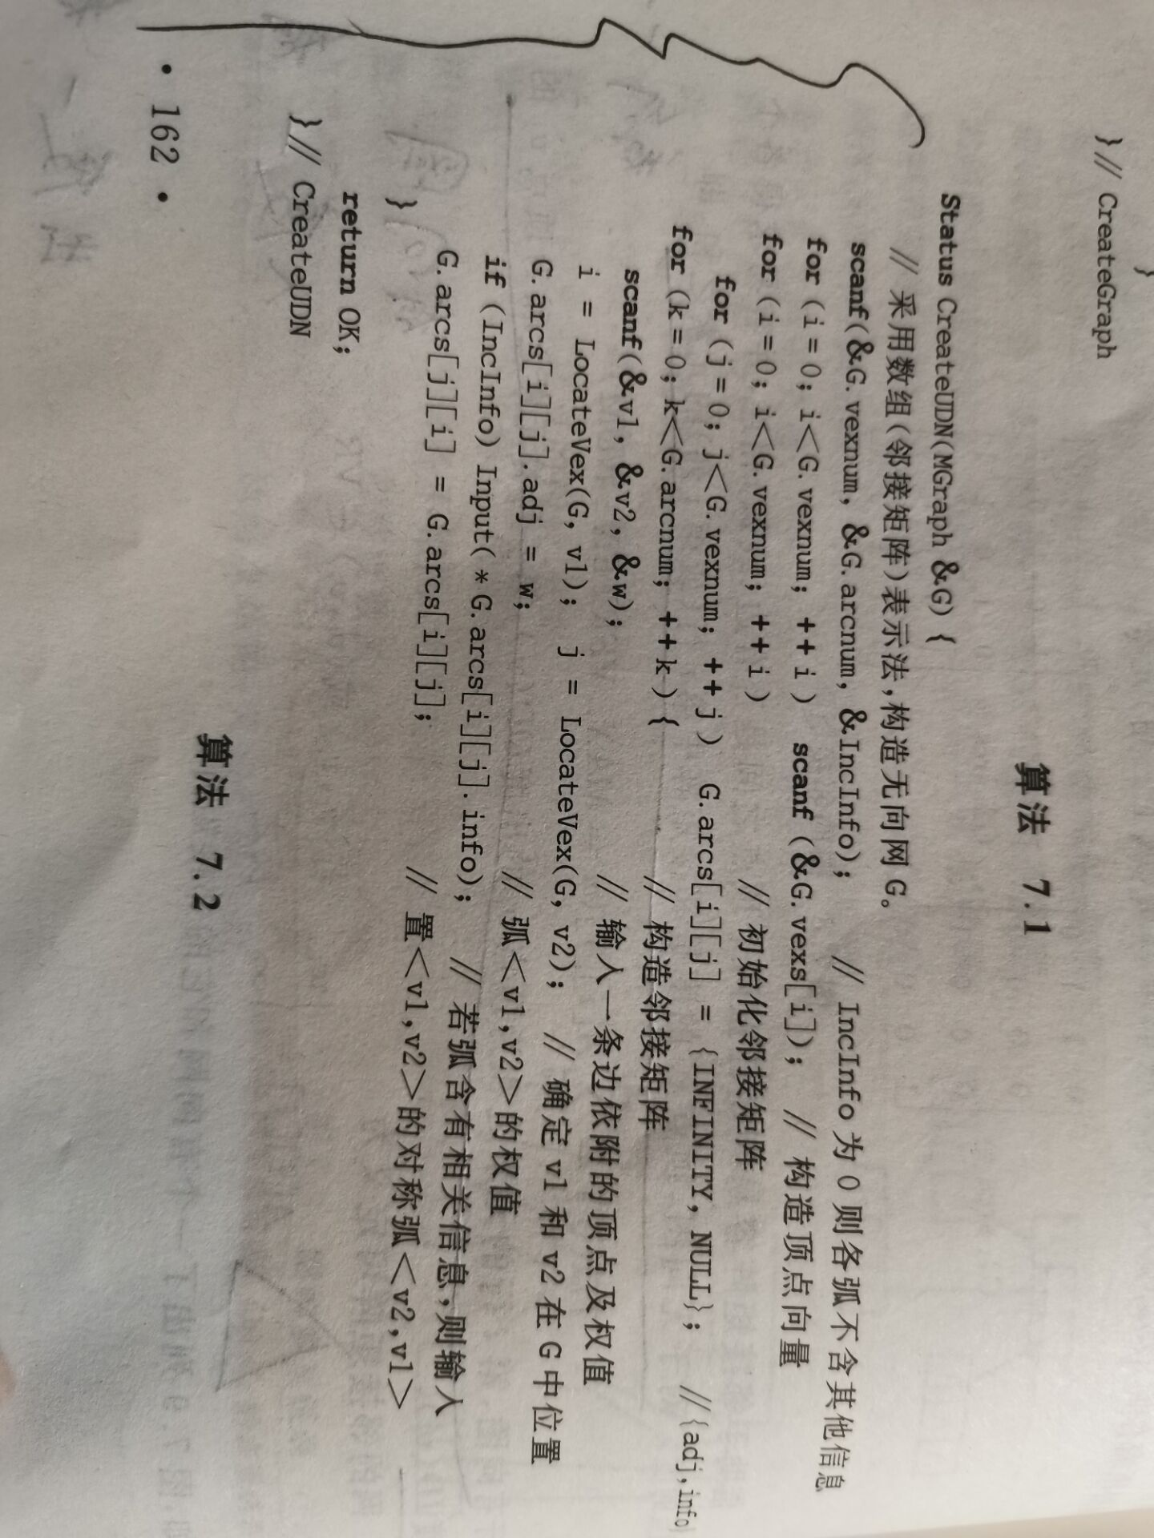

编写函数部分

Status CreateUDN(MGraph* G)

{

int i, j, k, w;

VertexType v1, v2;

scanf_s("%d%d", &(*G).vexnum, &(*G).arcnum);

for (i = 0; i < (*G).vexnum; ++i) scanf_s("%d", &(*G).vexs[i]);

for (i = 0; i < (*G).vexnum; ++i)

for (j = 0; j < (*G).vexnum; ++j)

(*G).arcs[i][j].adj = 2000000, (*G).arcs[i][j].info = NULL;

for (k = 0; k < (*G).vexnum; ++k)

{

scanf_s("%s%s%d*c", v1, v2, &w);

i = LocateVex(*G, v1);

j = LocateVex(*G, v2);

(*G).arcs[i][j].adj = w;

(*G).arcs[j][i] = (*G).arcs[i][j];

}

return OK;

}

#include<string.h>

#include<ctype.h>

#include<malloc.h> /* malloc()等 */

#include<limits.h> /* INT_MAX等 */

#include<stdio.h> /* EOF(=^Z或F6),NULL */

#include<stdlib.h> /* atoi() */

#include<io.h> /* eof() */

#include<math.h> /* floor(),ceil(),abs() */

#include<process.h> /* exit() */

#include<string.h>

/* 函数结果状态代码 */

#define TRUE 1

#define FALSE 0

#define OK 1

#define ERROR 0

#define INFEASIBLE -1

/* #define OVERFLOW -2 因为在math.h中已定义OVERFLOW的值为3,故去掉此行 */

typedef int Status; /* Status是函数的类型,其值是函数结果状态代码，如OK等 */

typedef int Boolean; /* Boolean是布尔类型,其值是TRUE或FALSE */

#define INFINITY INT_MAX /* 用整型最大值代替∞ */

#define MAX_VERTEX_NUM 20 /* 最大顶点个数 */

typedef enum { DG, DN, AG, AN }GraphKind; /* {有向图,有向网,无向图,无向网} */

#define MAX_NAME 5 /* 顶点字符串的最大长度+1 */

#define MAX_INFO 20 /* 相关信息字符串的最大长度+1 */

typedef int VRType;

typedef char InfoType;

typedef char VertexType[MAX_NAME];

typedef struct

{

VRType adj; /* 顶点关系类型。对无权图，用1(是)或0(否)表示相邻否； */

/* 对带权图，c则为权值类型 */

InfoType *info; /* 该弧相关信息的指针(可无) */

}ArcCell, AdjMatrix[MAX_VERTEX_NUM][MAX_VERTEX_NUM];

typedef struct

{

VertexType vexs[MAX_VERTEX_NUM]; /* 顶点向量 */

AdjMatrix arcs; /* 邻接矩阵 */

int vexnum, arcnum; /* 图的当前顶点数和弧数 */

GraphKind kind; /* 图的种类标志 */

}MGraph;

int LocateVex(MGraph G, VertexType u)

{ /* 初始条件:图G存在,u和G中顶点有相同特征 */

/* 操作结果:若G中存在顶点u,则返回该顶点在图中位置;否则返回-1 */

int i;

for (i = 0; i<G.vexnum; ++i)

if (strcmp(u, G.vexs[i]) == 0)

return i;

return -1;

}

Status CreateFAG(MGraph *G)

{ /* 采用数组(邻接矩阵)表示法,由文件构造没有相关信息的无向图G */

int i, j, k;

char filename[13];

VertexType va, vb;

FILE *graphlist;

printf("请输入数据文件名(f7-1.dat)：");

scanf("%s", filename);

graphlist = fopen(filename, "r");

fscanf(graphlist, "%d", &(*G).vexnum);

fscanf(graphlist, "%d", &(*G).arcnum);

for (i = 0; i<(*G).vexnum; ++i) /* 构造顶点向量 */

fscanf(graphlist, "%s", (*G).vexs[i]);

for (i = 0; i<(*G).vexnum; ++i) /* 初始化邻接矩阵 */

for (j = 0; j<(*G).vexnum; ++j)

{

(*G).arcs[i][j].adj = 0; /* 图 */

(*G).arcs[i][j].info = NULL; /* 没有相关信息 */

}

for (k = 0; k<(*G).arcnum; ++k)

{

fscanf(graphlist, "%s%s", va, vb);

i = LocateVex(*G, va);

j = LocateVex(*G, vb);

(*G).arcs[i][j].adj = (*G).arcs[j][i].adj = 1; /* 无向图 */

}

fclose(graphlist);

(*G).kind = AG;

return OK;

}

Status CreateDG(MGraph *G)

{ /* 采用数组(邻接矩阵)表示法,构造有向图G */

int i, j, k, l, IncInfo;

char s[MAX_INFO], *info;

VertexType va, vb;

printf("请输入有向图G的顶点数,弧数,弧是否含其它信息(是:1,否:0): ");

scanf("%d,%d,%d", &(*G).vexnum, &(*G).arcnum, &IncInfo);

printf("请输入%d个顶点的值(<%d个字符):\n", (*G).vexnum, MAX_NAME);

for (i = 0; i < (*G).vexnum; ++i) /* 构造顶点向量 */

scanf("%s", (*G).vexs[i]);

for (i = 0; i < (*G).vexnum; ++i) /* 初始化邻接矩阵 */

for (j = 0; j < (*G).vexnum; ++j)

{

(*G).arcs[i][j].adj = 0; /* 图 */

(*G).arcs[i][j].info = NULL;

}

printf("请输入%d条弧的弧尾 弧头(以空格作为间隔): \n", (*G).arcnum);

for (k = 0; k < (*G).arcnum; ++k)

{

scanf("%s%s%*c", va, vb); /* %*c吃掉回车符 */

i = LocateVex(*G, va);

j = LocateVex(*G, vb);

(*G).arcs[i][j].adj = 1; /* 有向图 */

if (IncInfo)

{

printf("请输入该弧的相关信息(<%d个字符): ", MAX_INFO);

gets_s(s);

l = strlen(s);

if (l)

{

info = (char*)malloc((l + 1)*sizeof(char));

strcpy(info, s);

(*G).arcs[i][j].info = info; /* 有向 */

}

}

}

(*G).kind = DG;

return OK;

}

void Print(MGraph G)

{

for (int i = 0; i<G.vexnum; i++)

{

for (int j = 0; j<G.vexnum; j++)

printf("%d ", G.arcs[i][j]);

printf("\n");

}

}

void main()

{

MGraph G;

CreateUDN(&G);

Print(G);

}