实验三

#include<iostream>

#include<cmath>

//#include<string>

using namespace std;

class coordinate {

private:

int times;

float a[100][2];

public:

coordinate();

coordinate(int times1);

~coordinate();

void input();

void show();

};

coordinate::coordinate()

{

times = 2;

cout << "Coordinate construction1 called! " << endl;

}

coordinate::coordinate(int times1)

{

if (times1 > 100)

times1 = 100;

times = times1;

cout << "Coordinate construction2 called! " << endl;

}

coordinate::~coordinate()

{

cout << "Coordinate disconstruction called! " << endl;

}

void coordinate::input()

{

int i;

for ( i = 0; i < times; i++)

{

cout << "Please input x: " << endl;

cin >> a[i][1];

cout << "Please input y: " << endl;

cin >> a[i][2];

}

}

void coordinate::show()

{

int n;

float avgx=0,avgy=0;

for (n = 0; n < times; n++)

{

avgx = avgx + a[n][1];

avgy = avgy + a[n][2];

}

avgx = avgx / times;

avgy = avgy / times;

cout << "Yuor numbers are: " << endl;

for (n=0;n<times;n++)

{

cout << a[n][1] << " " << a[n][2] << endl;

}

cout << "The averages are: " << endl;

cout << "X is : " << avgx << " " << "Y is : " << avgy << endl;

}

int main()

{

int t;

cout << "How many groups will you input? " << endl;

cin >> t;

coordinate coord(t);

coord.input();

coord.show();

return 0;

}

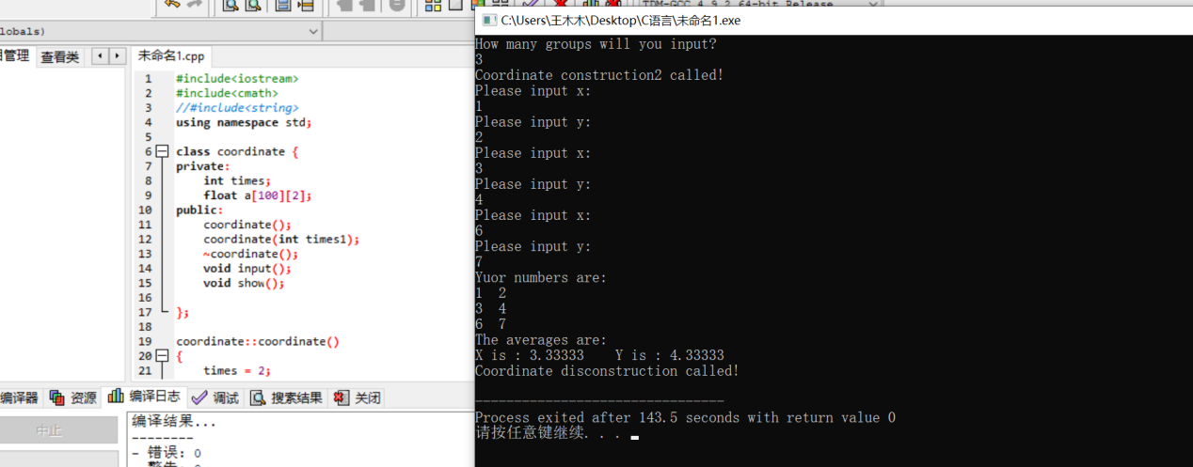

心得：

这次实验主要是教我们如何使用类，类包含数据说明和一组操作数据或传递消息的函数。掌握了类之后，提供了可重用性的好处。之后运用了析构函数和构造函数，掌握了编程的一些基础。