**程序代码：**

**实验内容和实验内容1：**

#include<iostream>

using namespace std;

class Coordinate{ // 定义Coordinate类

public:

Coordinate()

{

times=2;

cout<<"Coordinate construction1 called!"<<endl;

}

Coordinate(int times1)

{

times=times1;

cout<<"Coordinate construction2 called!"<<endl;

}

~Coordinate()

{

cout<<"Coordinate destruction called!"<<endl;

}

void InputCoord()

{

for(int i=0;i<times;i++)

{

cout<<"Please Input x:"<<endl;

cin>>Coord[i][1];

cout<<"Please Input y:"<<endl;

cin>>Coord[i][2];

}

}

void ShowCoord()

{

cout<<"The coord is:"<<endl;

for(int i=0;i<times;i++)

{

cout<<"("<<Coord[i][1]<<","<<Coord[i][2]<<")"<<endl;

}

}

void ShowAvgCoord()

{

float avgx = 0;

float avgy = 0;

for(int i=0;i<times;i++)

{

avgx = avgx + Coord[i][1];

avgy = avgy + Coord[i][2];

}

avgx = avgx/times;

avgy = avgy/times;

cout<<"The AVG coord is:"<<endl;

cout<<"("<<avgx<<","<<avgy<<")"<<endl;

}

private:

float Coord[100][100]; // 存放输入坐标的数组

int times; // 存放输入坐标数目

};

int main()

{

Coordinate x; // 定义对象

x.InputCoord(); //输入

x.ShowCoord();//显示坐标

x.ShowAvgCoord();//显示左边均值

Coordinate y(5);

y.InputCoord();

y.ShowCoord();

y.ShowAvgCoord();

return 0;

}

**实验内容2：**

#include <iostream>

#include <string>

using namespace std;

class score

{

private:

int time;

double cj[100][100];

string name[100];

string copy[100];

public:

score()

{

time = 2;//默认为2

cout << "默认两组" << endl;

}

score(int time1)

{

time = time1;

cout << "用户自定义组数" << endl;

}

~score()

{

cout << "Destructor called" << endl;

}

void input()

{

for (int i = 0; i < time; ++i)

{

cout << "请输入学生的姓名和成绩：" << endl;

cin >> name[i];

cin >> cj[i][1] >> cj[i][2] >> cj[i][3];

}

}

void show()

{

for (int i = 0; i < time; ++i)

{

cout << name[i] << "学科A的成绩为：" << cj[i][1] << " ";

cout << name[i] << "学科B的成绩为：" << cj[i][2] << " ";

cout << name[i] << "学科C的成绩为：" << cj[i][3] << endl;

}

}

void avg()

{

double a=0;

for (int i = 0; i < time; ++i)

{

a = cj[i][1] + cj[i][2] + cj[i][3];

cout << name[i] << "的平均成绩为：" << a/3 <<" ";

}

cout << endl;

}

void showavg()

{

double a=0;

double b=0;

double c=0;

for (int i=0; i < time; ++i)

a = a + cj[i][1];

for (int i=0; i < time; ++i)

b = b + cj[i][2];

for (int i=0; i < time; ++i)

c = c + cj[i][3];

cout << "学科A的平均成绩为" << a / time << " ";

cout << "学科B的平均成绩为" << b / time << " ";

cout << "学科C的平均成绩为" << c / time << endl;

}

void px()

{

for (int i = 0; i < time; ++i) //将name数组复制一个

copy[i] = name[i];

for (int i = 0; i < time - 1; i++)

for (int j = 0; j < time - i - 1; j++)

if (cj[j][1] < cj[j + 1][1]) //改变了name数组数据的位置

{

double temp = cj[j + 1][1];

cj[j + 1][1] = cj[j][1];

cj[j][1] = temp;

string t = name[j + 1];

name[j + 1] = name[j];

name[j] = t;

}

cout << "学科A的排序为：" << endl;

for (int i = 0; i < time; ++i) //打印姓名和对应的成绩

{

cout << name[i] << " " << cj[i][1] << endl;

}

for (int i = 0; i < time; ++i) //重置name数组

name[i] = copy[i];

for (int i = 0; i < time - 1; i++)

for (int j = 0; j < time - i - 1; j++)

if (cj[j][2] < cj[j + 1][2])

{

double temp = cj[j + 1][2];

cj[j + 1][2] = cj[j][2];

cj[j][2] = temp;

string t = name[j + 1];

name[j + 1] = name[j];

name[j] = t;

}

cout << "学科B的排序为：" << endl;

for (int i = 0; i < time; ++i) //打印姓名和对应的成绩

{

cout << name[i] << " " << cj[i][2] << endl;

}

for (int i = 0; i < time; ++i) //重置name数组

name[i] = copy[i];

for (int i = 0; i < time - 1; i++)

for (int j = 0; j < time - i - 1; j++)

if (cj[j][3] < cj[j + 1][3])

{

double temp = cj[j + 1][3];

cj[j + 1][3] = cj[j][3];

cj[j][3] = temp;

string t = name[j + 1];

name[j + 1] = name[j];

name[j] = t;

}

cout << "学科C的排序为：" << endl; //打印姓名和对应的成绩

for (int i = 0; i < time; ++i)

{

cout << name[i] <<" "<< cj[i][3] << endl;

}

}

};

int main()

{

score a(3);

a.input();

a.show();

a.avg();

a.showavg();

a.px();

return 0;

}

**程序结果：**

实验内容和实验内容1：（Input 1 2 3 4 5 6 7 8 … 13 14） 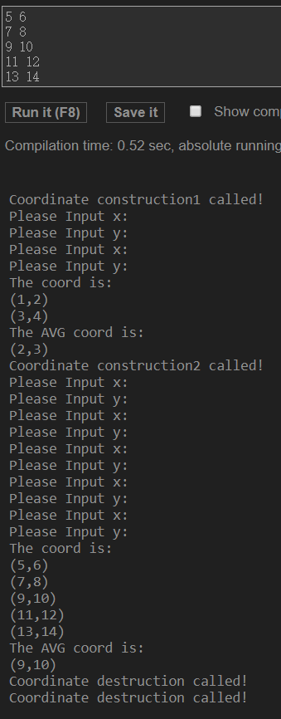

实验内容2：（input如图上方框图所示）

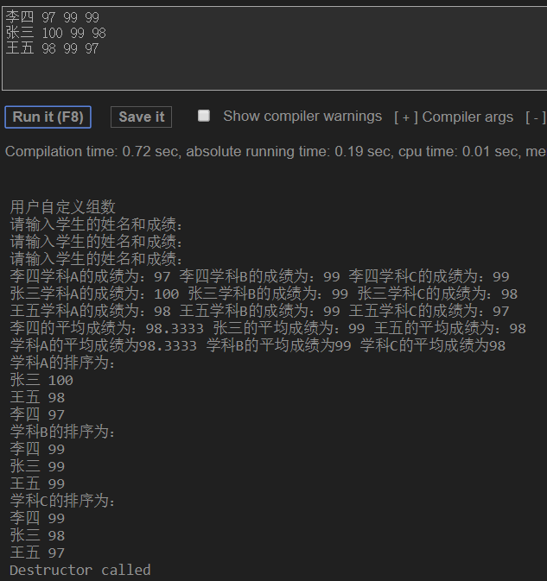

**感想心得：**

第三章是C++入门的一把很重要的钥匙，虽说知识点和课后作业稍微简单一些，但是在上机实践的时候的确让我感受到了巨大的阻力，在书写大量代码的同时，要时刻注意类成员的安全性和代码的调用，果然实践能够发现许多问题，在改正后相信会对本章知识有一个新的理解！