**心得：**本次实验我学习了静态变量，这是一种静态储存方式，静态变量并不是说其就不能改变值，不能改变值的量叫常量。很重要的一点是静态成员的定义，初始化，使用为什么是用友元函数，如何声明，同时我也掌握静态成员的概念和使用，知道了静态变量不代表它的值不会改变。同时掌握了几种对象传递的使用。

**代码：**# include<iostream>

using namespace std;

class Tr {

public:

Tr(int n)

{

i = n;

}

void set_i(int n)

{

i = n;

}

int get_i()

{

return i;

}

private:

int i;

};

void sqr_it(Tr ob) // 对象ob作为函数sqr_it的形参

{

ob.set_i(ob.get_i() * ob.get_i());

cout << "在函数sqr_it内，形参对象ob的数据成员i的值为:" << ob.get_i();

cout << endl;

}

int main()

{

Tr obj(10);

cout << "调用函数sqr_it前, 实参对象obj的数据成员i的值为:";

cout << obj.get_i() << endl;

sqr_it(obj);

cout << "调用函数sqr_it后, 实参对象obj的数据成员i的值为:";

cout << obj.get_i() << endl;

return 0;

}

**程序结果：**

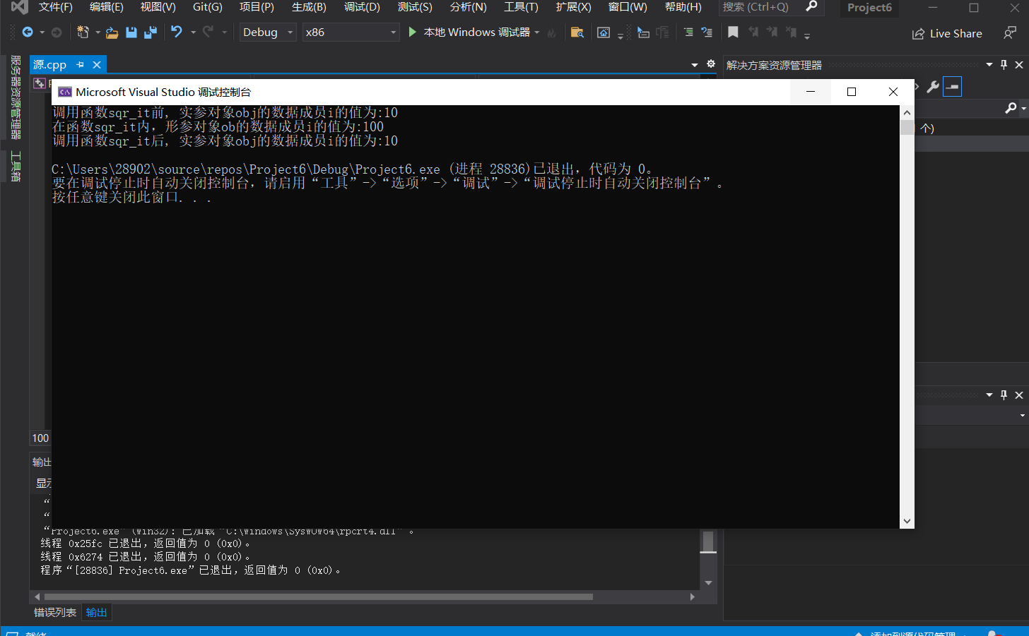

**代码：**#include<iostream>

#include<cmath>

#include<string>

using namespace std;

class tstudent {

private:

static float m_classmoney;

string name;

public:

static void showmoney();

void initstudent(string name1);

void expendmoney(float money);

};

float tstudent::m_classmoney = 1000;

void tstudent::initstudent(string name1)

{

name = name1;

}

void tstudent::expendmoney(float money)

{

m_classmoney = m_classmoney - money;

}

void tstudent::showmoney()

{

cout << "There is " << m_classmoney << "yuan left" << endl;

}

int main()

{

int i;

float b[3];

string a[3];

tstudent s1, s2, s3;

for (i = 0; i < 3; i++)

{

cout << "Please input student's name: " << endl;

cin >> a[i];

cout << "Please input how much money did this student spend: " << endl;

cin >> b[i];

}

s1.initstudent(a[0]);

s1.expendmoney(b[0]);

s2.initstudent(a[1]);

s2.expendmoney(b[1]);

s3.initstudent(a[2]);

s3.expendmoney(b[2]);

s1.showmoney();

return 0;

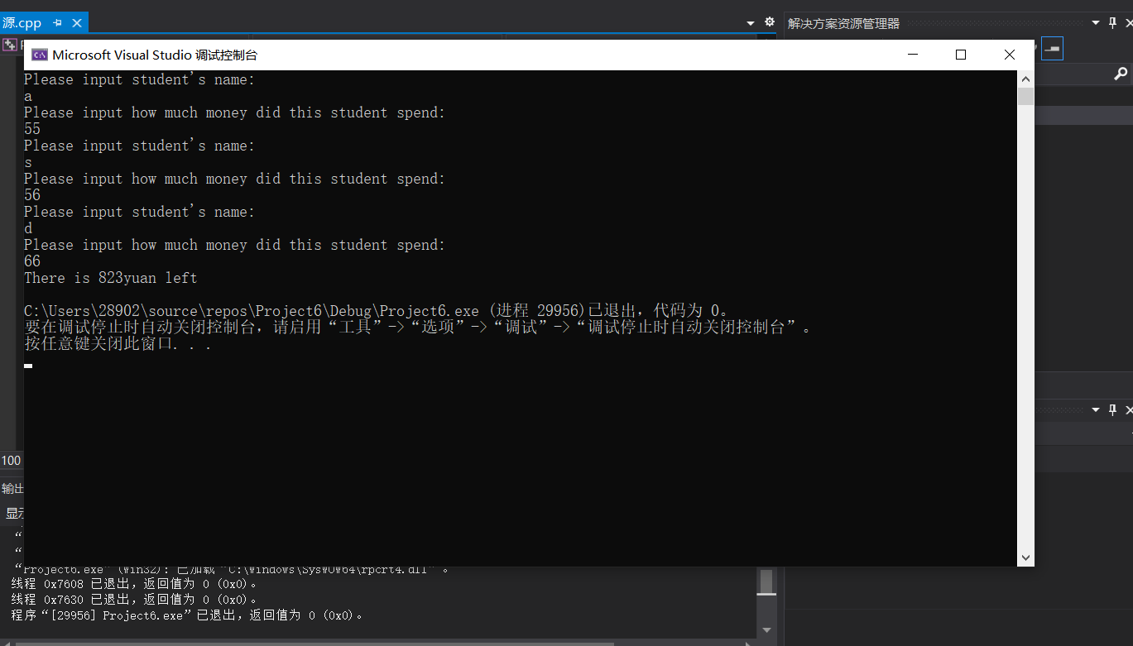**程序结果：**