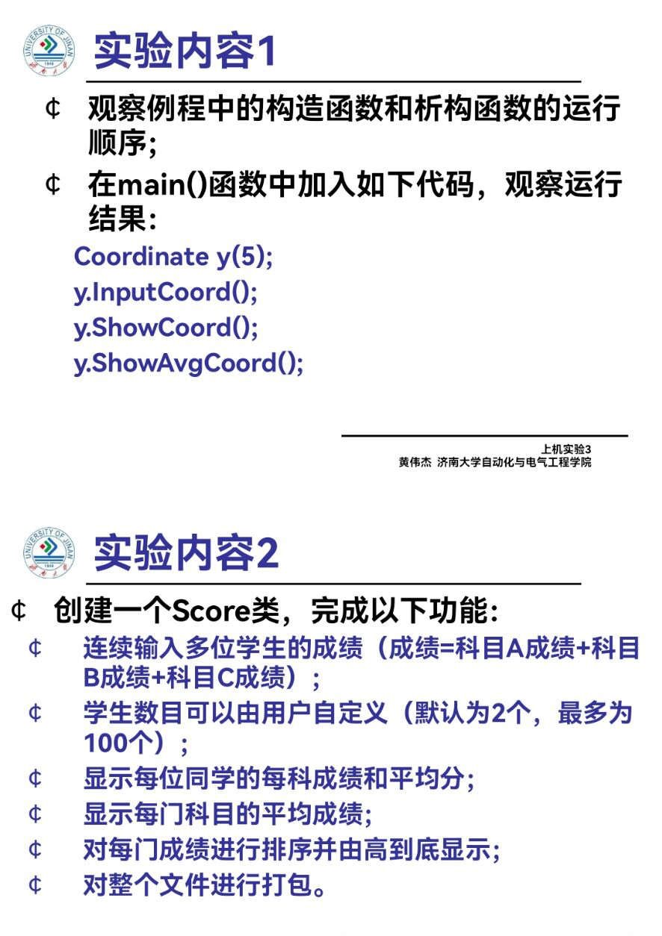

**#include<iostream>**

**#include<string>**

**using namespace std;**

**class Score{**

**public:**

**Score()**

**{ times=2; }**

**Score(int times1)**

**{ times=times1; }**

**void InputNameAndScore()**

**{**

**for(int i=0;i<times;i++)**

**{**

**cout<<"请输入学生姓名:"<<endl;**

**cin>>Name[i];**

**cout<<"请输入科目A成绩:"<<endl;**

**cin>>SScore[i][1];**

**cout<<"请输入科目B成绩:"<<endl;**

**cin>>SScore[i][2];**

**cout<<"请输入科目C成绩:"<<endl;**

**cin>>SScore[i][3];**

**}**

**}**

**}**

**void ShowNameAndScore()**

**{**

**for(int i=0;i<times;i++)**

**{**

**cout<<"姓名: "<<Name[i]<<" 科目A成绩: "<<SScore[i][1]<<" 科目B成绩 "<<SScore[i][2]<<" 科目C成绩: "<<SScore[i][3]<<endl;**

**}**

**}**

**}**

**void ShowStdentAvgScore(int Sid)**

**{**

**float avg = 0;**

**avg = (SScore[Sid][1]+SScore[Sid][2]+SScore[Sid][3])/3;**

**cout<<"姓名: "<<Name[Sid]<<" 平均成绩: "<<avg<<endl;**

**}**

**}**

**void ShowClassAvgScore(string ClassName)**

**{{ int Cid;**

**float avg = 0;**

**if(ClassName == "A") Cid = 1;**

**if(ClassName == "B") Cid = 2;**

**if(ClassName == "C") Cid = 3;**

**for(int i=0;i<times;i++)**

**{ avg = avg + SScore[i][Cid]; }**

**avg = avg/times;**

**cout<<"课程名称: "<<ClassName<<"平均成绩: "<<avg<<endl;**

**}**

**}**

**}**

**void OrderScore(string ClassName)**

**{ void OrderScore(string ClassName)**

**{**

**int Cid;**

**if(ClassName == "A") Cid = 1;**

**if(ClassName == "B") Cid = 2;**

**if(ClassName == "C") Cid = 3;**

**for(int i=0;i<times;i++)**

**{ SScore1[i] = SScore[i][Cid]; }**

**for(i=0;i<times;i++)**

**{ Name1[i] = Name[i]; }**

**for(i=1;i<times;i++)**

**{ if(SScore1[i] > SScore1[i-1])**

**{ float temp = SScore1[i-1];**

**SScore1[i-1] = SScore1[i];**

**SScore1[i] = temp;**

**string temp1;**

**temp1 = Name1[i-1];**

**Name1[i-1] = Name1[i];**

**Name1[i]= temp1;**

**}**

**}**

**cout<<"课程名称: "<<ClassName<<endl;**

**for(i=0;i<times;i++)**

**{**

**cout<<"姓名: "<<Name1[i]<<" 成绩: "<<SScore1[i]<<endl;**

**}**

**}**

**}**

**private:**

**float SScore[100][3],SScore1[100];**

**string Name[100],Name1[100];**

**int times;**

**};**

**int main()**

**{ Score x;**

**x.InputNameAndScore();**

**x.ShowNameAndScore();**

**x.ShowStdentAvgScore(1);**

**x.ShowClassAvgScore("A");**

**x.OrderScore("B");**

**return 0;**

**}**

**心得**

本次代码是从PPT里面学习收获的，通过编写代码的过程更加深入了解到类的定义与应用，渐入佳境。

**Copyright ©2021-2099 朱晓妍All rights reserved**