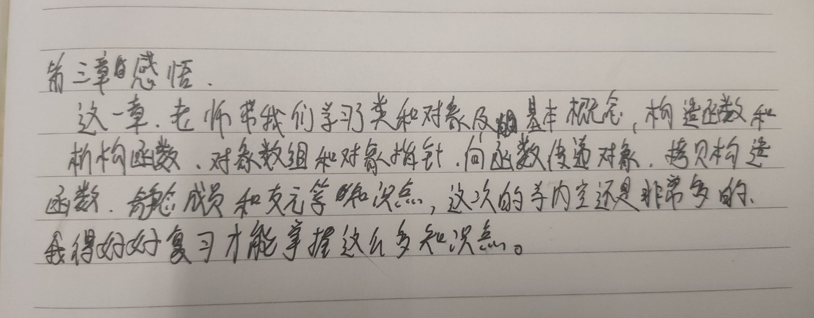

Copyright ©2021-2099 SongyuWang.All rights reserved