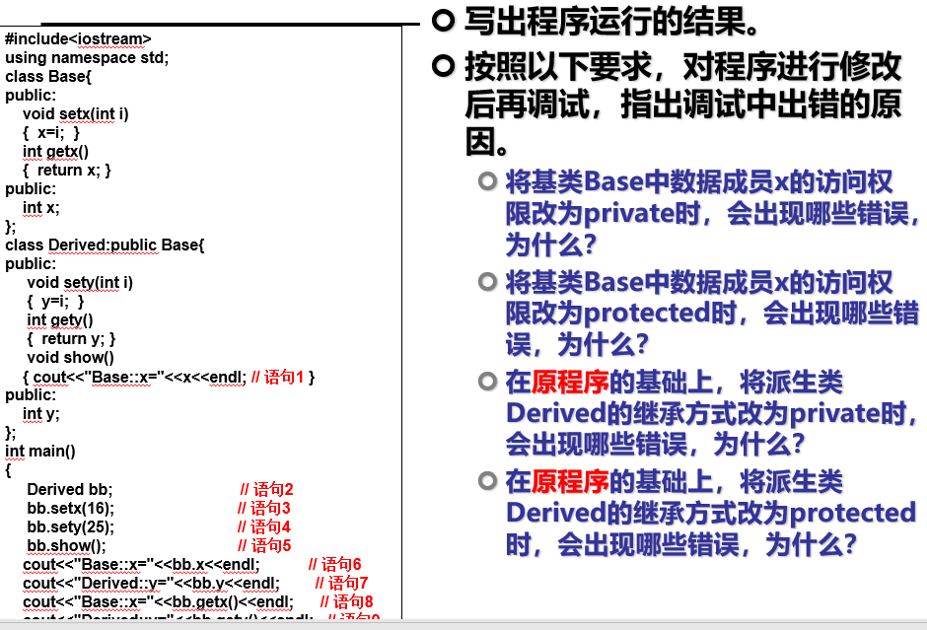

Copyright ©2021-2099朱晓妍. All rights reserved

#include<iostream>

using namespace std;

class Base{

public:

void setx(int i)

{ x=i; }

int getx()

{ return x; }

public:

int x;

};

class Derived:public Base{

public:

void sety(int i)

{ y=i; }

int gety()

{ return y; }

void show()

{ cout<<"Base::x="<<x<<endl; // 语句1 }

public:

int y;

};

int main()

{

Derived bb; // 语句2

bb.setx(16); // 语句3

bb.sety(25); // 语句4

bb.show(); // 语句5

cout<<"Base::x="<<bb.x<<endl; // 语句6

cout<<"Derived::y="<<bb.y<<endl; // 语句7

cout<<"Base::x="<<bb.getx()<<endl; // 语句8

cout<<"Derived::y="<<bb.gety()<<endl; // 语句9

return 0;

}

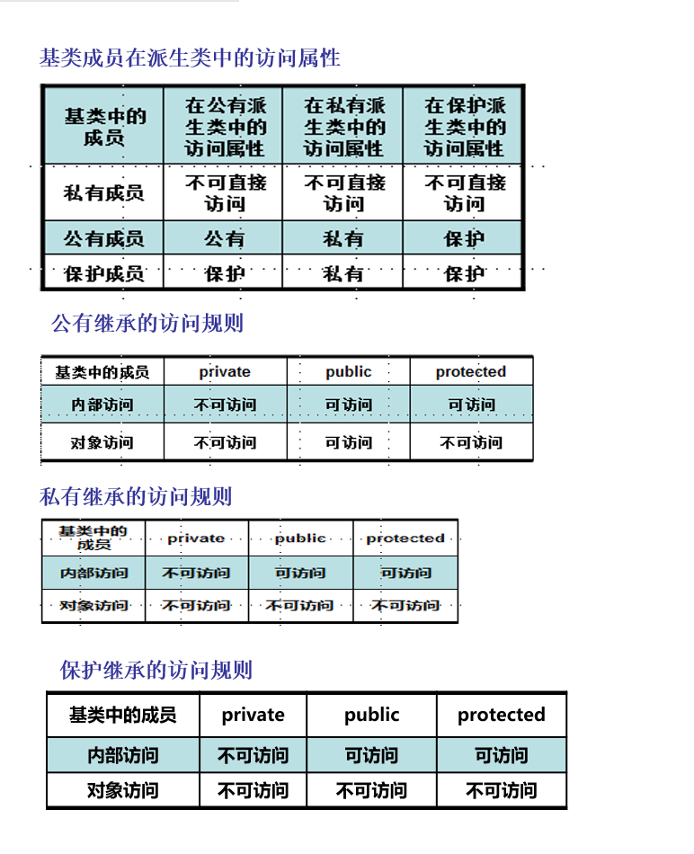

**心得**

我只是知识的搬运工