实验报告（第七次上机）

自动2002班 周骏 202030310294

实验一：

代码：

#include<iostream>

//#include<cstring>

#include<cmath>

using namespace std;

class complex {

private:

double real;

double image;

public:

complex(double real1=0 ,double image1=0):real(real1),image(image1){}

friend complex operator\*(complex& x, complex& y);

void show();

};

void complex::show()

{

cout << "The multiplication of the complexes is : " << endl;

cout << real;

if (image > 0)

cout << "+";

if(image!=0)

cout << image << "i" << endl;

}

complex operator\*(complex& x, complex& y)

{

complex temp;

temp.real = x.real \* y.real;

temp.image = x.image \* y.image;

return temp;

}

int main()

{

double x1, x2, y1, y2;

cout << "Please input the first complex: " << endl;

cin >> x1 >> y1;

cout << "Pease input the second complex: " << endl;

cin >> x2 >> y2;

complex a(x1 ,y1);

complex b(x2, y2);

complex c;

c = a \* b;

c.show();

return 0;

}

图片：  
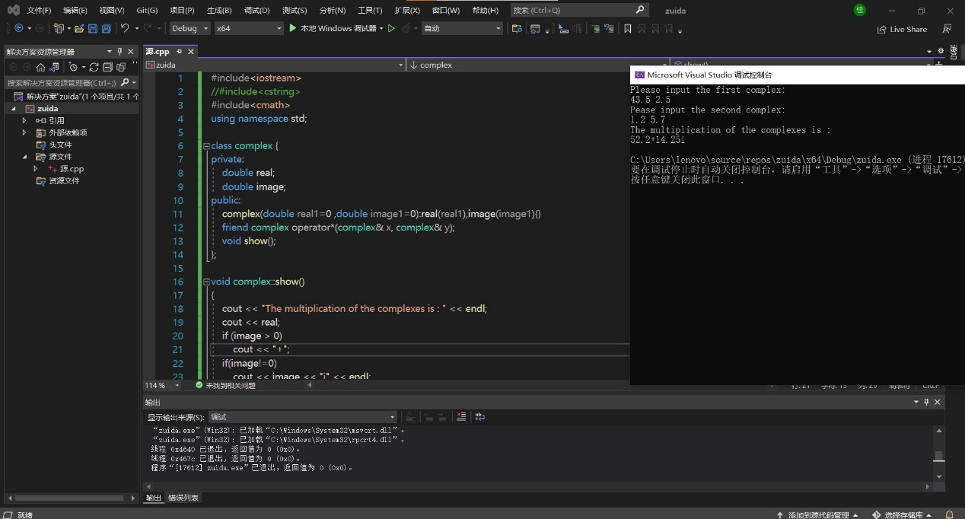

实验二：

代码：

#include<iostream>

//#include<cstring>

#include<cmath>

using namespace std;

class complex {

private:

double real;

double image;

public:

complex(double real1=0 ,double image1=0):real(real1),image(image1){}

friend complex operator\*(complex& x, complex& y);

void show();

};

void complex::show()

{

cout << "The multiplication of the complexes is : " << endl;

cout << real;

if (image > 0)

cout << "+";

if(image!=0)

cout << image << "i" << endl;

}

complex operator\*(complex& x, complex& y)

{

complex temp;

temp.real = x.real \* y.real-x.image\*y.image;

temp.image = x.real \* y.image+x.image\*y.real;

return temp;

}

int main()

{

double x1, x2, y1, y2;

cout << "Please input the first complex: " << endl;

cin >> x1 >> y1;

cout << "Pease input the second complex: " << endl;

cin >> x2 >> y2;

complex a(x1 ,y1);

complex b(x2, y2);

complex c;

c = a \* b;

c.show();

return 0;

}

图片：

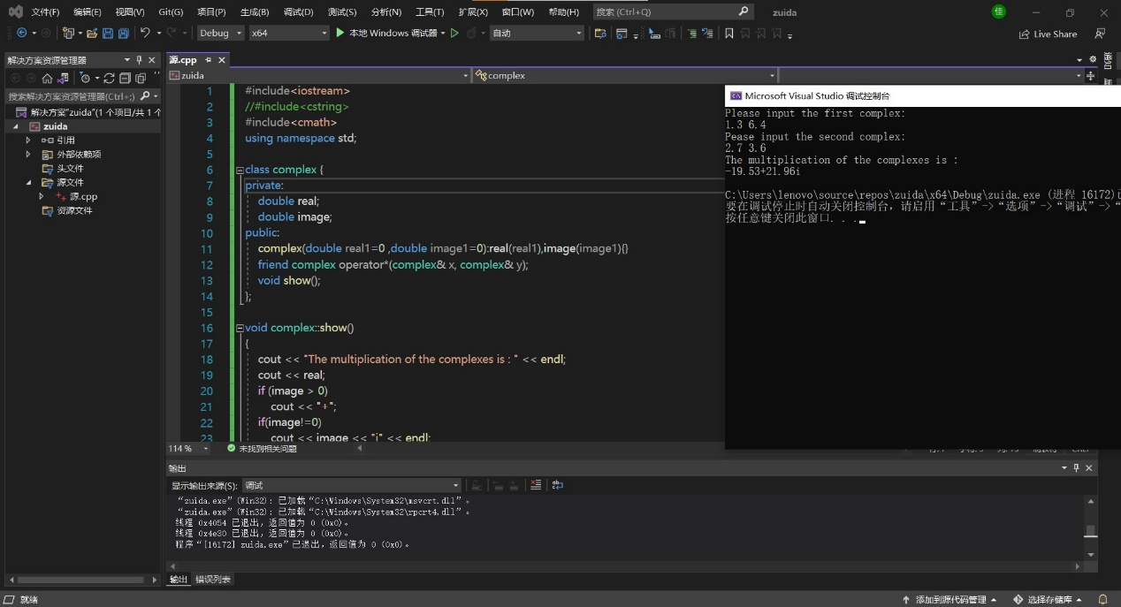

总结：

本次上机实验主要考察运算符重载函数的运用，运算符重载函数本质上是用户为了实现特殊的函数运算而自定义的一种函数，在使用时可将其看作一个运算符号。还学会了用编程实现两个复数的乘法，了解了运算符重载是通过创建运算符重载函数来实现的。运算符重载是针对新类型数据的实际需要，对原有运算符进行适当的改造完成的。重载不能改变运算符的操作对象的个数。这就是本次上机我的感受。

Copyright ©2021-2099 JunZhou. All rights reserved