**Running Instructions for TomatoXL**

1. **Install GroIMP**

Download the GroIMP version 1.5in the link <https://download.grogra.de/>. Double-click the “GroIMP-1.5-win64.exe” file to complete the software installation.

1. **Install and Configure Java environment**

Download the java 8 to install and configure the Java environment.

1. **Import Custom Java Package**

Copy the “TomatoXL.jar” file to the *“..\jdk1.8.0_351\jre\lib\ext”* directory under the Java installation path.

1. **Create Working Directory**
   1. Create a model IO file directory under the root directory of any disk (e.g., E): *“E:/modelIO/TEST”*; Copy “Input_canopy”, “Input_climate”, “Input_physiology”, and “Output_PPFD” into this directory.
   2. Create a scenario file directory under the same disk root: *“E:/Projects/TEST/Moel”.* Copy the “Scenario_parameter.xlsx” file into this directory.
2. **Run GroIMP**

* Double-click to run GroIMP, and open the file TomatoXL-TEST.gsz.
* In the main.rgg file, modify “*wd*” to the created working directory.
* At the beginning of the main.rgg file, modify “*startOrder*” and “*endOrder*” to the desired file order numbers. The order numbers are defined in the “*order*” column of the “Scenario_parameter.xlsx” file.
* 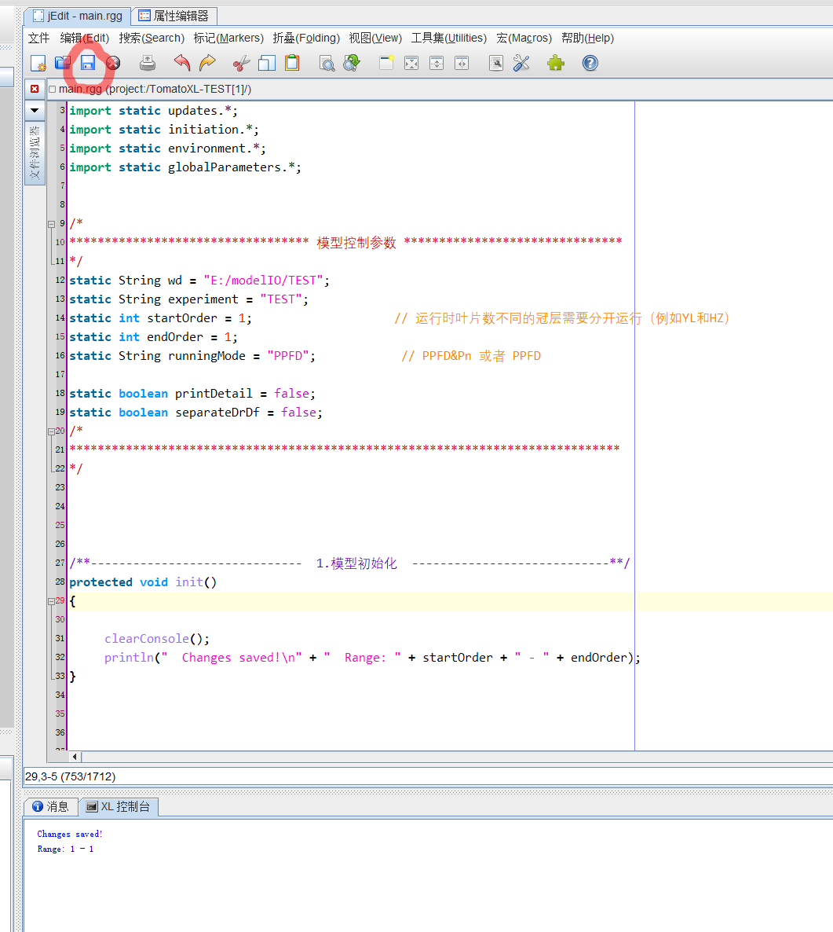Click the “save” button on the right panel of GroIMP.
* 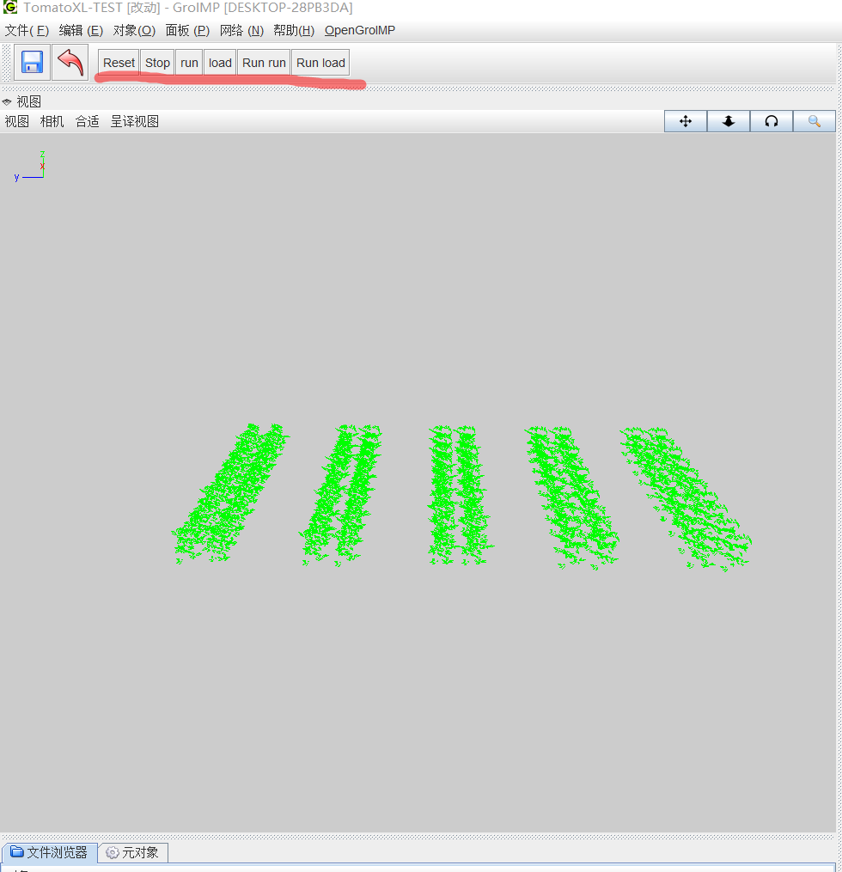Click the “load” button on the left panel of GroIMP.
* 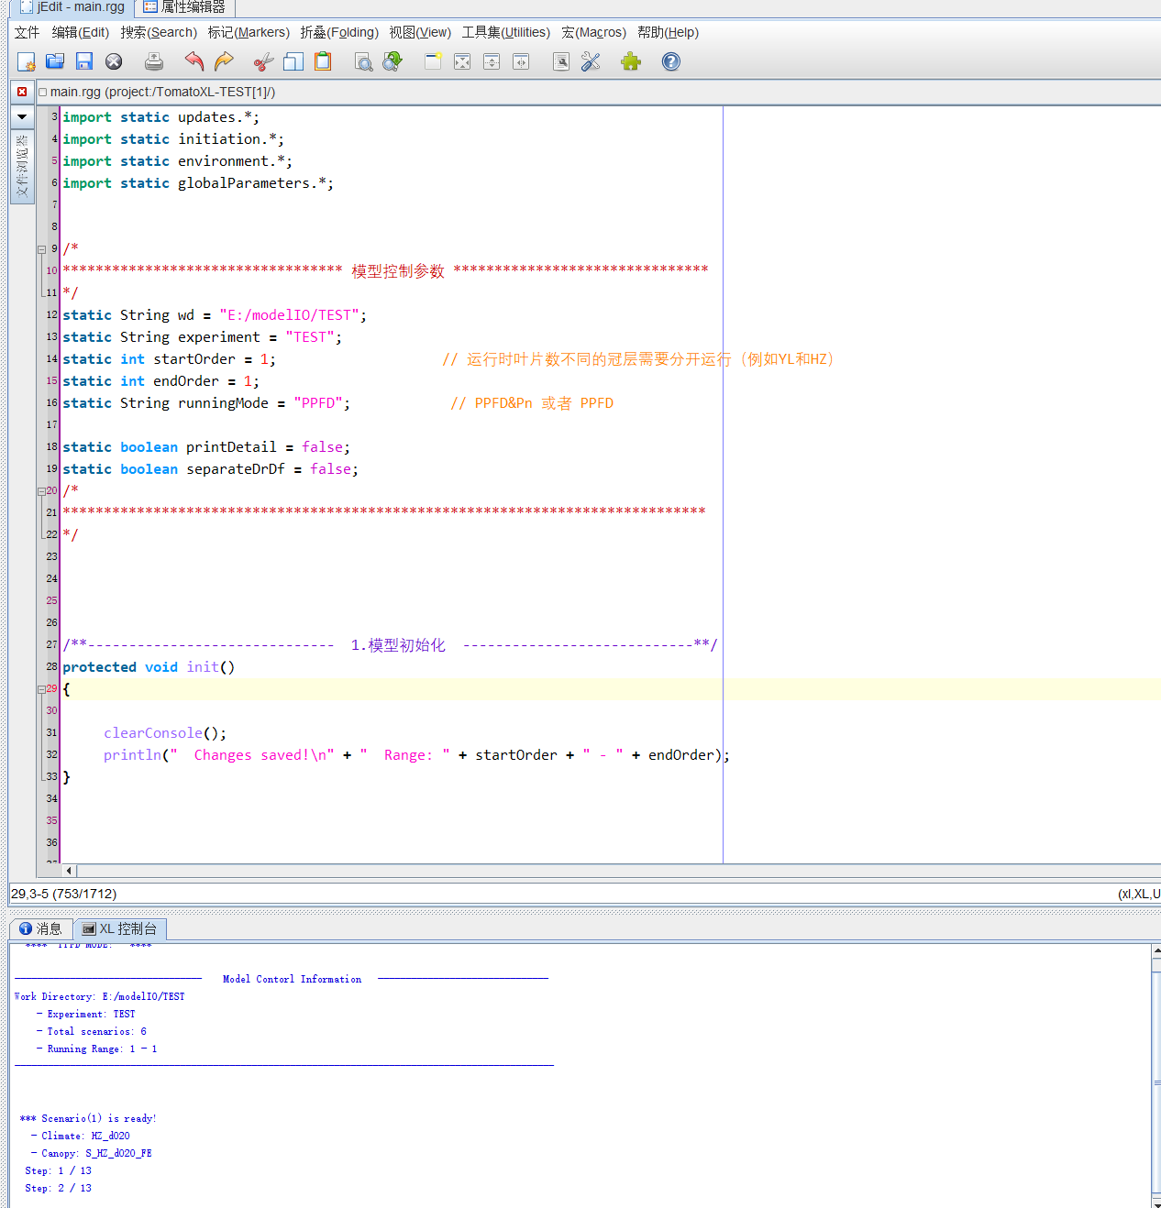Click the “run” button on the left panel of GroIMP and wait for execution to complete.

1. **View Output Files**

When the model finishes running, the output files will be saved in the “…/Output_PPFD/TEST” directory as .txt files.