Running Instructions for TomatoXL
- Install GroIMP
Download the GroIMP version 1.5 in the link https://download.grogra.de/. Double-click the “GroIMP-1.5-win64.exe” file to complete the software installation.
- Install and Configure Java environment
Download the java 8 to install and configure the Java environment.
- Import Custom Java Package
Copy the “TomatoXL.jar” file to the “..\jdk1.8.0_351\jre\lib\ext” directory under the Java installation path.
- Create Working Directory
  - Create a model IO file directory under the root directory of any disk (e.g., E): “E:/modelIO/TEST”; Copy “Input_canopy”, “Input_climate”, “Input_physiology”, and “Output_PPFD” into this directory.
  - Create a scenario file directory under the same disk root: “E:/Projects/TEST/Moel”. Copy the “Scenario_parameter.xlsx” file into this directory.
- Run GroIMP
- Double-click to run GroIMP, and open the file TomatoXL-TEST.gsz.
- In the main.rgg file, modify “wd” to the created working directory.
- At the beginning of the main.rgg file, modify “startOrder” and “endOrder” to the desired file order numbers. The order numbers are defined in the “order” column of the “Scenario_parameter.xlsx” file.
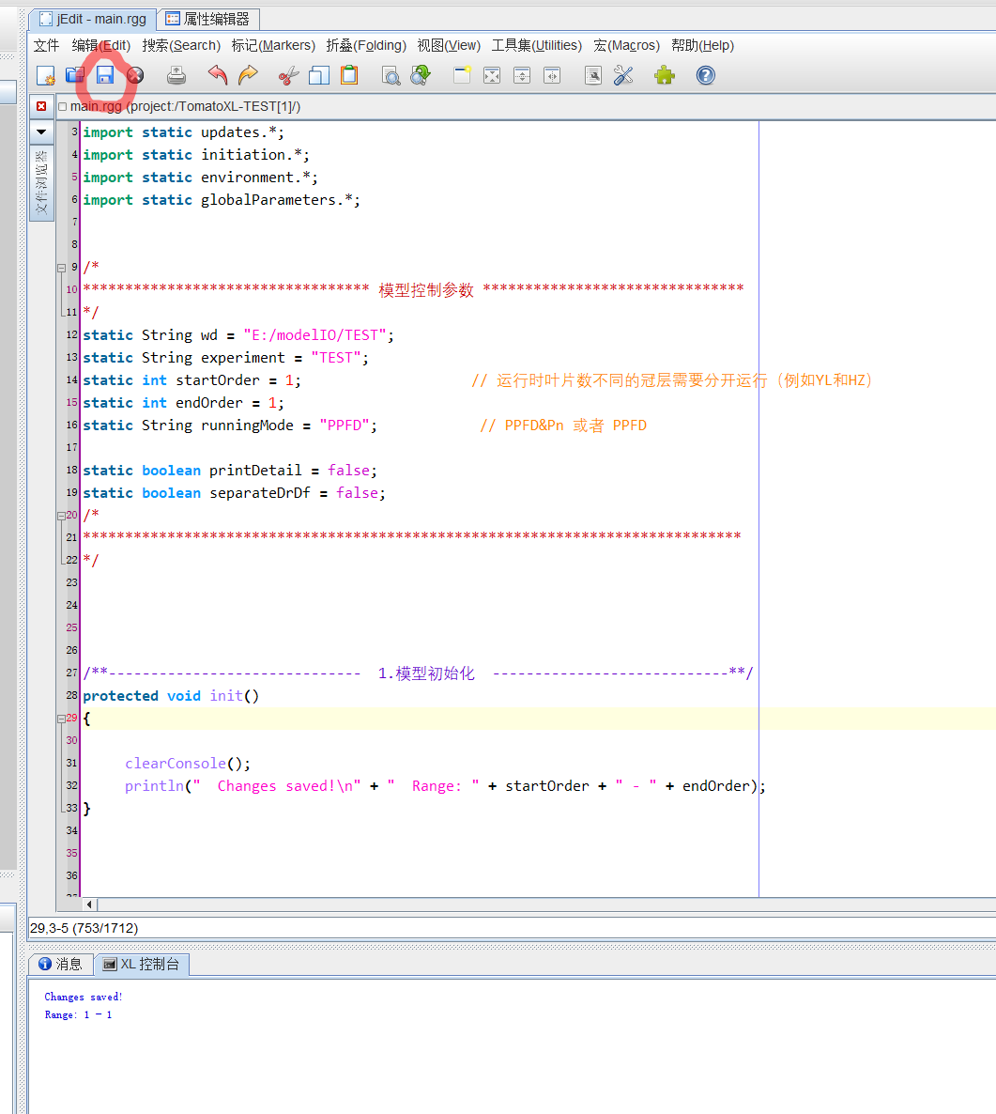
- Click the “save” button on the right panel of GroIMP.
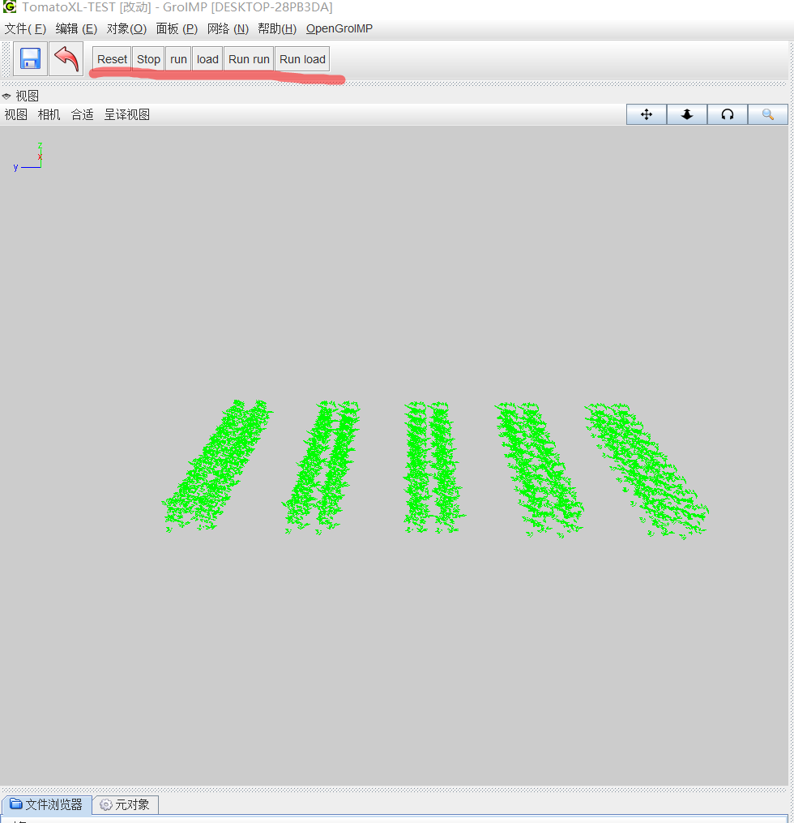
- Click the “load” button on the left panel of GroIMP.

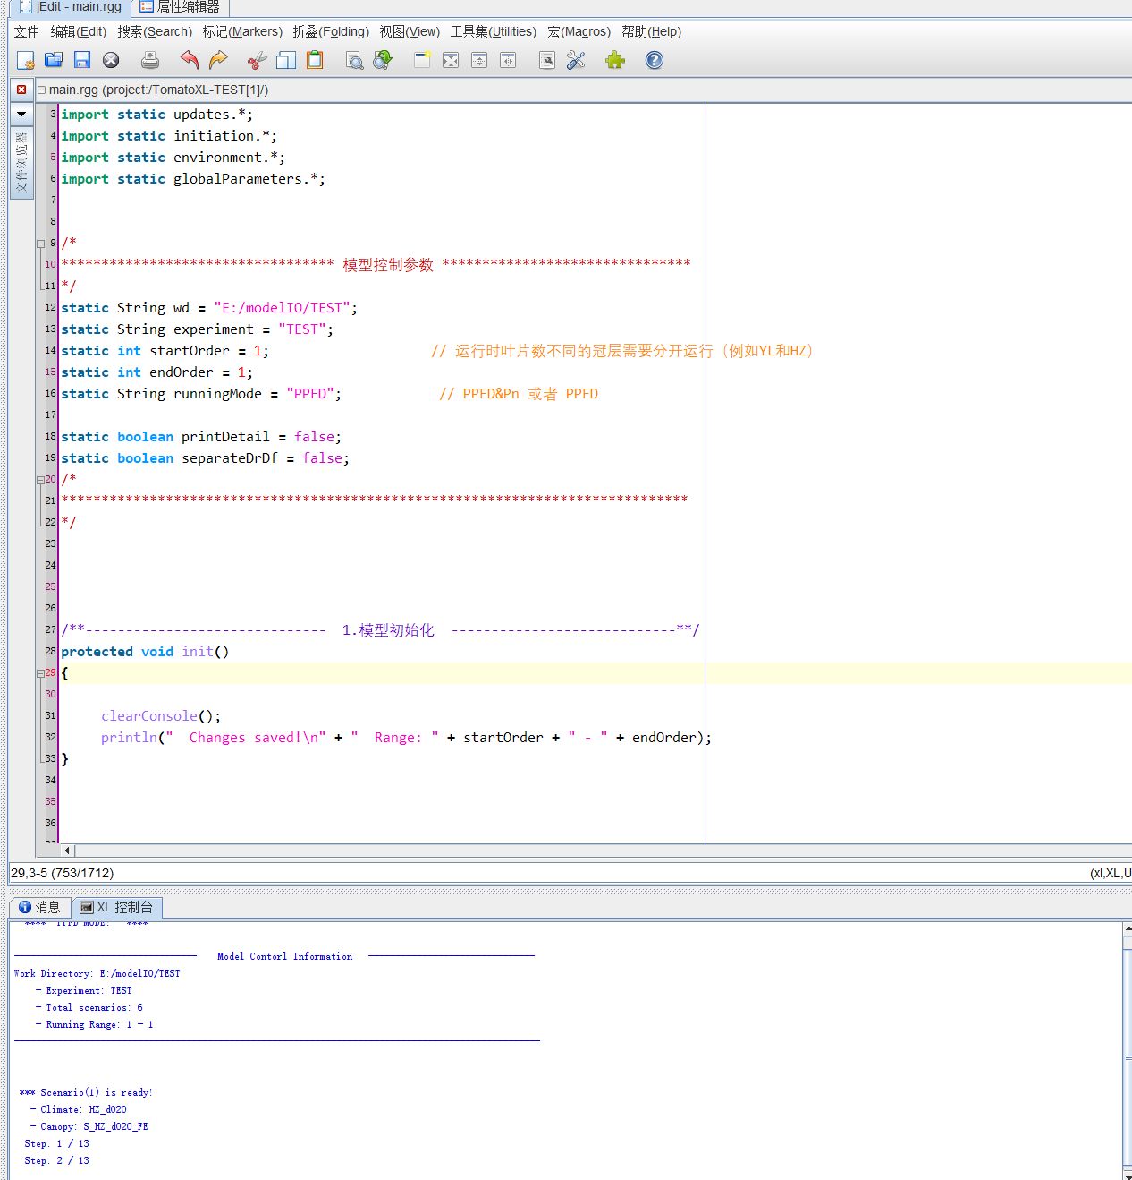
- Click the “run” button on the left panel of GroIMP and wait for execution to complete.
- View Output Files
When the model finishes running, the output files will be saved in the “…/Output_PPFD/TEST” directory as .txt files.

