Screenshot of successful search:
Input 3 jugs with capacities (3, 5, 8), initial status (0, 0, 8) and target amount 4
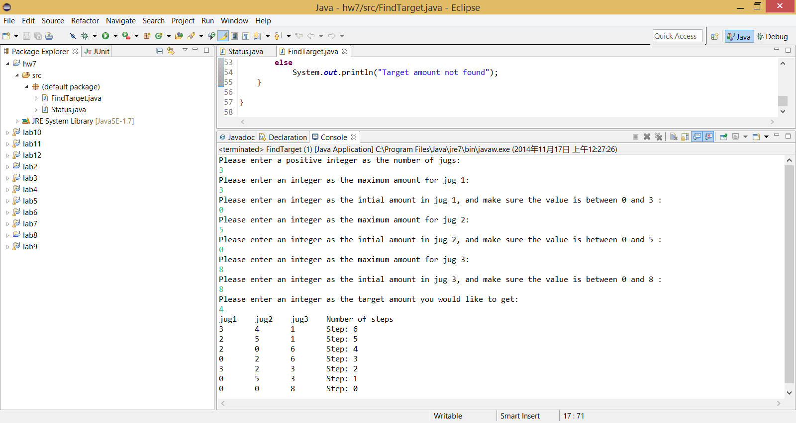
Screenshot of unsuccessful search:
Input 4 jugs with capacities (2, 2, 2, 6), initial status (0, 0, 0, 6) and target amount 5
